

**Takouba**

Veterans Affairs

Participatory System Dynamics Platform   
(to Increase Timely Access to VHA Evidence-based Outpatient Mental Health Care)

**Design Document -- Iteration C**

Tue 20-Feb 2018  
Version 11



# Document History & Status

|  |  |  |
| --- | --- | --- |
| Version | Date | Description/ Status |
| v 1 | 17-Nov 2017 | Start of Document / Development. |
| v 2 | 19-Dec 2017 | External G-SS for variables info (for Agg model). |
| v 3 | 21-Dec 2017 | Removed variable table, added some graphics, notes for review. |
| v 4 | 26-Dec 2017 | Takouba review. |
| v 5 | 26-Dec 2017 | Release version for development. |
| v 6 | 30-Jan 2018 | DEPRECATED (New Iteration C Design Document here) |
| v 7 | 30-Jan 2018 | New version (this version) created. |
| v 8 | 07-Feb 2018 | Included several Figures (for CC and MM). |
| v 9 | 13-Feb 2018 | Move some UI items to Global; build out Psy and Agg areas; Phone/tablet section. |
| v 10 | 20-Feb 2018 | Updated model diagrams (CC and MM); TAK review for client review. |
| v 11 | 20-Feb 2018 | Client review version. |

**Table of Contents (Quick Link)**

Document History & Status

Objective of This Document

Basics

Iteration Objectives

Key Dates

Graphic Standards and 508 Accessibility Standards

Vensim Model(s)

Roles

Page Flows, Wireframes, and Graphics

Graphics

Wireframes

Phone/Tablet Responsive Design

SOW Requirements

2.02 Admin’s Dashboard / Administration Features / 5.2.1. Basic Administrative Functionality for administration from the National Center for PTSD

2.02 Admin’s Dashboard / Administration Features / 5.6.2. Overview page with list of users and their current progress

2.03 Player’s Dashboard / 5.9.10 Decisions Page (for CC)

2.03 Player’s Dashboard / 5.9.10 Decisions Page (for MM)

2.03 Player’s Dashboard / 5.9.10 Decisions Page (for Psy)

2.03 Player’s Dashboard / 5.9.10 Decisions Page (for Agg)

2.03 Player’s Dashboard / 5.9.6 Dashboard with access to key metrics

2.03 Player’s Dashboard / 5.9.12 Ability to export data as a Comma Separated Values (CSV) File

2.03 Player’s Dashboard / 5.10.01 Introduction & Help: Text-based 'prepare' section

[(Help Page Content) 2.03 Player’s Dashboard / 5.10.02 Introduction & Help: Text-based 'help' section AND   
2.03 Player’s Dashboard / 5.10.03 Integrate tutorial videos AND   
2.03 Player’s Dashboard / 5.10.04 Interactive tutorial walking through the user interface](#_hk7zanbp4md5)

[2.04 Retune the Model for Different Locations / 5.3.1 Framework for Multiple Cities, States, other Locations AND   
5.3.2 Ability to Upload Datasets by Location](#_oltztmguosr)

2.05 User Management / 5.4.2 Upload List of Users from a Comma Separated Values (CSV) file

2.05 User Management / 5.9.3 Set team name

2.06 Game Assignment / 5.4.3 Assign Users to Roles (Role Player, Simulation User role) and Teams

2.06 Game Assignment / 5.4.4 Remove Users/ Reset Passwords/ Other User-management Features

2.07 Game Progress / 5.9.8 Scoring / Compare to Other Teams (only for Admins)

2.10 Exogenous Events / 5.8.1 Allow Administrator to Trigger Exogenous Events in the Simulation

Unspecified in workplan / 5.7.2 Ability of Manager/Facilitator to Impersonate Team Members to View Decision Details

Updates to Iteration B

Iteration C Design-Related Questions

Recordings of Calls

Notes on Colors:

1. Most text is in black
2. We can use text color for different indications. For example, Purple is used as notes from Takouba about questions or items yet to be resolved.
3. Orange is to indicate a questions.
4. When questions are acknowledged/resolved we can turn it Dark Green 1, then eventually, back to black.

# Objective of This Document

1. This document describes the design for “Iteration C” for the Participatory System Dynamics Simulation.
2. The document is also used to track questions and clarifications during the development and potentially the testing phases of the project.
3. This document does NOT describe all the work to be performed during the Iteration C development period. For more information, please also refer to the separate documents: “VA PSD -- Design Document -- Iteration A”, and “VA PSD -- Design Document -- Iteration B”.

# Basics

## Iteration Objectives

Revised (01-Nov)

1. Iteration A: Logon, basic UI, screen flows, initial input/output (few example elements).
2. Iteration B: Initial reports and output, initial user input, gameplay and session, chat, compare scenarios/teams. CC/MM/ Psy, no Phone, no Admin/Fac Expanded Output Tile.
3. Iteration C: Iteration C: User/access management, videos and training-related resources, additional inputs and outputs. CC/MM/Psy/Agg, Phone, Admin/Fac Expanded Output Tile.
4. Iteration D: Test and Acceptance Plan. Full feature application v1.0.

## Key Dates

1. Initial Design Finalized Date: Mon 27-Dec 2017
2. Revised Iteration C Design Finalized Date: Mon 26-Feb 2018
3. WW Development Due Date: XXX
4. Submit to Client Date: XXX

## Graphic Standards and 508 Accessibility Standards

1. Colors
   1. VA Navy blue - #003F72; RGB 0, 63, 114
   2. VA Light blue - #0083BE; RGB 0, 131, 190
   3. VA Dark red - #772432; RGB 119, 36, 50
   4. VA Bright red - #C4262E; RGB 198, 38, 46
   5. VA Blue Green - #115E67; RGB 17, 95, 103
   6. VA Evergreen - # 154734; RGB 22, 71, 52
   7. VA Green - #598527; RGB 89, 133, 39
   8. VA Vibrant Green - #78B43, RGB 120, 190, 32
   9. VA Vibrant Light Blue (312PC) - #00A9CE; RGB 0, 169, 206
   10. VA Vibrant Purple (2725PC) - #685BC7 ; RGB 104, 91, 199
   11. VA Gray (7544PC) - #768692; 118, 134, 146
   12. Official standards
   13. The links below also have information about fonts, use of logos, and 508 compliance. If there are questions or issues with the standards or compliance, let’s discuss and see if we can use the Iterations to test.
   14. Links
       1. [Tier 1 Graphic Standards](https://www.va.gov/opa/publications/graphicstandards/va_graphicstandardsguide_508_0113.pdf) (Aug 2012)
       2. [Graphic Style Guide](https://www.vets.gov/playbook/downloads/VHA_Style_Guide_508.pdf) (508 compliant, Feb 2012)
       3. [VA Mobile Style Guid](https://mobile.va.gov/sites/default/files/files/VAMobileStyleGuide508compliant.pdf)e (508 compliant, Jul 2014)
2. All text needs to be Ascii-based (and not embedded into graphics)
3. All controls need to be accessible by tab controls (i.e., we cannot have a control that is not accessible through the tab button, including navigation, expanding Tiles, controlling values of sliders, checkboxes, radio buttons, drop-downs).
4. Values for sliders must be controllable by the arrow key.

## Vensim Model(s)

1. The Vensim models to use for Iteration C:
   1. CC -- CC_PROD_Iteration_C.vmf   
      (this is based on CC_v33_2018_2_16_UIFreeze.mdl)
   2. MM -- MM_PROD_Iteration_C.vmf   
      (this is based on MM_v32_2018_2_16_UIFreeze.mdl)
   3. Psy -- Psy_PROD_Iteration_C.vmf   
      (this is based on PSY_v15_2018_02_20_UIFreeze.mdl)
   4. Agg -- Agg_PROD_Iteration_C.vmf   
      (this is based on AGG_v08_2018_02_15.mdl)
2. Model Parameters template -- Please use ModelParameters_Template_Iteration_C.xlsx as the template.
3. Use of Arrays
   1. The MM model and Agg model uses arrayed variables where some of the Vensim variables are arrays with index values. The “decode” of the arrayed variables are indicated below.
      1. MM: dep, aud, oud, other
      2. Agg: Intake, Psych, EBPsych, CC, MM, Adjunctive, Group
4. Model Time and retaining values for the model run
   1. All Vensim models will have INITIAL TIME < 0, and “Units for time” = Week. Psy will have INITIAL TIME = -500 while the others will have INITIAL TIME = -13.
   2. When the Player or Team Lead is initially directed to the PLAY page after selecting a new model (or when the Player or Team Lead “restarts” the experiment, the simulation should run from INITIAL TIME to Week = 0.
   3. The simulation should retain values on a weekly basis (i.e., we do NOT have to retain values or show values for week 0.0625, 0.1250, etc.). We only need to retain values from Week = -13 forward.
   4. In graph and other outputs, Week 0 is equal to “Today”.
   5. We are generally showing time units as “quarters” (i.e., 3 months). We are lso running the model in no smaller than quarter year increments. Each quarter is equal to 13 weeks.

## Roles

This has not changed from Iteration B, but includes as a reference.

1. We will have three roles for the simulation
   1. Administrator (or Admin, or Facilitator; these terms are used interchangeably throughout this document)
   2. Team Lead
   3. Player

Table 01

|  |  |  |
| --- | --- | --- |
| Role | Examples | Description |
| Administrator (or Admin, or Facilitator; these terms are used interchangeably throughout this document) | 1. Lindsey Zimmerman 2. Jane Branscomb 3. Stacey Park 4. James Rollins 5. Howard Park | 1. These are instructors and other “core project” team members. 2. Administrators will also be able to access Admin-only screens/features. |
| Team Lead | NA at this time. | 1. At a given time, there is only on Team Lead for a team. 2. Only the Team Lead can select a Vensim Model and XL file for the team. |
| Player | NA at this time. | 1. This is the rest of the team members (aside from the Team Lead). |

# Page Flows, Wireframes, and Graphics

## Graphics

1. The VA Team PSD logo has been changed as indicated in the graphic below (Figure 01).
2. The plus sign “+” has been removed from the feedback loop symbol, and the VA has been enlarged to the same width as the “Team PSD” portion of the logo.

Figure 01



## Wireframes

1. We have the following changes and clarifications to the previous Wireframes described in the Iteration A and Iteration B Design Documents.
   1. For the Team Lead and Player roles (i.e., NOT Admin/Facilitators), the changes to the wireframe and page arrangement are:
      1. Page renames
         1. Rename the “Select” Page to “HOME” Page.
         2. Rename the “Train” Page to “HELP” Page.
      2. Re-order of top navigation links
         1. Instead of: SELECT | PLAY | TRAIN | CHAT | LOGOFF
         2. Change to: HOME | PLAY | CHAT | HELP | LOGOFF
      3. “HOME” Page (this is what used to be “Select” Page)
         1. Have the following text directly on the “Home” Page at the top (not inside any Tiles:  
              
            “Welcome to the VA Team PSD simulation! This is a tool for clinic teams to explore, learn, and make decisions together for optimizing services to Veterans with their existing or projected resources.  
              
            Remember the key is Modeling to Learn – team learning to improve team decision-making. As you and your team play and discuss experiments, you’ll gain deeper clarity about how your clinic works, what’s within your control to change, and how to make decisions that balance a lot of objectives at once.”
         2. Rename the “Main” Tile to “Select” Tile.
         3. Move the “Play Simulation” button just after the “Select” Tile.
         4. Remove the “Welcome” Tile and the associated content. Note: we may re-add the “Welcome” Tile and add some content for Iteration D.
         5. ~~For Team Leads, add a new Tile “Upload Model Parameters” below the “Play Simulation” button. Please see description~~ ~~below~~~~.~~
      4. There are many design elements for the “PLAY” page. These are described across several sections below. There are four “2.03 Player’s Dashboard / 5.9.10 Decisions Page” sections (one for each Vensim model). Some design elements are better described as global and are consistent across all four models. These global items are described in Updates to Iteration B below.
      5. For the “HELP” Page content, pls see Help Page Content.
   2. For the Admin/Facilitators, the changes and clarifications to the wireframe and page arrangement are:
      1. Re-order of top navigation links
         1. Instead of: SELECT | PLAY | TRAIN | CHAT | LOGOFF
         2. ~~Change to: HOME | DASHBOARDS | CHAT | HELP | LOGOFF~~
         3. Change to: DASHBOARDS | CHAT | HELP | LOGOFF
      2. Clarifying Pages and Tiles for Admin/Facilitator
         1. ~~“Home” Page (this is what used to be “Select” Page) is only used to upload Model Parameters.~~
            1. ~~Add a new Tile “Upload Model Parameters”. Please see description~~ ~~below~~~~.~~
            2. ~~The Admin/Facilitator will NOT have a “Play Simulation” button.~~
         2. After a successful log in, the Admin/Facilitator will be taken to the “DASHBOARDS” page, which only shows the ~~“Play” Page is renamed as “Dashboards” Page and is now only showing~~ Outputs Tile, which is described below. ~~Therefore, while “Play” Page is still needed, it is simpler than the Team Lead and Player views.~~
         3. “Administer” Page (which had been considered in previous Iterations) is no longer needed.
      3. Admin/Facilitator’s “CHAT” Page
         1. Since Facilitators log into the “Group” (which will contain all Teams) and not at the “World” (or Team) level, the Chat Tiles will be slightly different for Admin/Facilitator.
         2. There is no “Team Chat” Tile for Admin/Facilitator.
         3. We still have “Team Lead” Tile for Admin/Facilitator.
      4. For the “HELP” Page content, pls see Help Page Content.

## Phone/Tablet Responsive Design

1. Overview
   1. We want to enable users to access the simulation from a phone/tablet. This section describes which features we are “keeping the same”, “not enabling”, or “modifying” for the phone/tablet access.
   2. The descriptions will be organized by Roles. For more information on Roles, please see Roles section above.
2. Overall Navigation
   1. The overall navigation will follow what is described in the Wireframes section above (i.e., the overall top navigation will be the same as the browser version).
3. Team Lead and Player  
   1. Overall navigation
      1. The overall top navigation will be the same (same links, order, icons) as described for the browser. For an illustration, pls see the top part of Figure 04.
      2. The overall top navigation will persist at the top and be available regardless of where the user has scrolled to in the main screen. For illustration, please see below Figure 02.

Figure 02 (Top Navigation)



* + 1. In addition to the overall top navigation, if a page has several tiles, we will have a bottom navigation (as described in previous Iteration design documents). For an illustration, pls see below Figures 03 and 04.

Figure 03 (Bottom Navigation)  
  
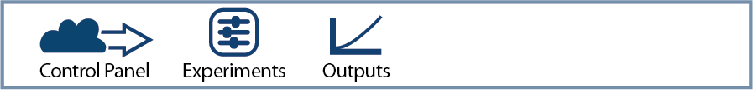

* 1. “HOME” Page
     1. All the functionality available in the browser will also be available for the “HOME” page, including the Tiles, “Start New Game”, as well as the look and feel.
     2. The functionality will also correspond to the Team Lead and Player roles as defined for the browser design.
  2. “PLAY” Page
     1. The overall arrangement of the “PLAY” Page is indicated in Figure 04.

Figure 04

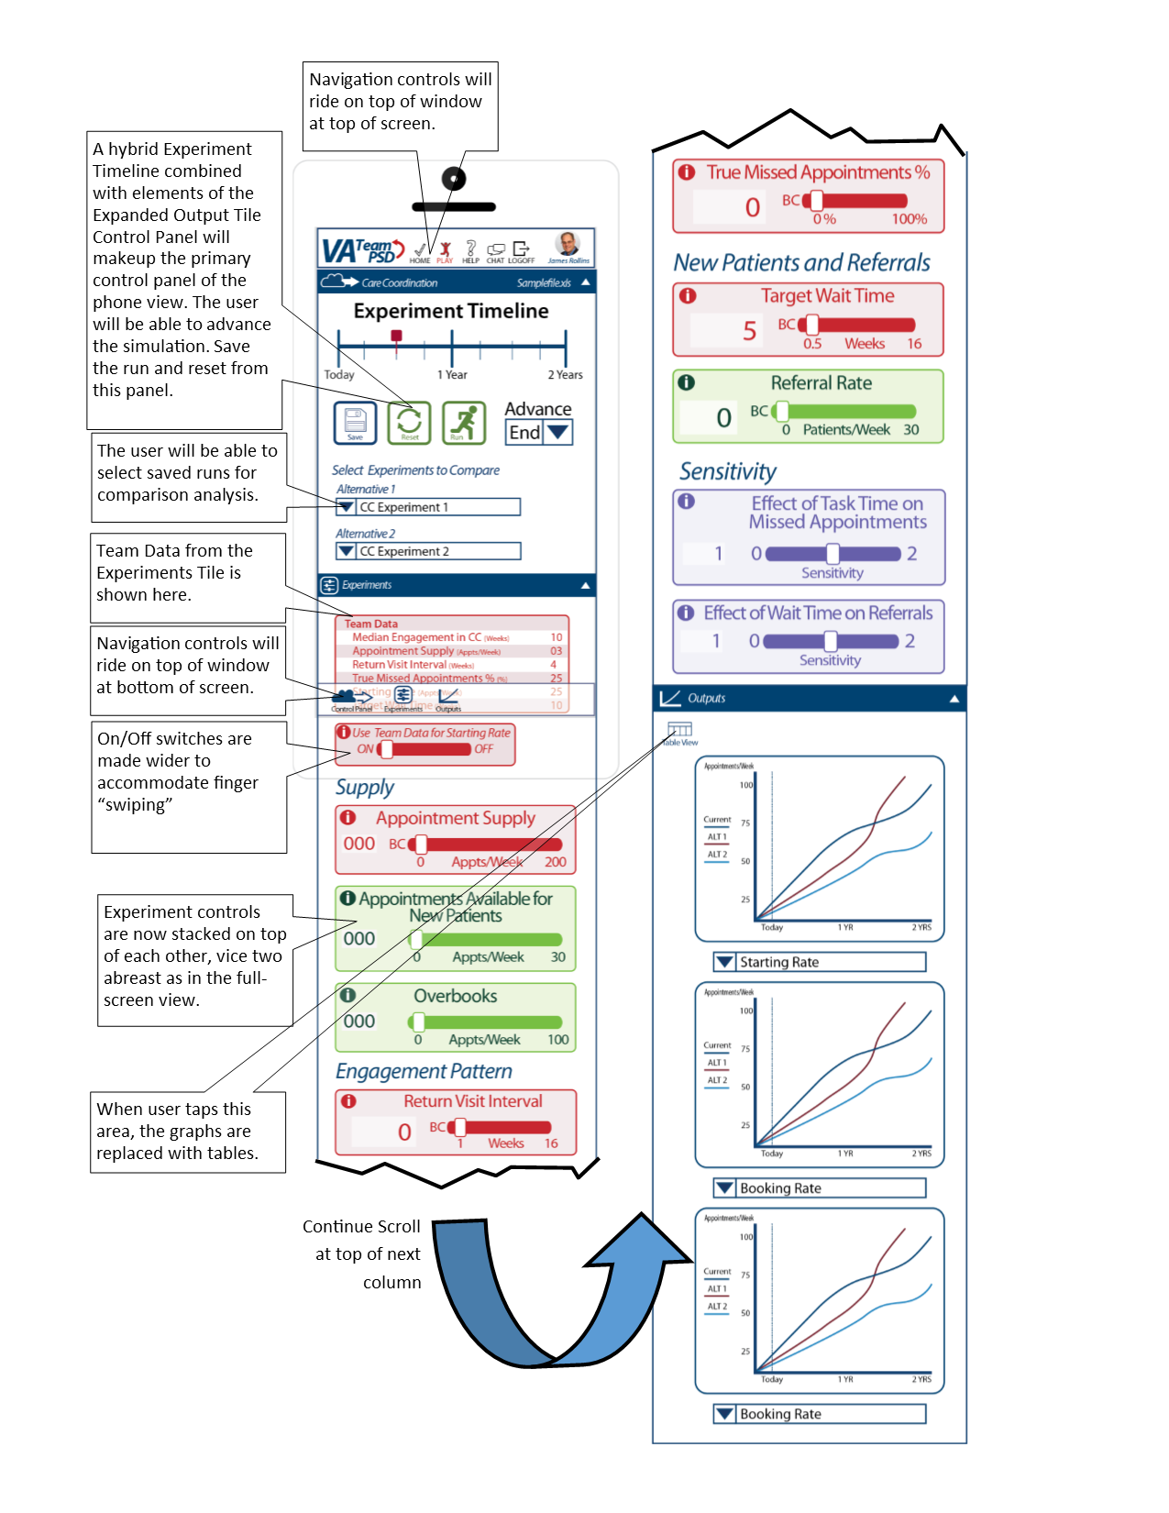

* + - 1. Specific Tiles for the different Vensim Models will be indicated below.
      2. The overall order of the Tiles for the phone/tablet is different from the browser version. For the phone/tablet, the Tile order is:
         1. Control Panel Tile (which has the name of the selected model in the title bar, such as “Care Coordination”.)
         2. Experiments Tile
         3. Outputs Tile
    1. Model Diagram will not be enabled. In other words, the tile that shows the Model Diagram will not be shown on the phone/tablet version. Instead of the the Model Diagram tile, we will have a Control Panel Tile.
    2. Rolled Up View.
       1. The Control Panel, Experiments and Output Tiles can be rolled up into just menu-bar headers.
       2. By tapping on the triangle control on the right side of the menu bar, the tile will expand. See Figure 05 as an example.

Figure 05

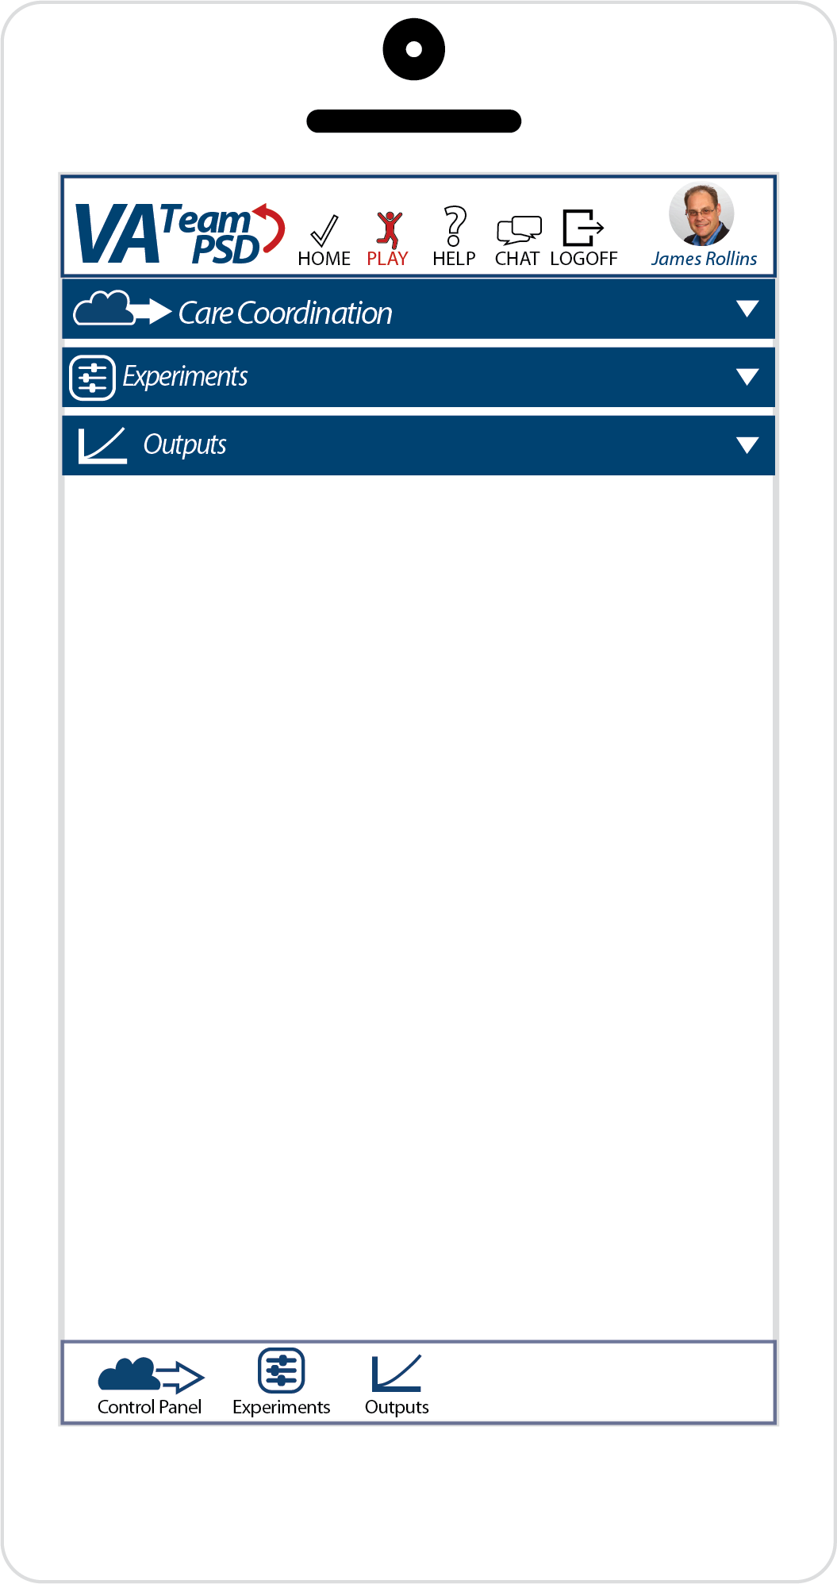

* + 1. Control Panel Tile
       1. The Control Panel will be a hybrid of the Experiment TImeline and the Expanded Outputs Tile, Control Panel. The use will be able to advance the simulation (by pressing the “Run” icon), save it (by pressing the “Save” icon), and reset (by pressing the “Reset” icon) from this panel. Additionally, the user will be able to select experiments and variables for comparisons as is supported by each model.
       2. CC

Figure 06 (Compare Experiments)

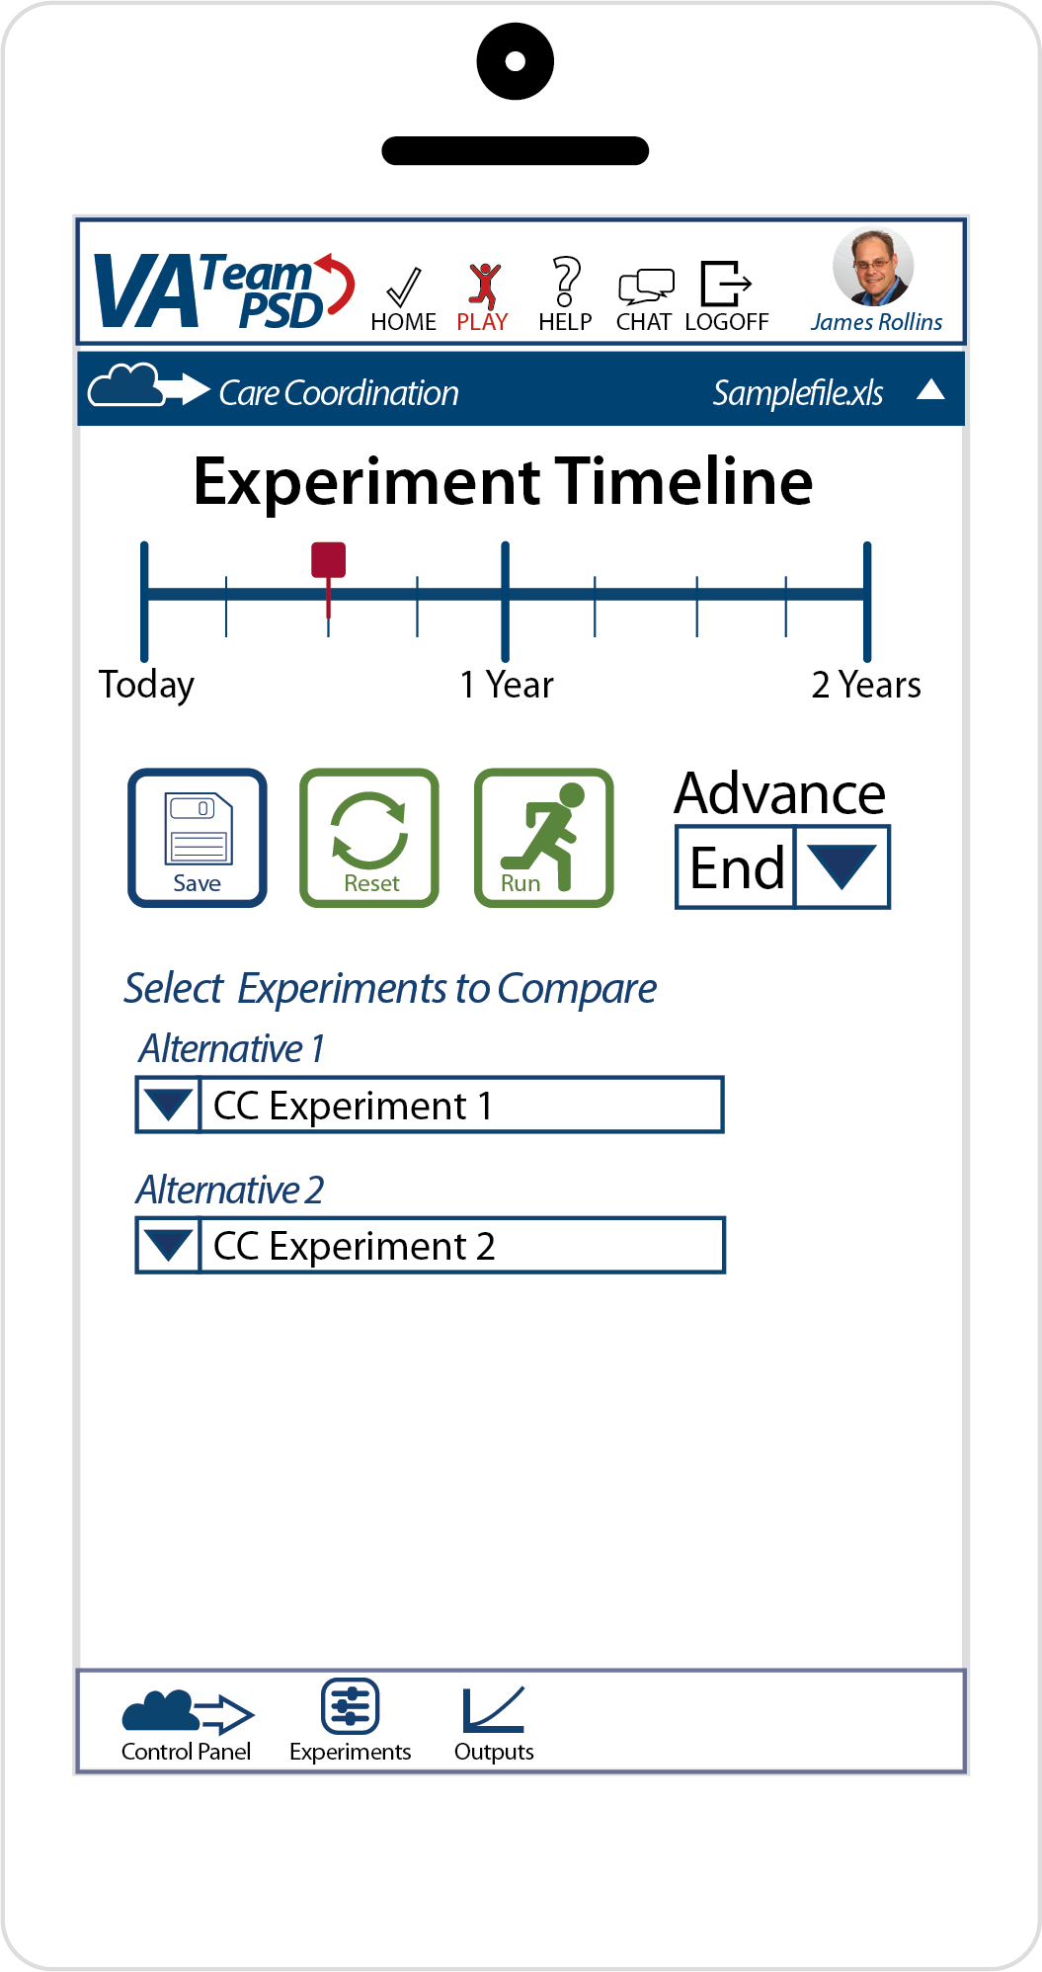

* + - 1. MM

Figure 07 (Compare Experiments)

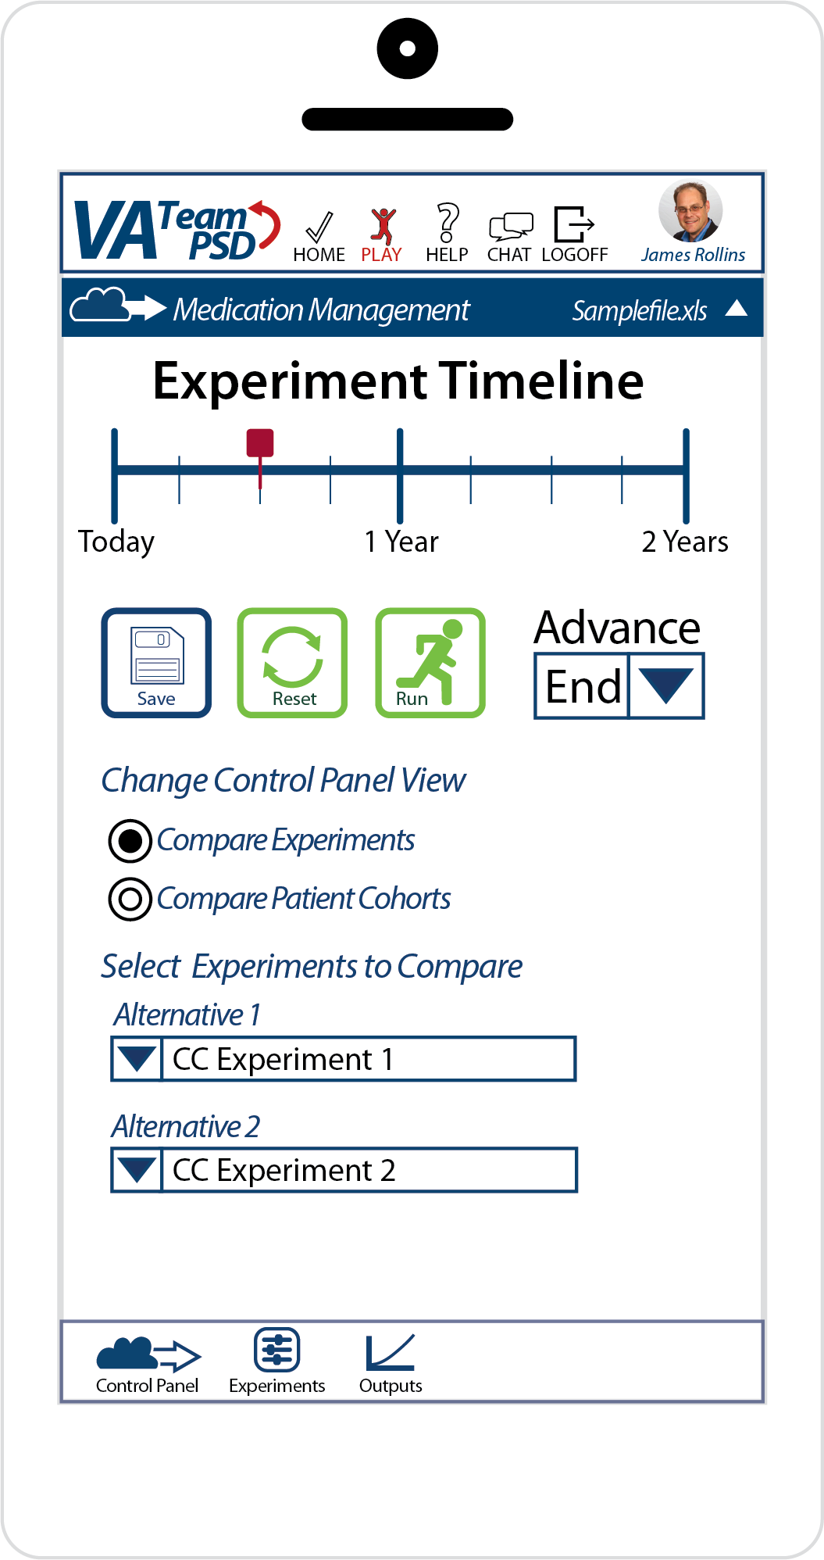

Figure 08 (Compare Patient Cohorts)

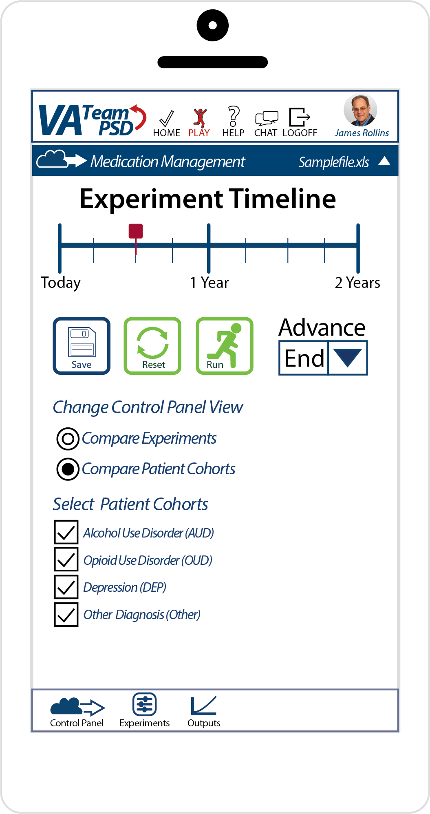

* + - 1. Psy

Figure 09

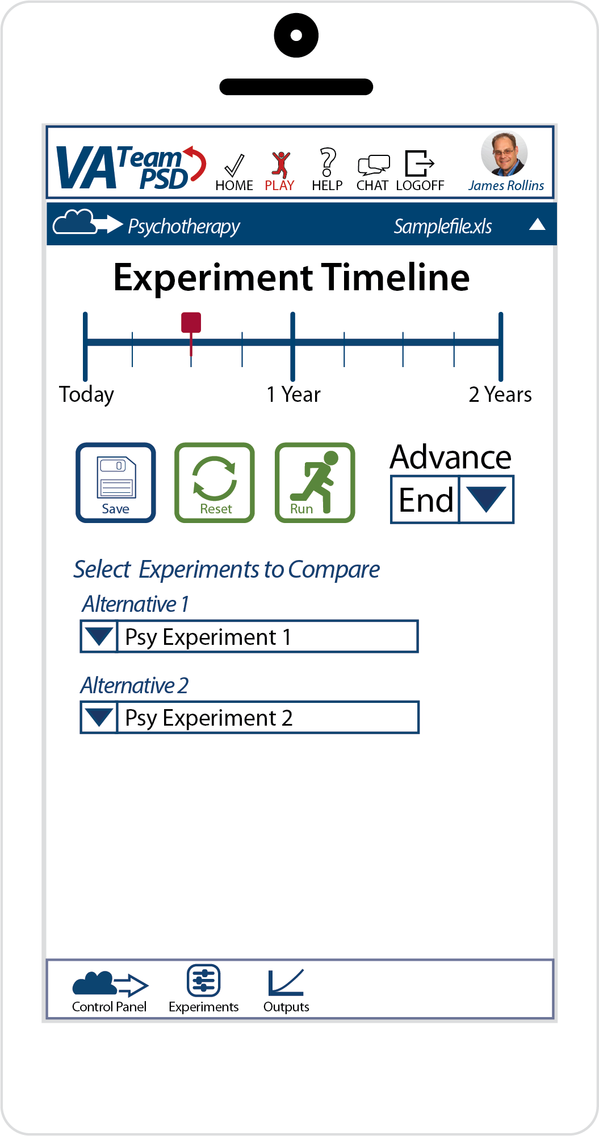

* + - 1. Agg

Figure 10 (Compare Experiments)

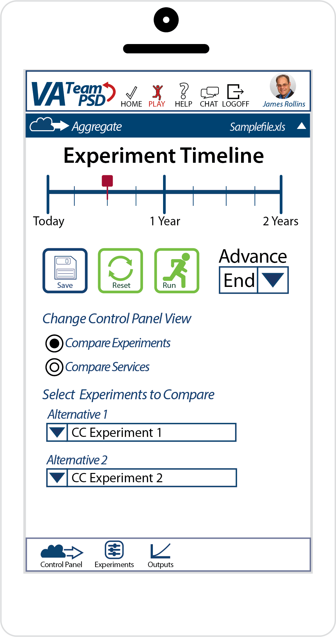

Figure 11 (Compare Services)

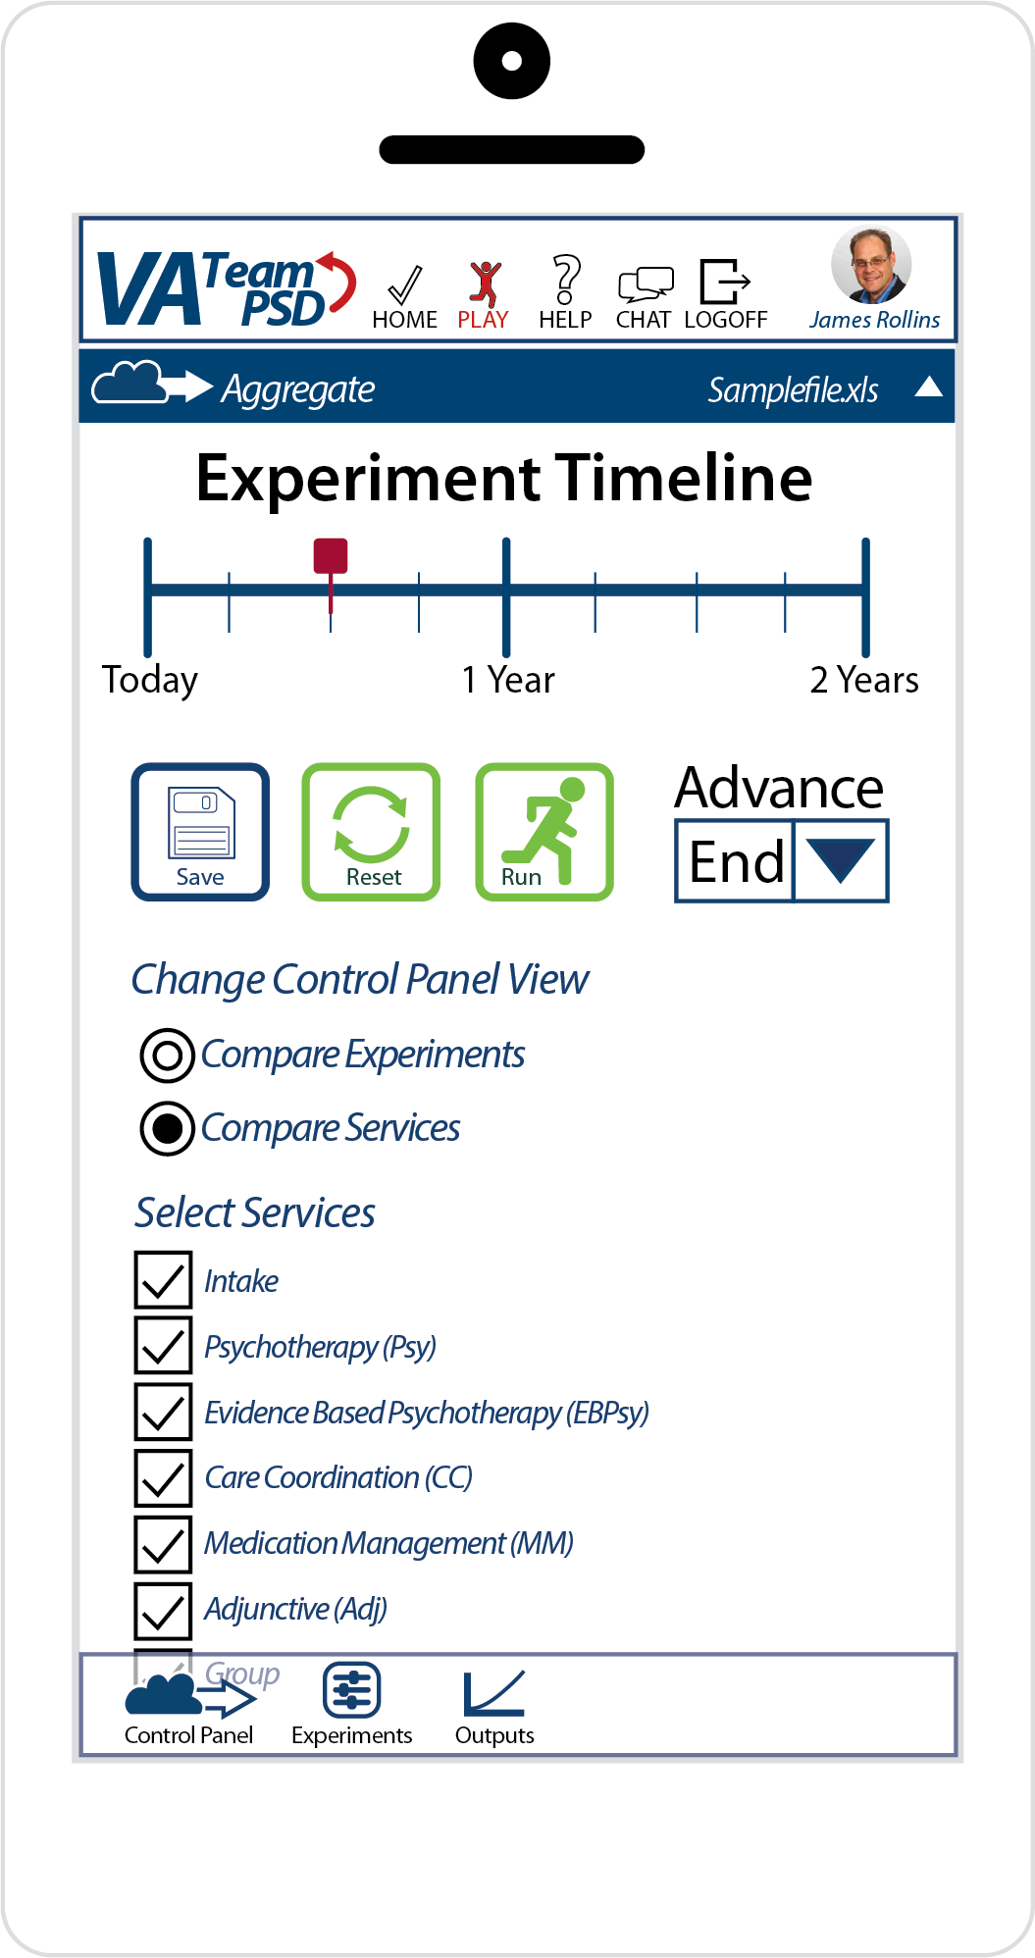

* + 1. Experiments Tile
       1. The functionality and related UI of the Experiments Tile for phone/tablet will be similar to the browser versions; the arrangement of the UI components will be different to accommodate the phone/tablet format. Please see Figure 12 for an example of a phone/tablet Experiment Tile. Please refer to the sections below that describe the Experiment Tiles for the various Vensim Models (browser versions).

Figure 12

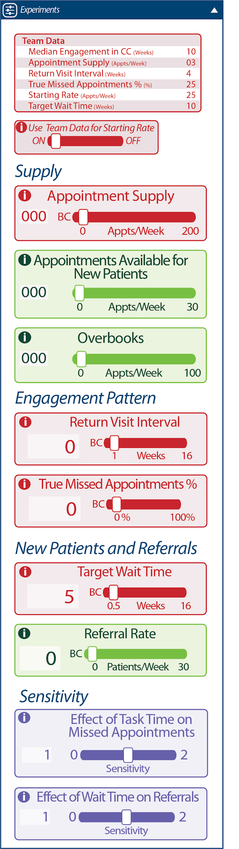

* + - 1. CC: 2.03 Player’s Dashboard / 5.9.10 Decisions Page (for CC)
      2. MM: 2.03 Player’s Dashboard / 5.9.10 Decisions Page (for MM)
      3. Psy: 2.03 Player’s Dashboard / 5.9.10 Decisions Page (for Psy)
      4. Agg: 2.03 Player’s Dashboard / 5.9.10 Decisions Page (for Agg)
      5. Information Pop-up Tile
         1. Please see “PLAY Page -- Experiments tile, Information Pop-up Tile” in the Updates to Iteration B section below.
      6. The Experiment Timeline, the “Save” icon, “Reset”icon , “Run” icon, and “Advance”drop-down functions the same as described for the browser. Please see “PLAY Page -- Experiments Timeline and Reveal Complexity Menu” in the Updates to Iteration B section below.
         1. Note: Reveal Complexity does not apply to phone/tablet.
    1. Outputs Tile
       1. See Figures 13 and 14 for an illustration of how the Outputs Tile will be rendered for the phone/tablet.

Figure 13 (Graph View)  
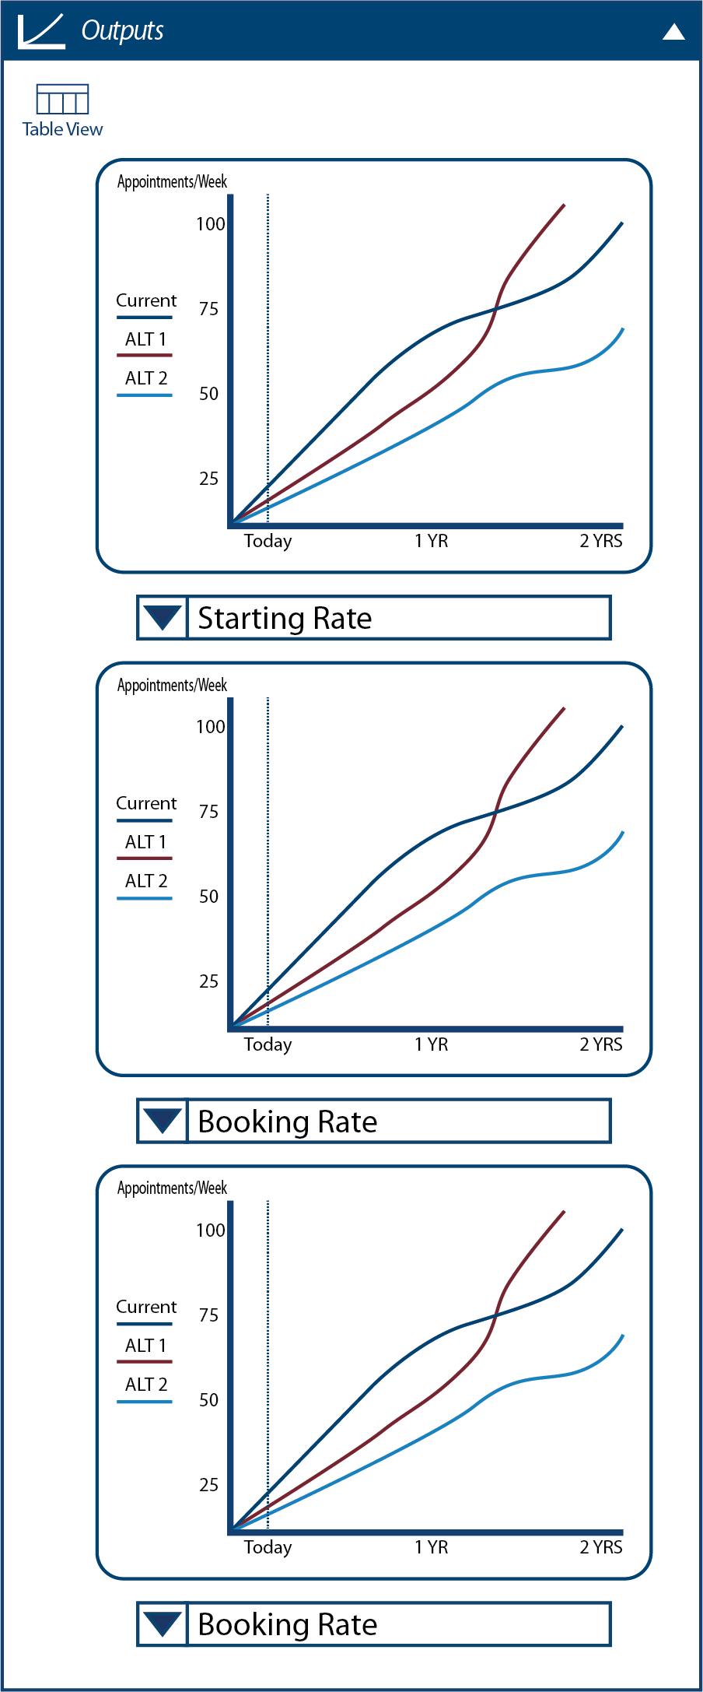

Figure 14 (Table View)  
  
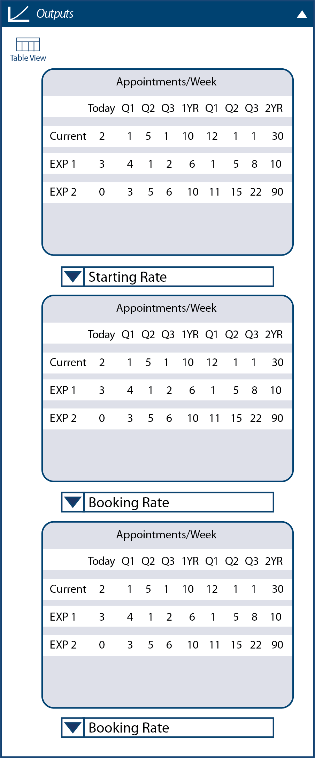

* + - * 1. Clicking on the Table View icon will toggle the view from Graph View to Table View. The Graph View is the default view.
      1. Note: for the Psy model, the phone/tablet will NOT have the Sankey feature.
      2. Note: the phone/tablet will not support Expand, Copy, Export.
  1. “CHAT” Page
     1. All the functionality available in the browser will also be available for the “CHAT” page, including the Team Chat.
     2. The Team Lead will have the “Facilitators” tile as defined in the browser design.
  2. “HELP” Page
     1. All the functionality available in the browser will also be available for the “HELP” page.
     2. [caveat about videos may not play correctly]
     3. Videos that may work on the browser version may not work at all or properly on the phone/tablet.
     4. For more information, pls see Help Page Content.

1. Facilitator
   1. “DASHBOARDS” Page
      1. All the functionality available in the browser will also be available for the “DASHBOARDS” page.
      2. For the phone/tablet-specific illustration, please see Figures 15 and 16.

Figure 15 (Facilitator Dashboard - Rolled Up)

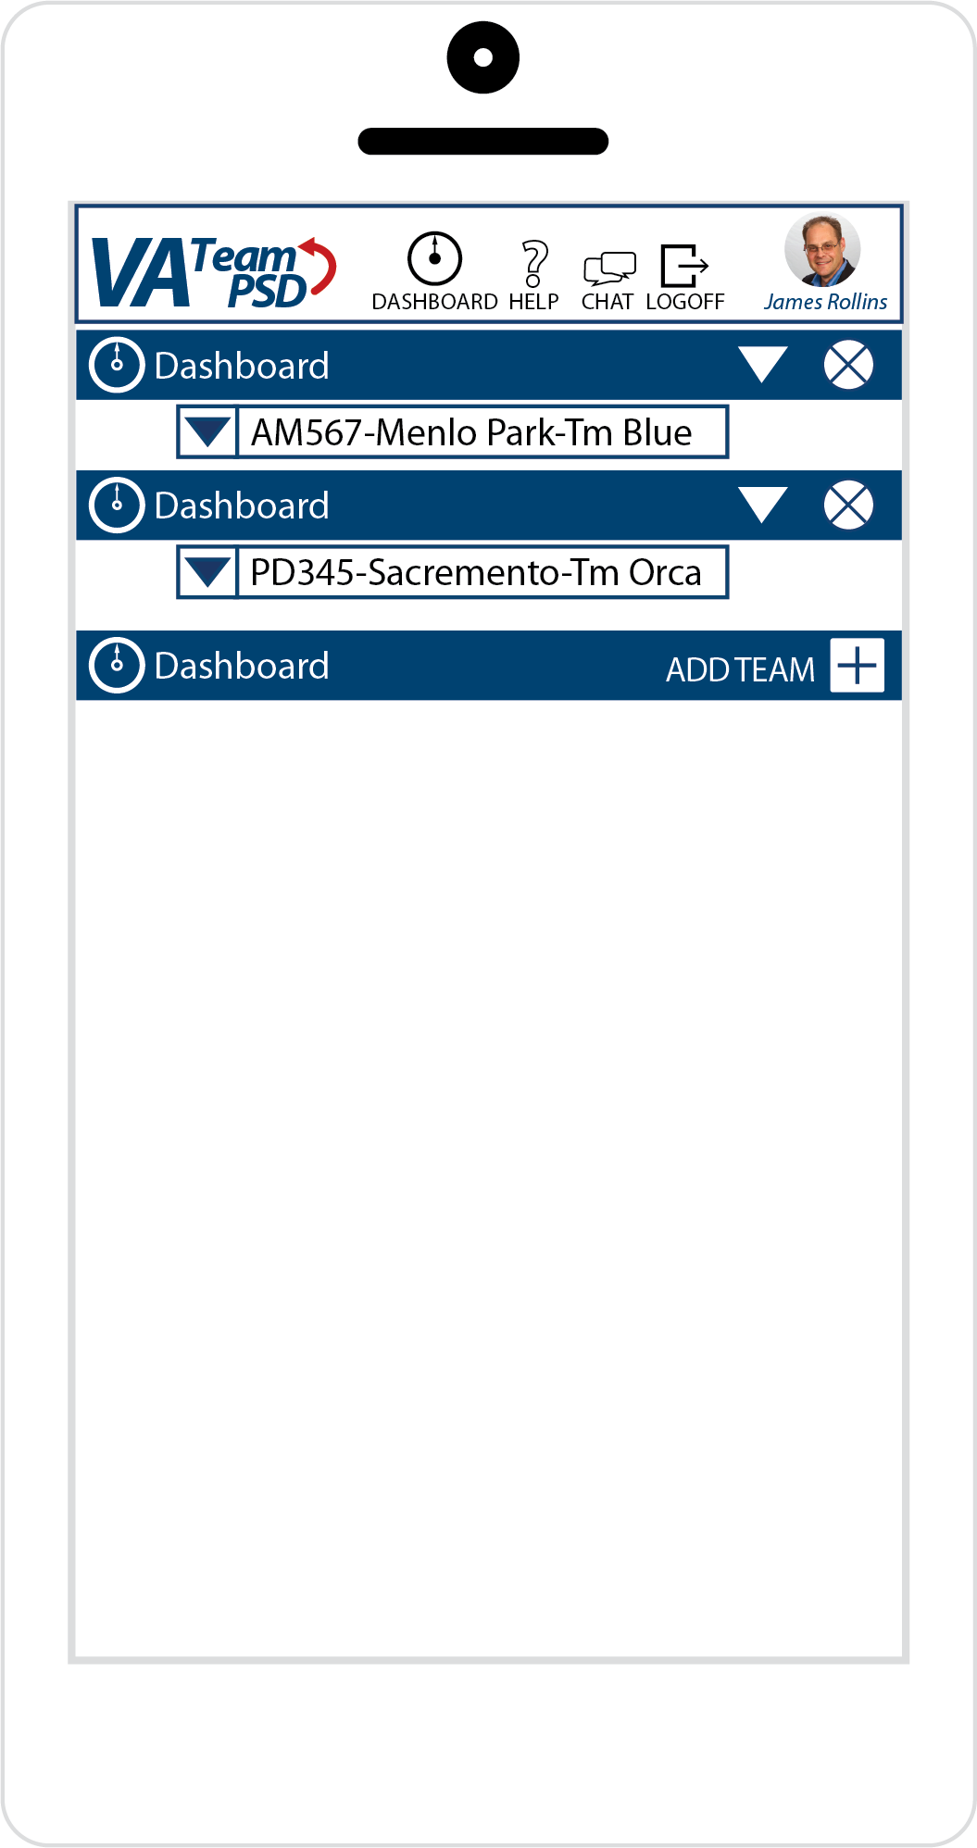

Figure 16 (Facilitator Dashboard)

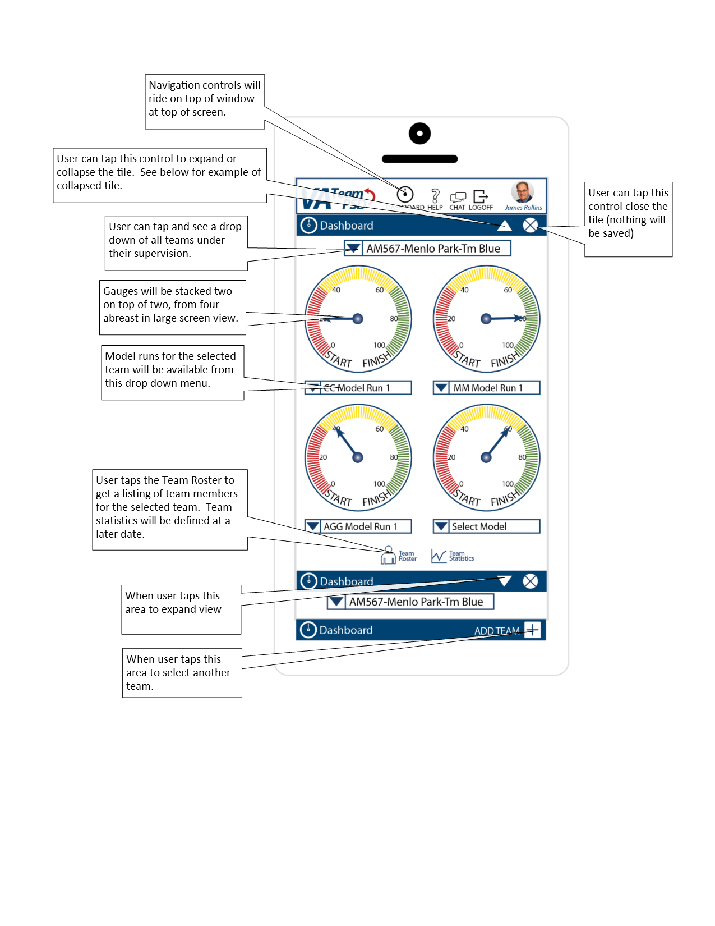

* 1. “CHAT” Page
     1. The Team Lead tile and functionality will also be available for the “CHAT” page.
  2. “HELP” Page
     1. All the functionality available in the browser will also be available for the “HELP” page.
     2. For more information, pls see Help Page Content.

# SOW Requirements

This section describes the requirements as outlined in the SOW.

We list the requirements organized by our workplan, then cross-listed to VA’s SOW (Statement of Work). More detail of the mapping of tasks can be found on "VA_PSD_Iterations_Features_HCP7.xlsx”.

As in previous Iteration Design Documents, the headings are in the format “Workplan Task / VA SOW”.

## 2.02 Admin’s Dashboard / Administration Features / 5.2.1. Basic Administrative Functionality for administration from the National Center for PTSD

1. Many of the Administrative Functionality of provided by the Forio platform. For example: the ability to create teams and assign members, impersonate team players, etc.
2. For a description of how we will do user management and setting team names, pls see 2.05 User Management / 5.9.3 Set team name.

## 2.02 Admin’s Dashboard / Administration Features / 5.6.2. Overview page with list of users and their current progress

1. Please see “# 5 Team Roster” under 2.07 Game Progress / 5.9.8 Scoring / Compare to Other Teams (only for Admins) below.

## 2.03 Player’s Dashboard / 5.9.10 Decisions Page (for CC)

1. Global information -- Please see General Information that applies to all pages, especially the “PLAY” Page in the Updates to Iteration B section below.
2. Below are diagrams that contain labels that have descriptions of design features, colors and other instructions for the model and each build layer.  
   1. User Interface - Default (Build) -- Figure 17

Figure 17  
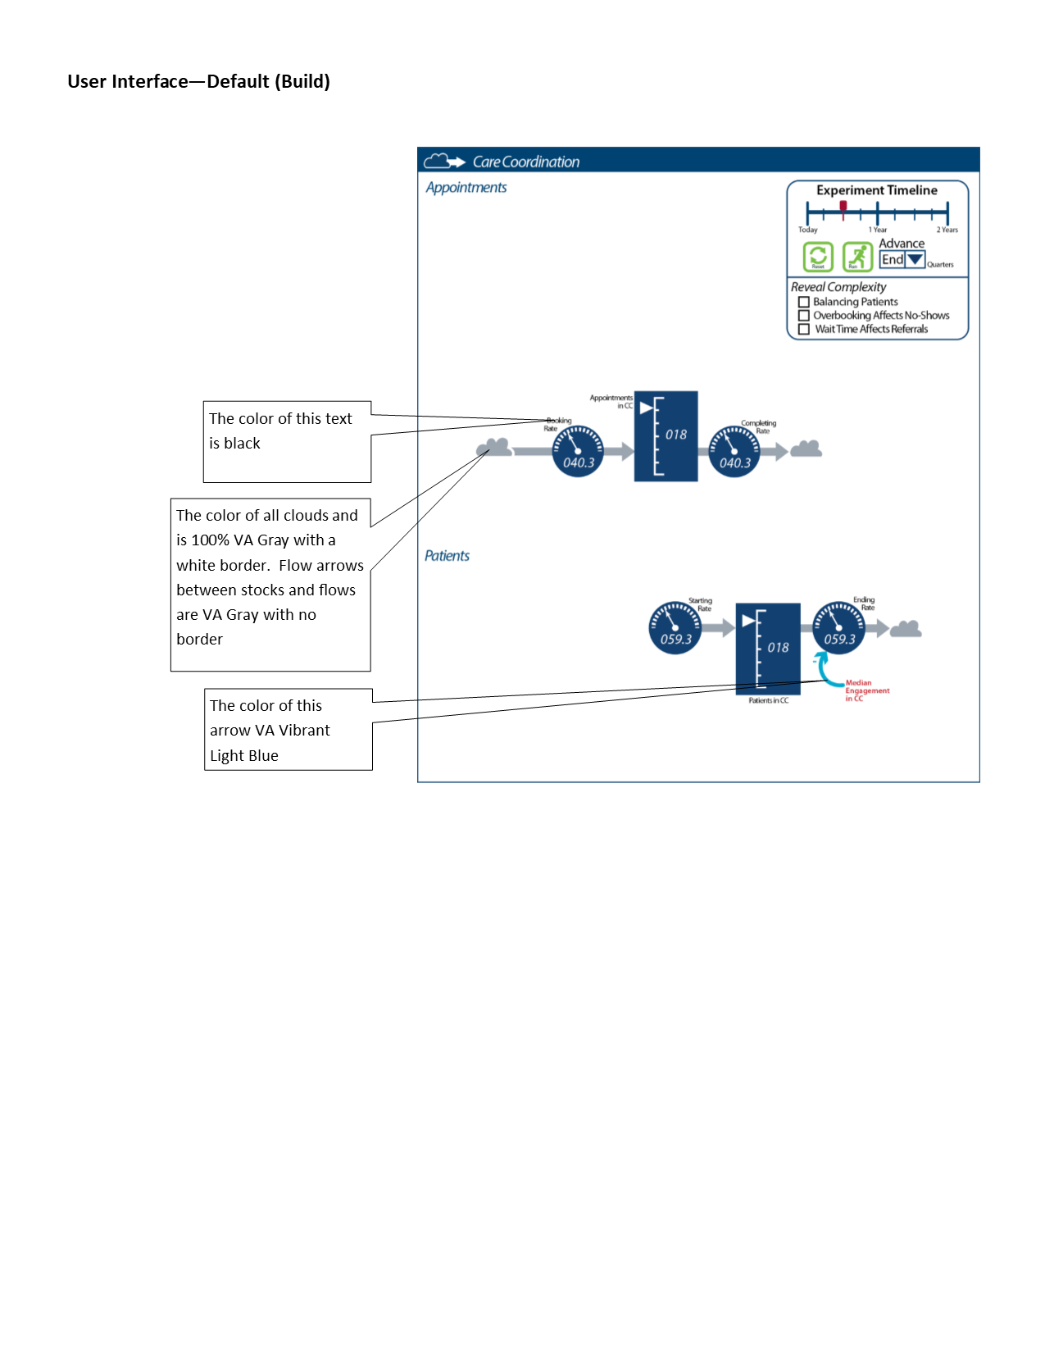

* + 1. Upon entering the “PLAY” page, the default view for the model diagram is the “unchecked” view indicated in Figure 17.
  1. User Interface - Balancing Patients (Build) -- Figure 18

Figure 18

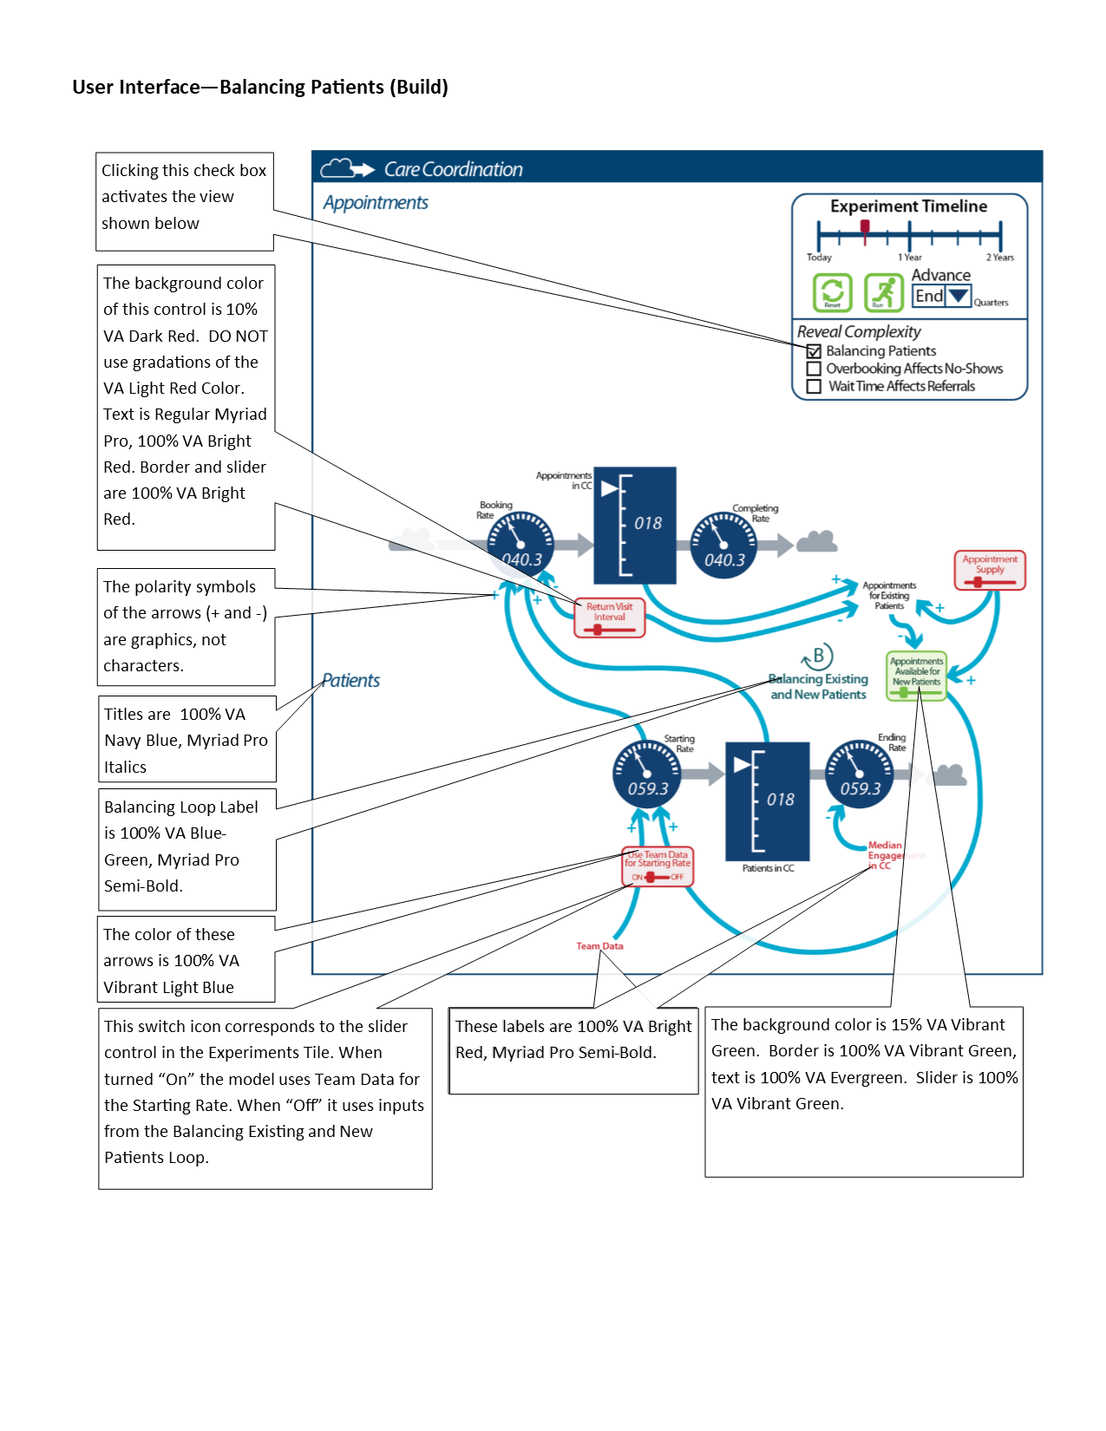

* 1. User Interface - Overbooking Affects No-Shows (Build) -- Figure 19

Figure 19  
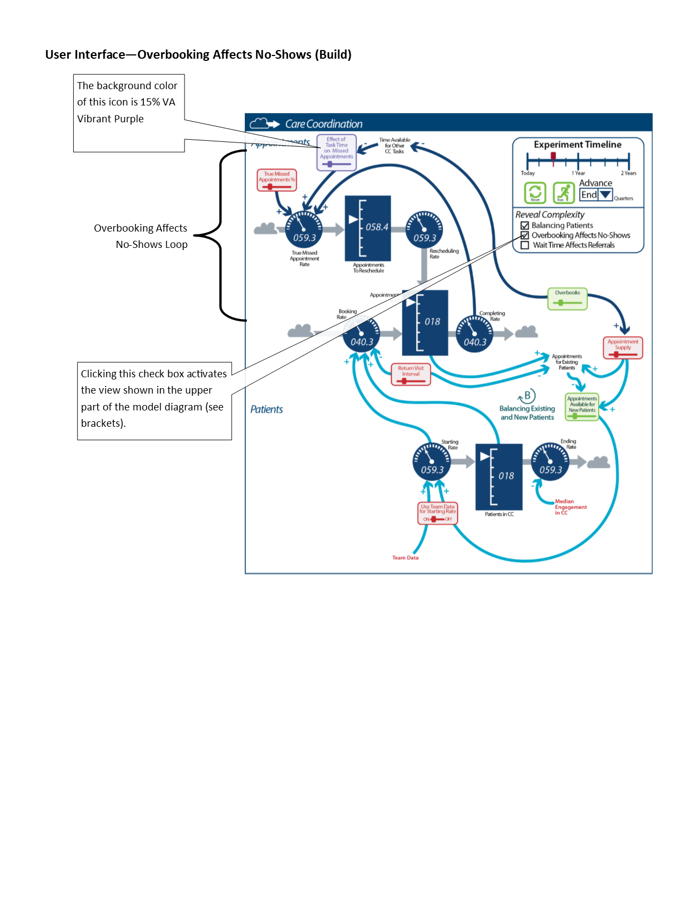

* 1. User Interface - Wait Time Affects Referrals (Build) -- Figure 20

Figure 20

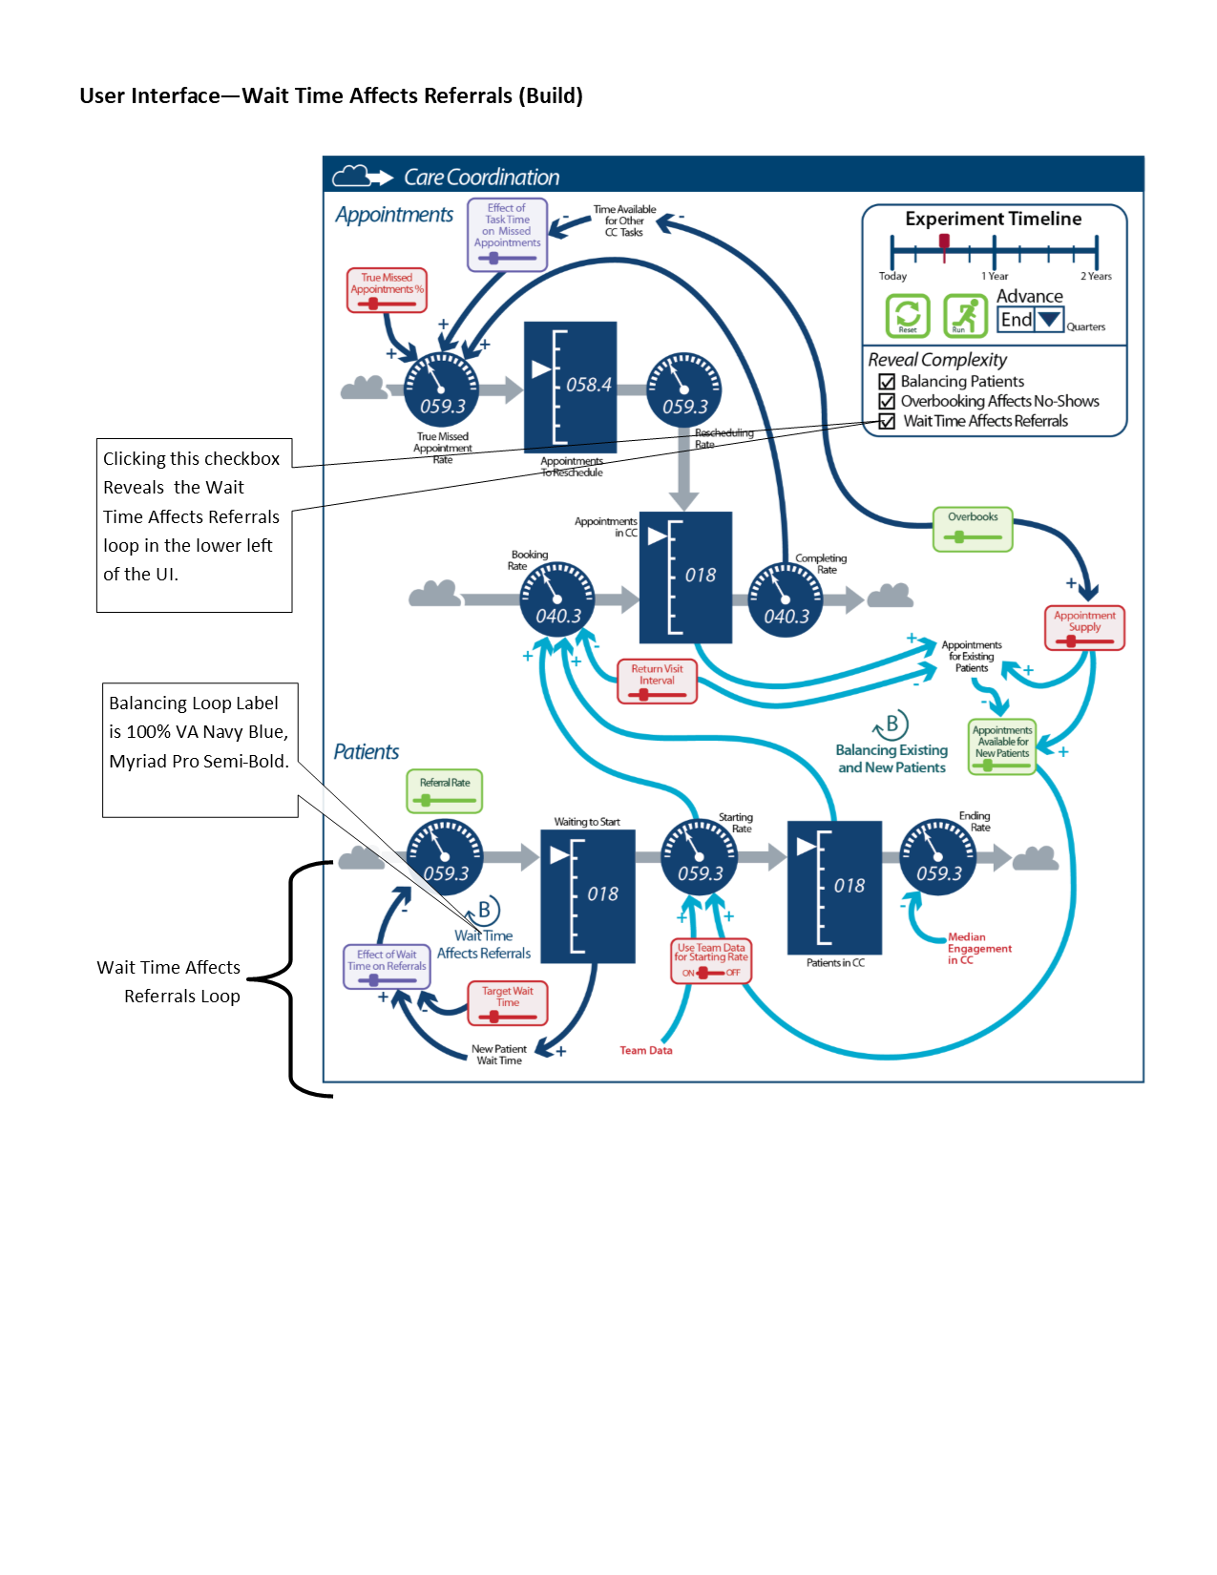

* 1. Experiments Tile -- Figure 21  
     *Please note that the “Decisions” tile has been renamed to “Experiments.”*

Figure 21

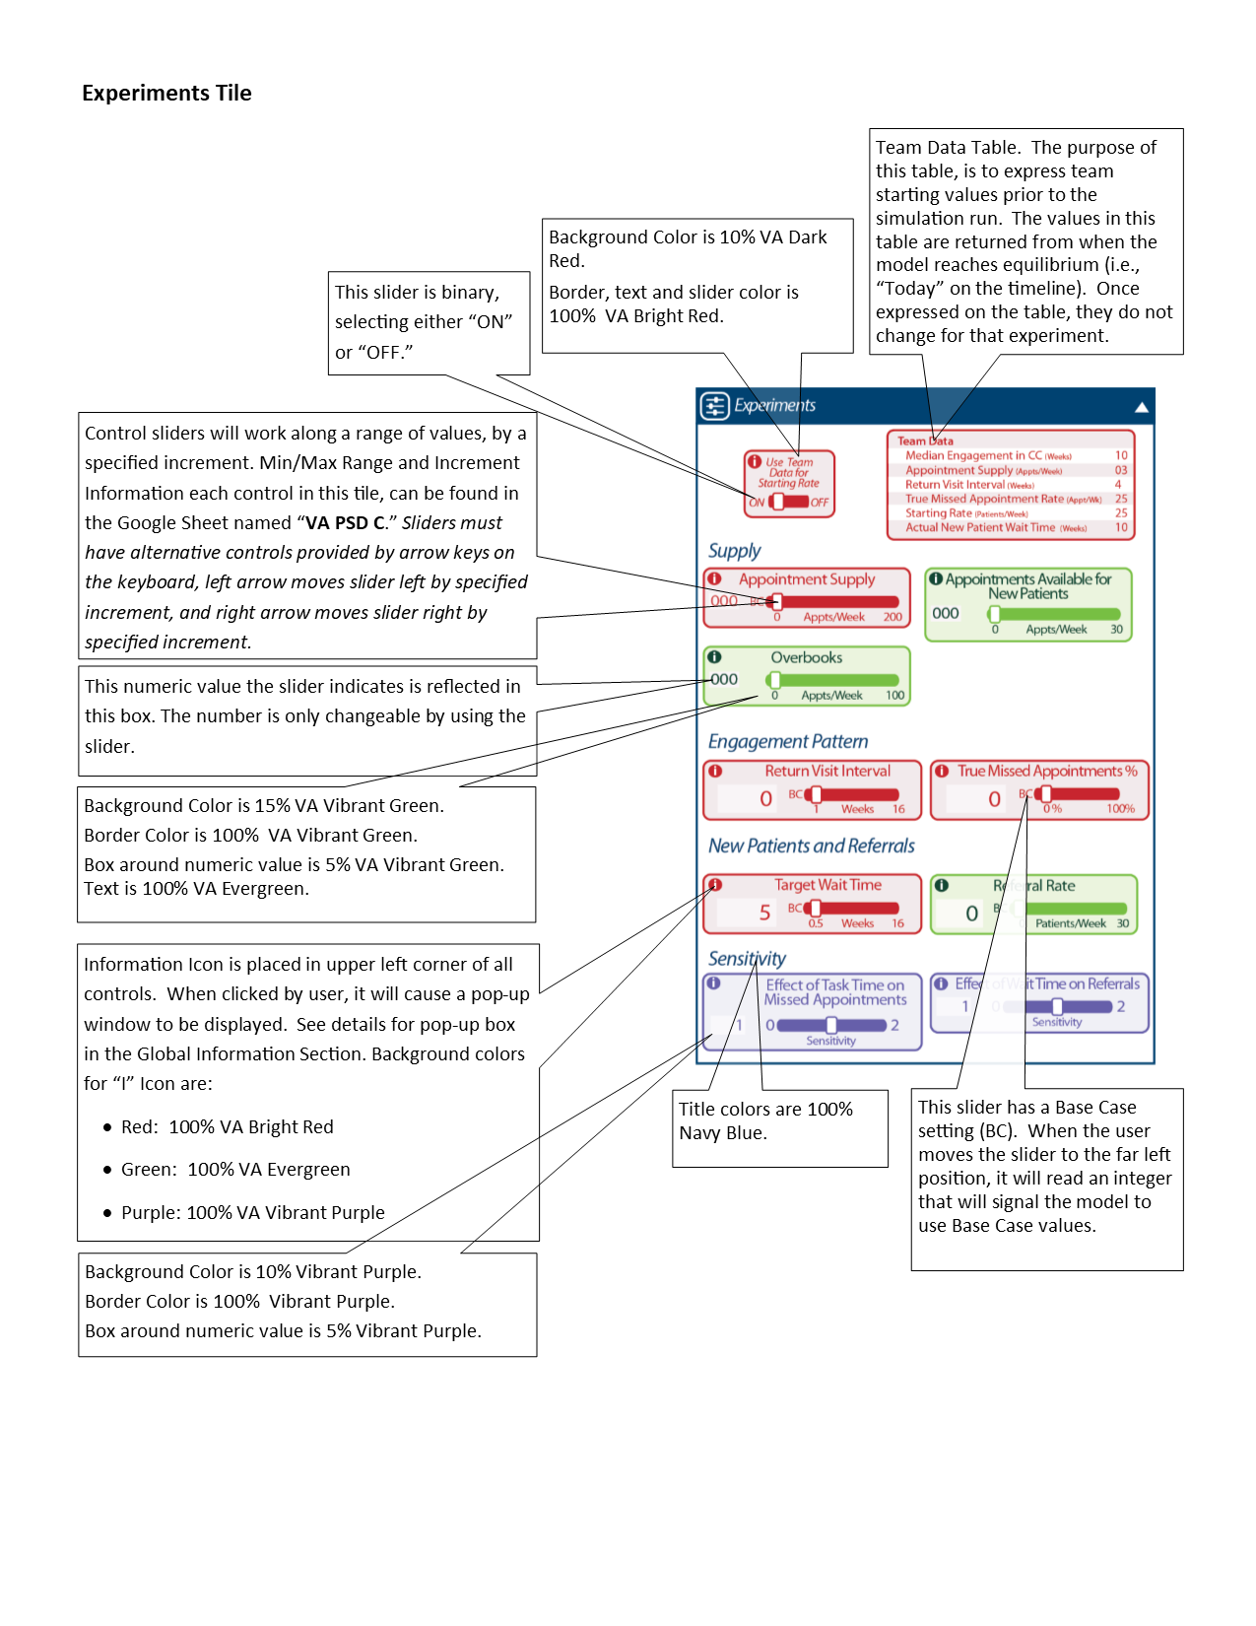

* + 1. Figure 21 is meant to indicate the graphical elements of the Experiments tile (colors, placement/arrangement of variable controls, callout text with descriptions of functionality). Please refer to the [variables table](https://docs.google.com/spreadsheets/d/1KoyHmZiai6FRC6tmquLPA3541N2N5Lgi_FEdN1HvmFQ/edit#gid=133039034) for min/max, units, gradations.
    2. Starting values for the variables should come from the Vensim model at “Today”. For more information, see “Model Time” under the Vensim Model(s) section.
  1. Information Pop-up Tile
     1. Please see “PLAY Page -- Experiments tile, Information Pop-up Tile” in the Updates to Iteration B section below.
  2. Outputs Tile
     1. Please see Updates to Iteration B, PLAY Page -- Outputs Tile > Graph, Alternatives Table, and Patient Cohorts Views for descriptions of Outputs Tile.
  3. Expanded Outputs Tile - Graph View -- Figure 22

Figure 22  
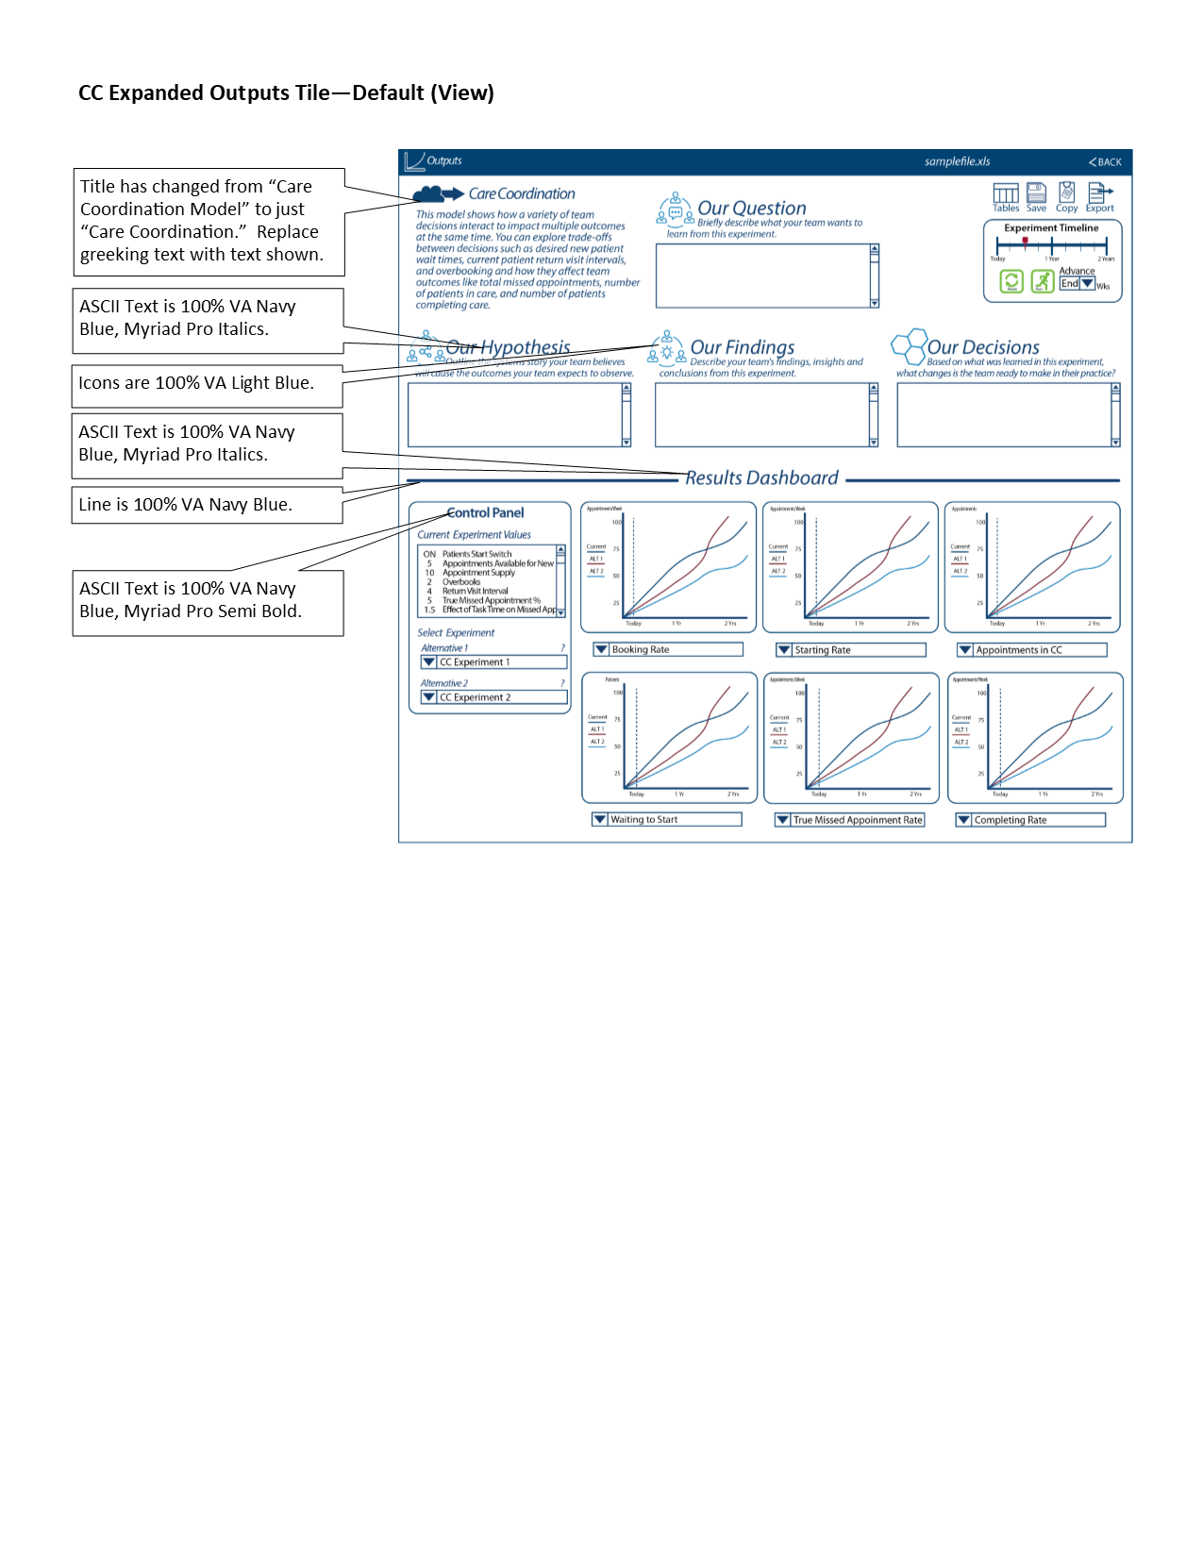

* + 1. The Graph View version of the Expanded Output Tile (Figure 21) is the default view (and is the version shown when the Expanded Output tile is opened).
    2. The graphs’ x-axis follows the descriptions given above in “Outputs Tile - Graph View”.
  1. Expanded Output Tile - Table View -- Figure 23

Figure 23

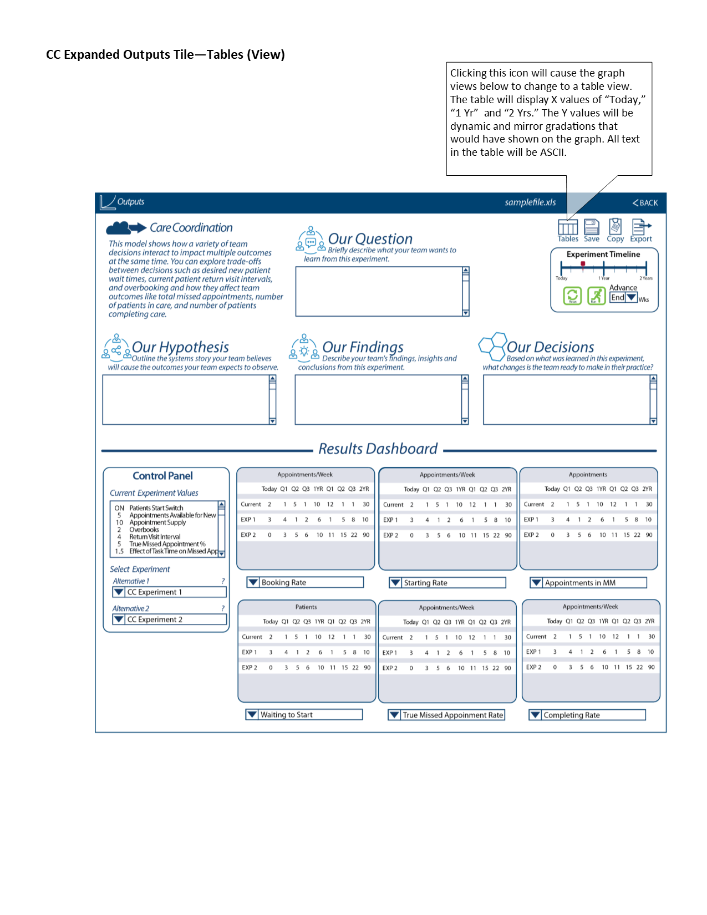

* + 1. The graphs’ x-axis follows the descriptions given above in “Outputs Tile - Table View”.
    2. On either the Table View (Figure 23) or Graph View (Figure 22), clicking on the “?” next to the “Alternative 1” or “Alternative 2” in the Control Panel will bring up the “Information Pop-up Tile”, which is described in the Updates to Iteration B section below.

## 2.03 Player’s Dashboard / 5.9.10 Decisions Page (for MM)

1. Global information -- Please see General Information that applies to all pages, especially the “PLAY” Page in the Updates to Iteration B section below.
2. Below are diagrams that contain labels that have descriptions of design features, colors and other instructions for the model and each build layer.  
   1. User Interface - Default View -- Figure 24

Figure 24

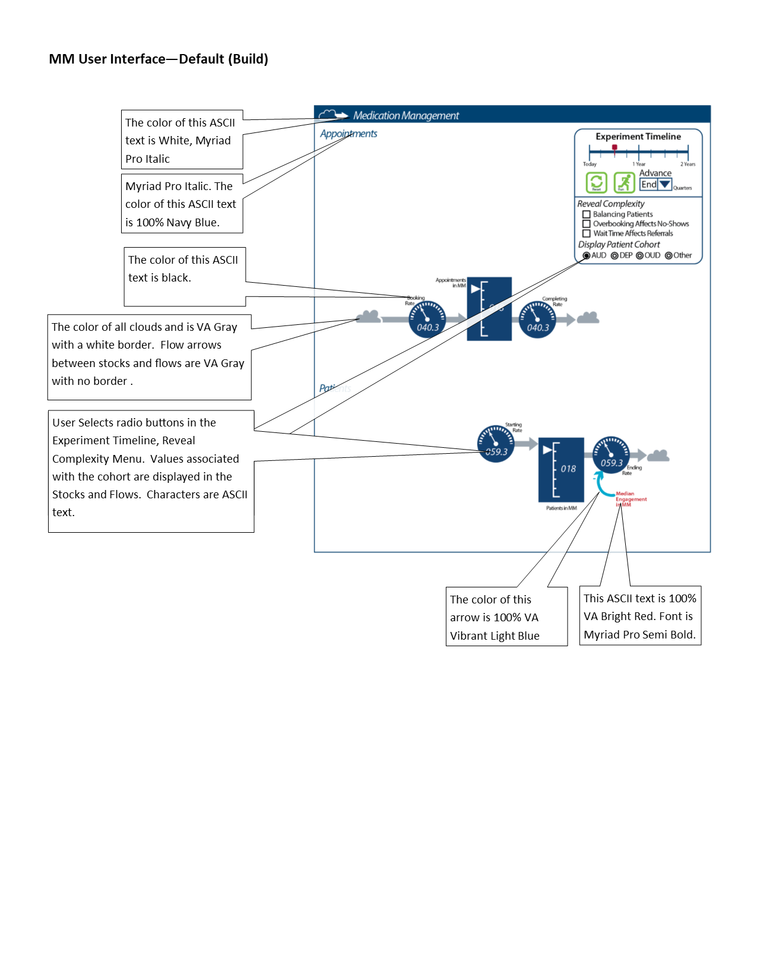

* 1. User Interface - Balancing Patients (Build) -- Figure 25

Figure 25

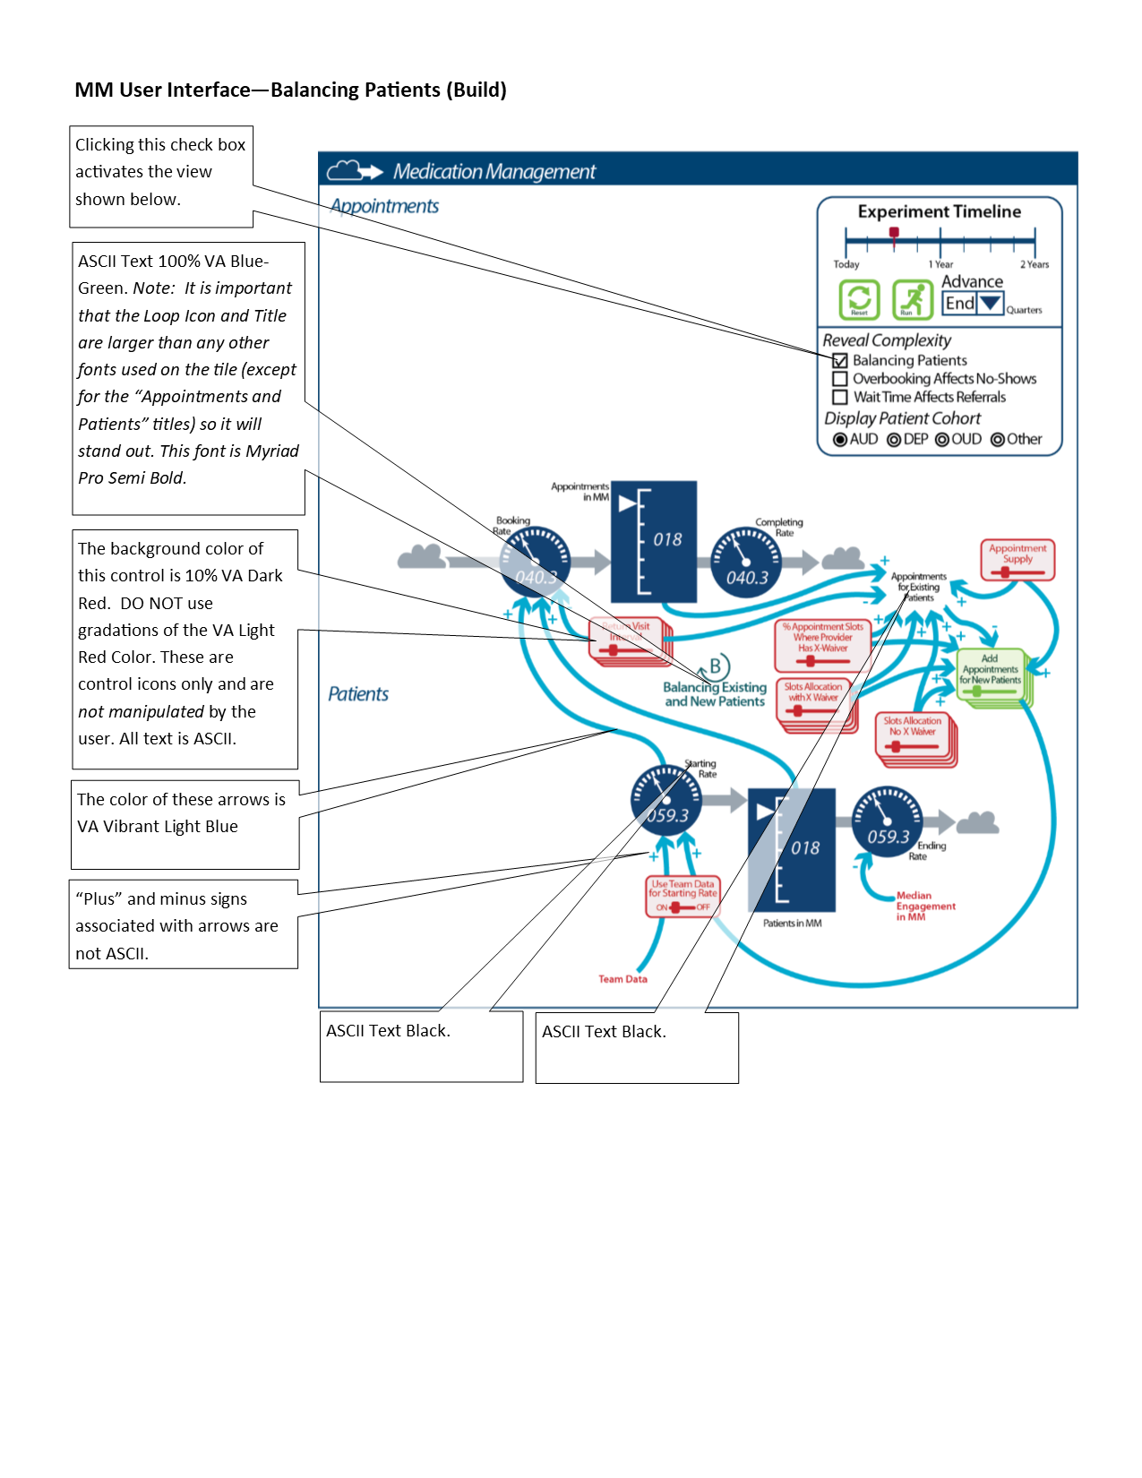

* 1. User Interface - Overbooking Affects No-Shows (Build) -- Figure 26

Figure 26

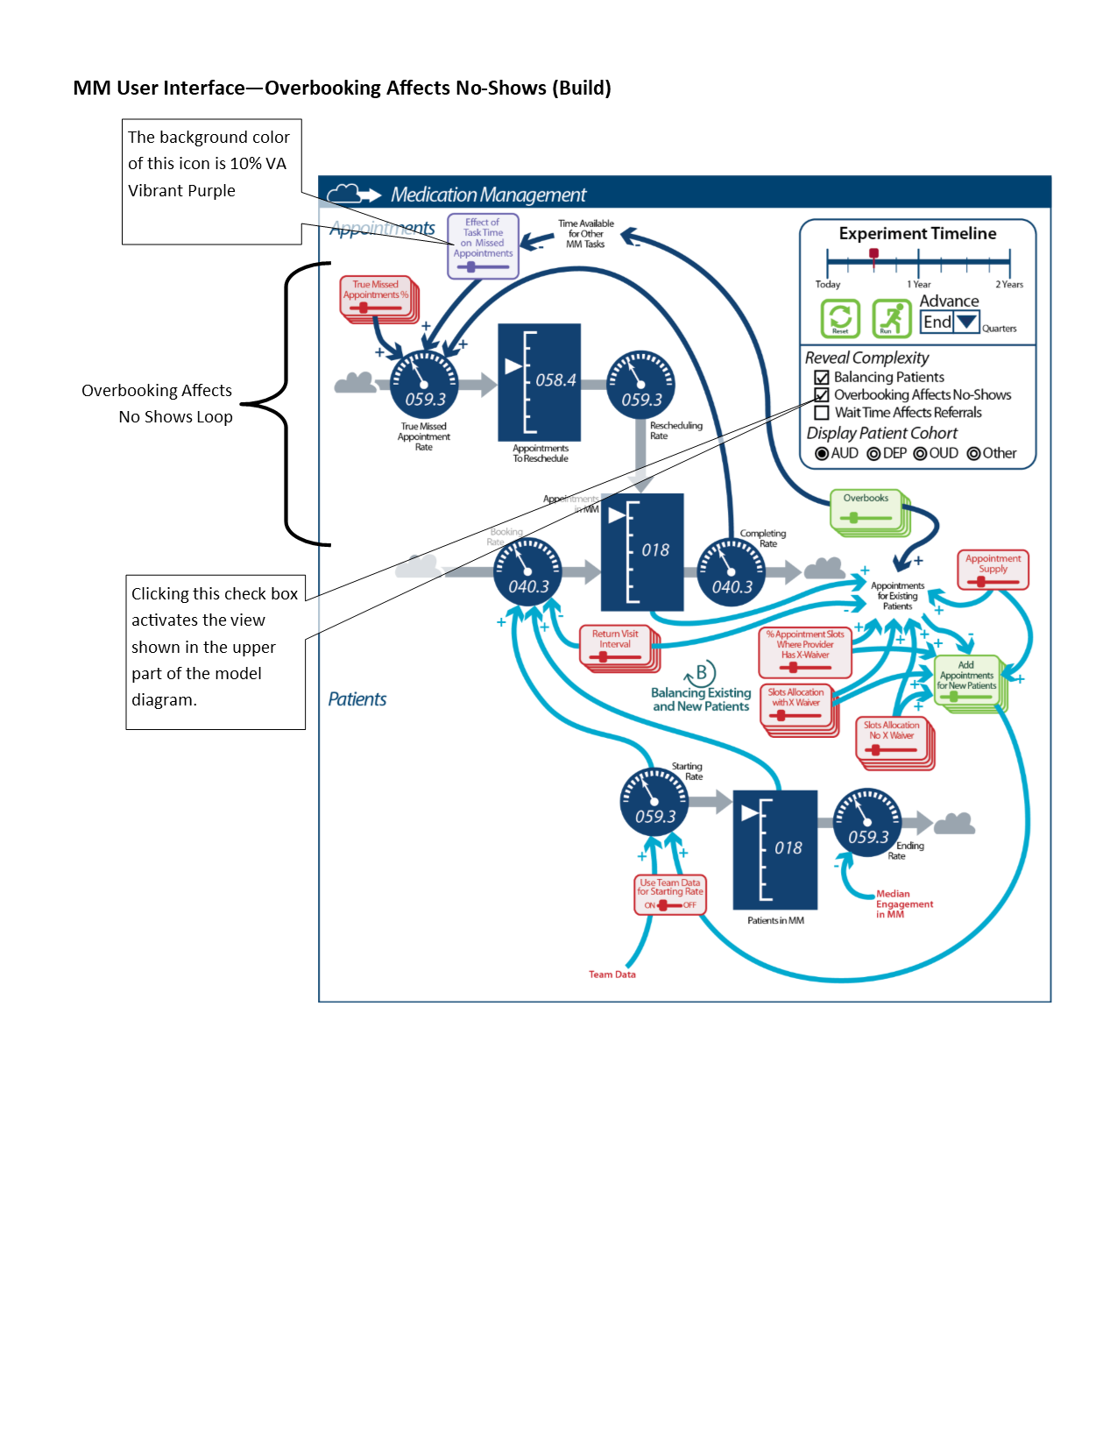

* 1. User Interface - Wait Time Affects Referrals (Build) -- Figure 27

Figure 27

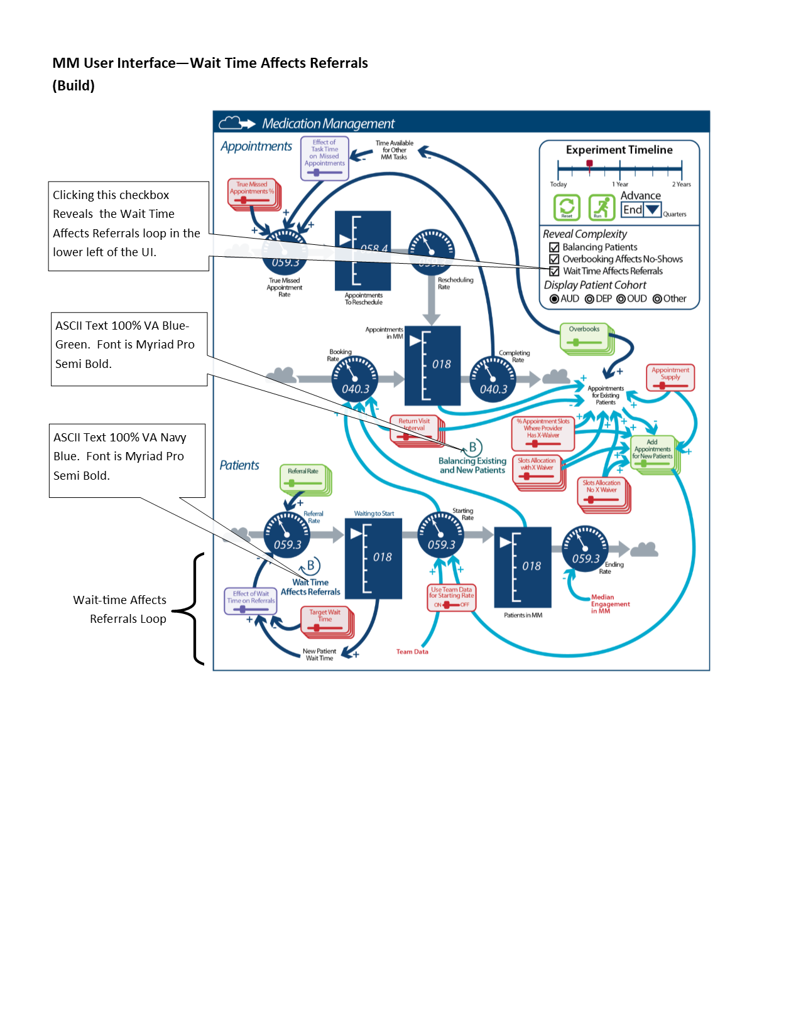

* 1. Experiments Tile -- Figure 28

Figure 28

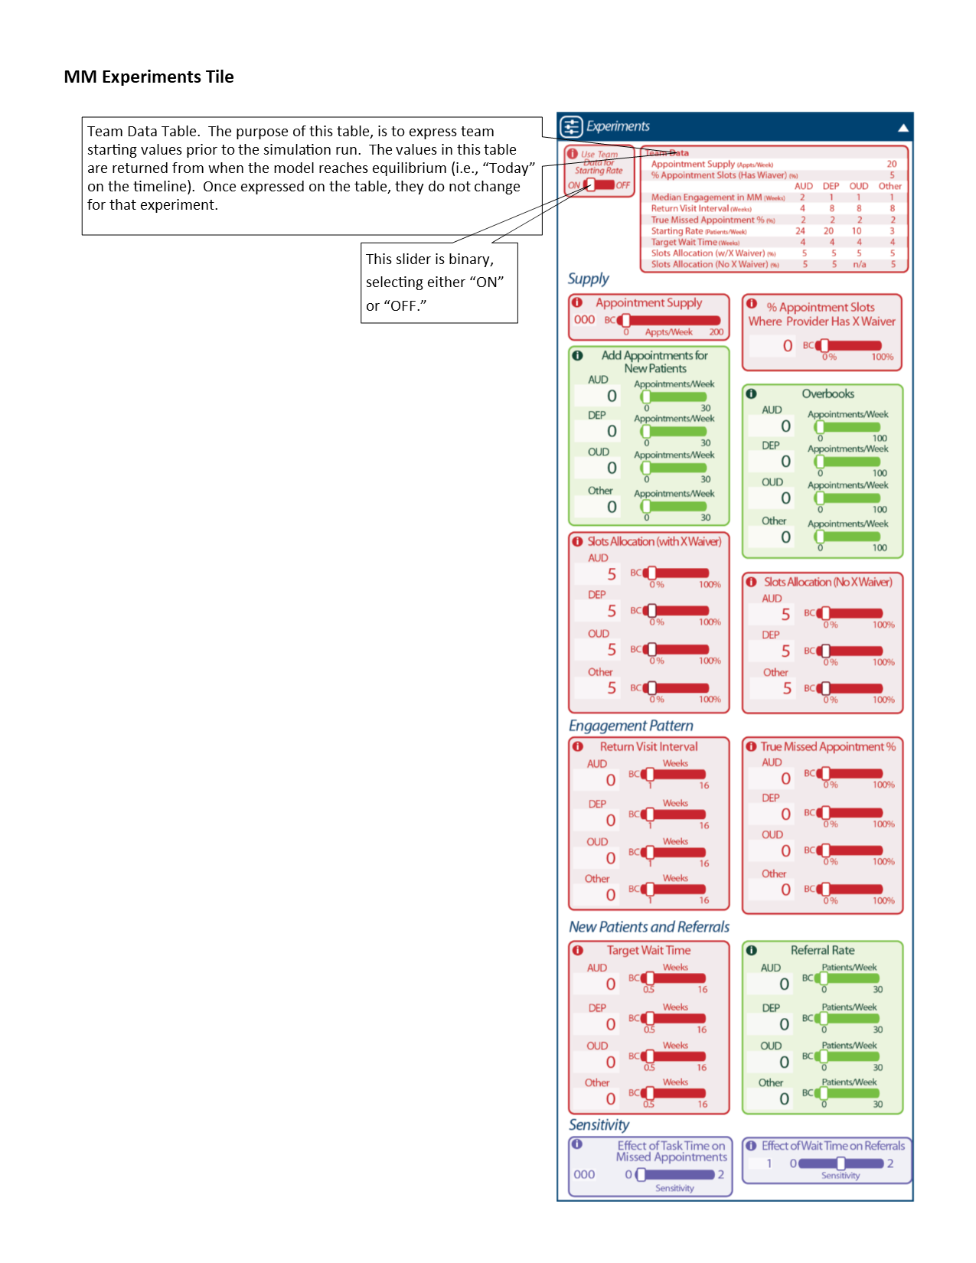

* 1. Information Pop-up Tile
     1. Please see “PLAY Page -- Experiments tile, Information Pop-up Tile” in the Updates to Iteration B section below.
  2. Outputs Tile
     1. Please see Updates to Iteration B, PLAY Page -- Outputs Tile > Graph, Alternatives Table, and Patient Cohorts Views for descriptions of Outputs Tile.
     2. The MM model will have Patient Cohorts and Compare Experiments views (as selected from the Expanded Outputs Tile).
  3. Expanded Outputs Tile - Compare Experiments Graph View -- Figure 29

Figure 29  
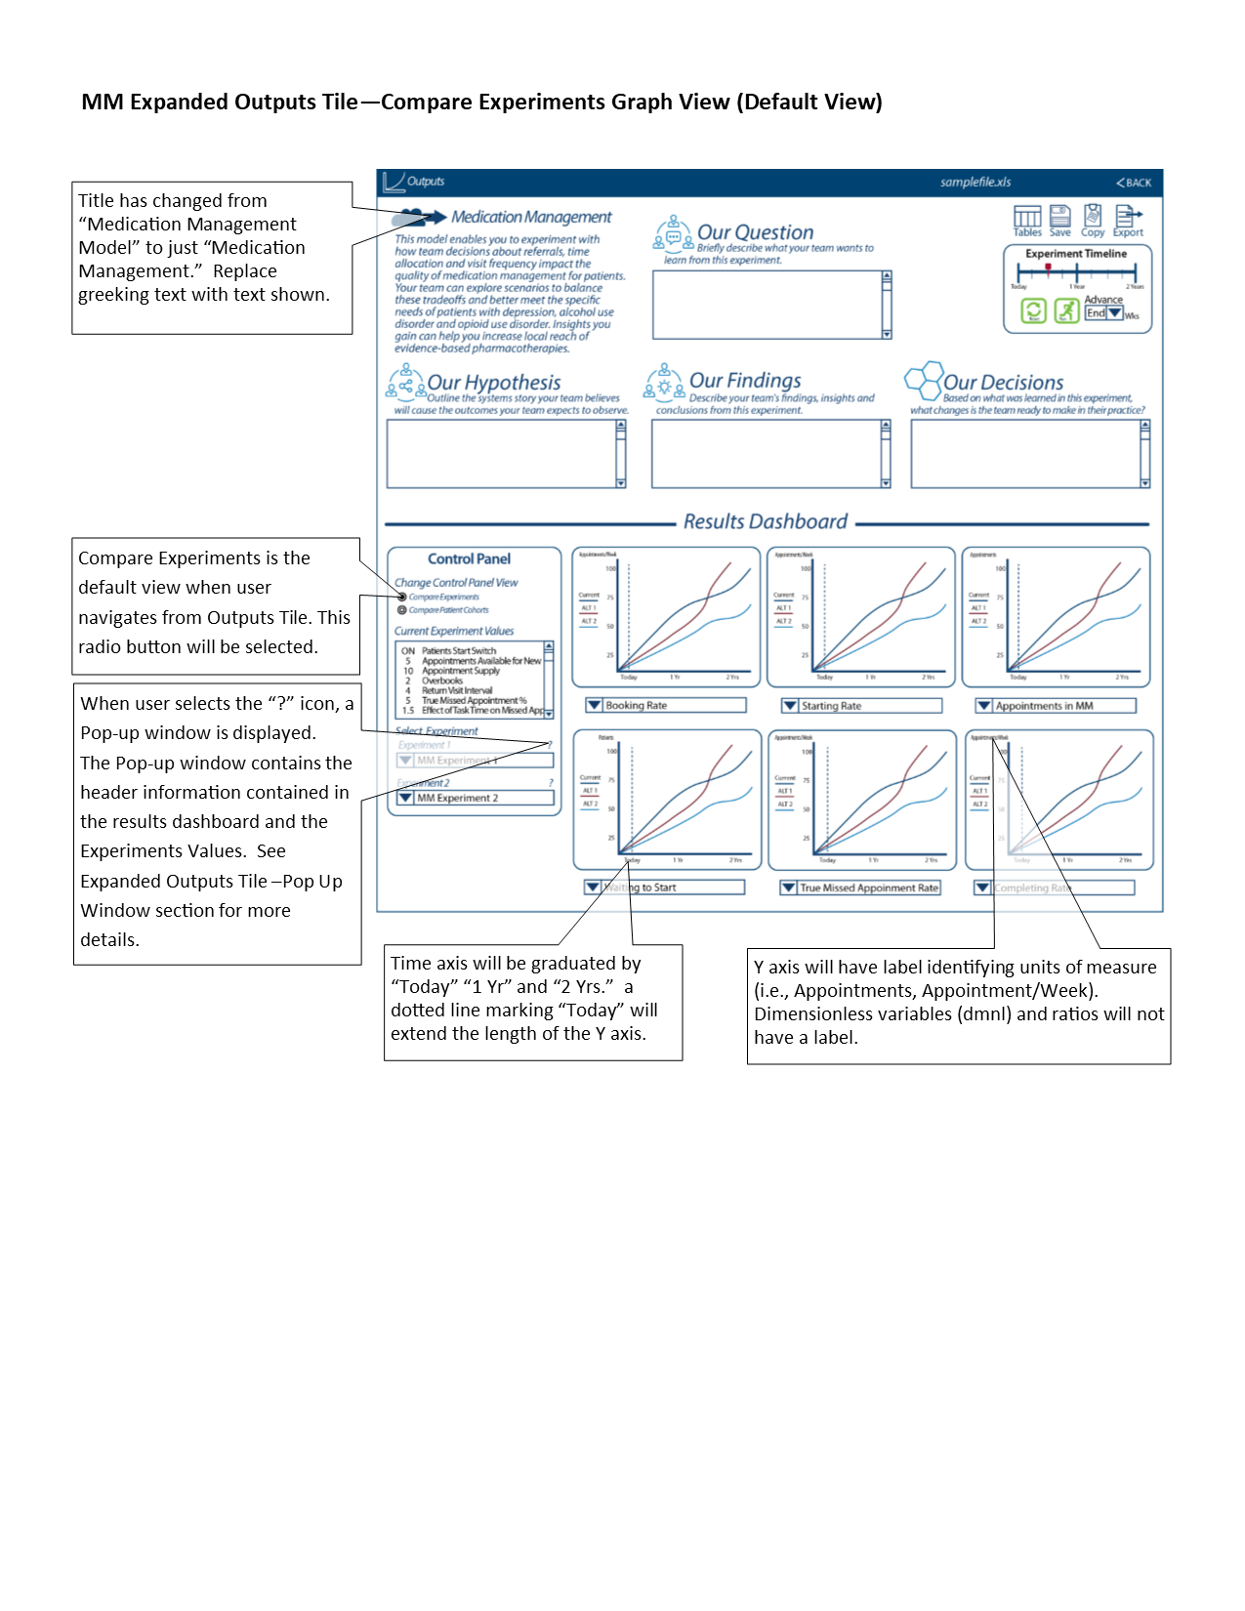

* + 1. The Compare Experiments Graph View version of the Expanded Output Tile (Figure ##) is the default view (and is the version shown when the Expanded Output tile is opened).
    2. The graphs’ x-axis follows the descriptions given above in “Outputs Tile - Graph View”.
  1. Expanded Outputs Tile - Compare Patient Cohorts Graph View -- Figure 30

Figure 30

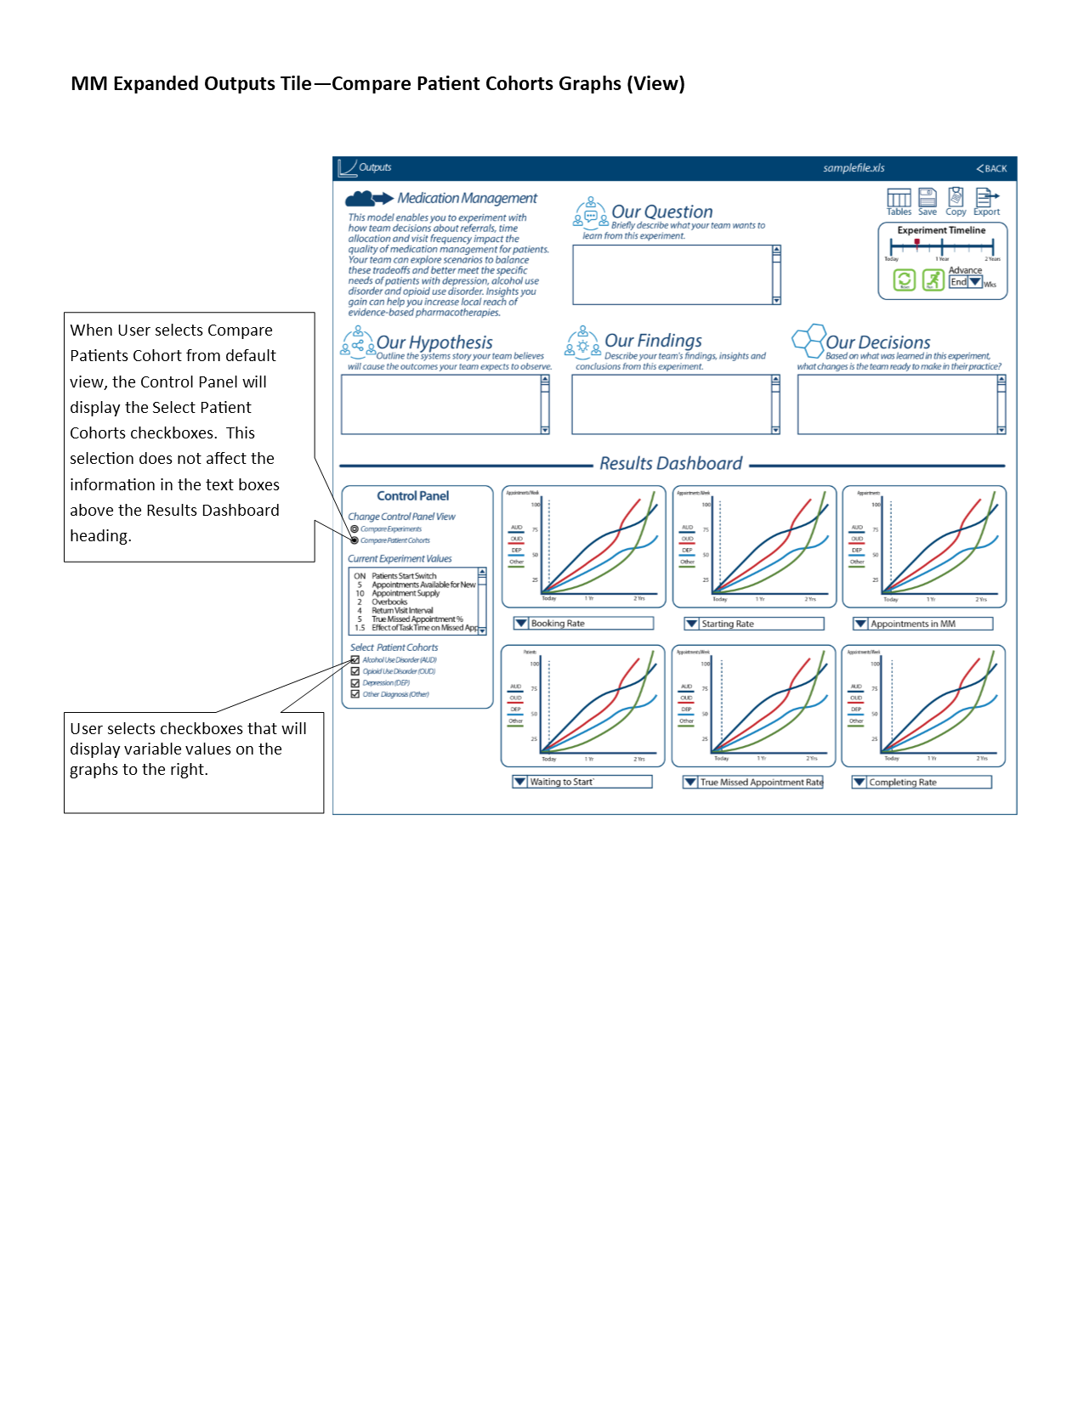

* 1. Expanded Outputs Tile - Compare Experiments Tables View -- Figure 31

Figure 31  
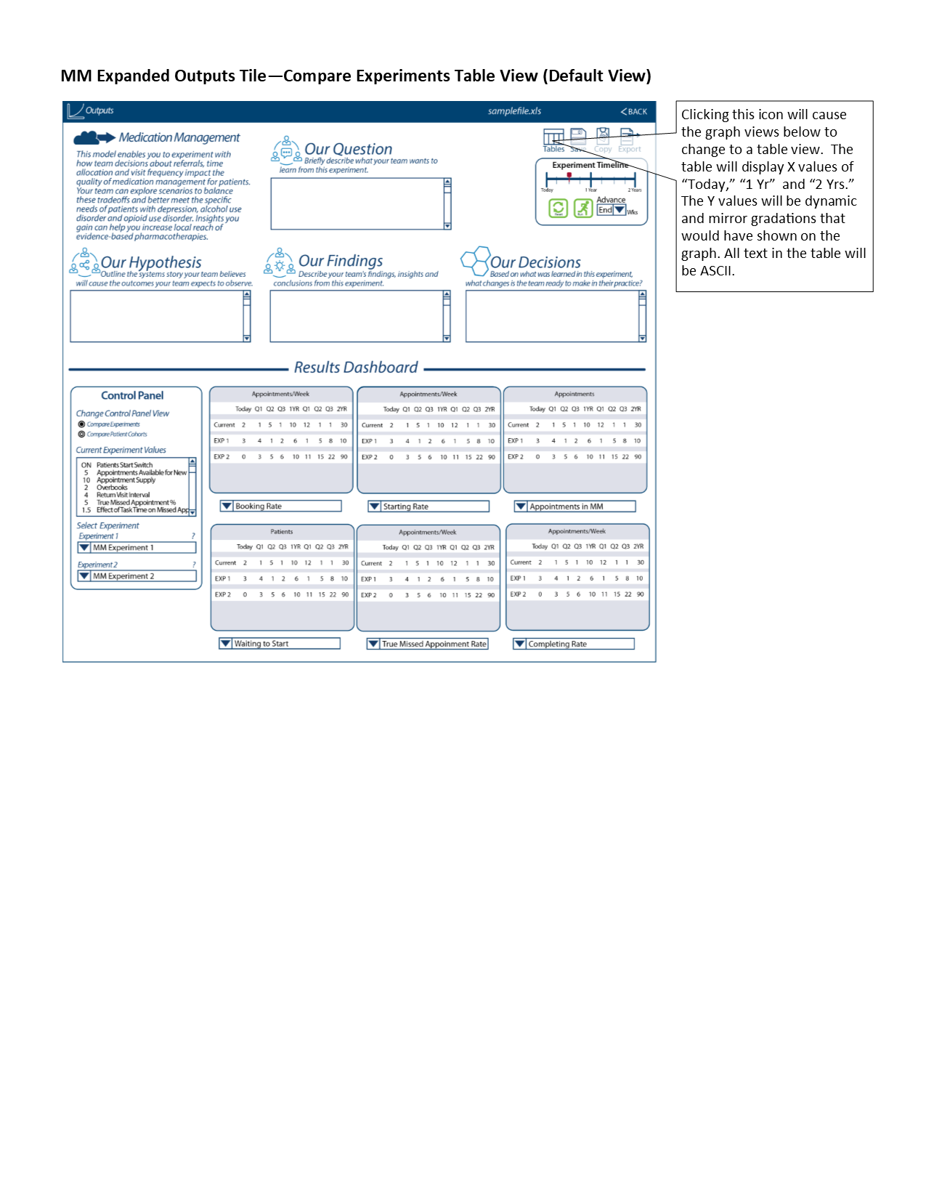

* 1. Expanded Outputs Tile - Compare Patient Cohorts Tables View -- Figure 34

Figure 34

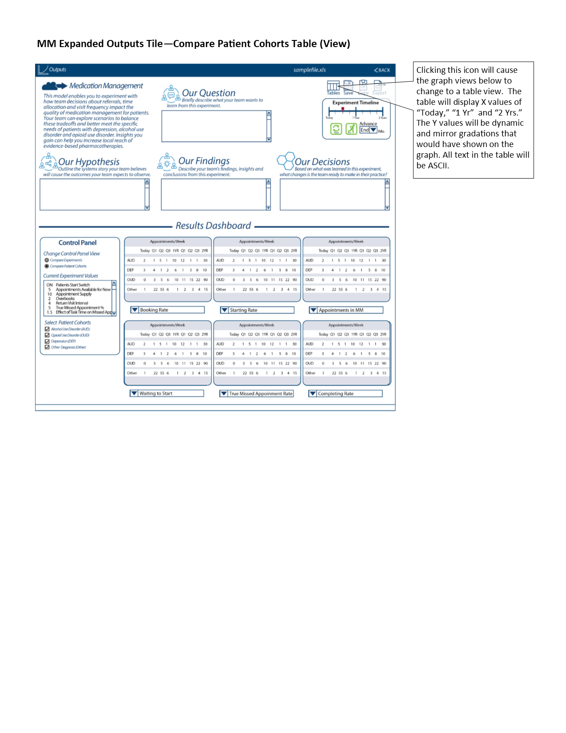

* + 1. On both the Compare Experiments Tables View (Figure 33) and Compare Patient Cohorts Tables View (Figure 34), the graphs’ x-axis follows the descriptions given above in “Outputs Tile - Table View”.
    2. On all the the Table Views (Figures ## and ##) and Graph Views (Figure ## and ##), clicking on the “?” next to the “Alternative 1” or “Alternative 2” in the Control Panel will bring up the “Information Pop-up Tile”, which is described in the Updates to Iteration B section below.

## 2.03 Player’s Dashboard / 5.9.10 Decisions Page (for Psy)

1. Below are diagrams that contain labels that have descriptions of design features, colors and other instructions for the model and each build layer.  
   1. User Interface - Default (View) -- Figure 35

Figure 35

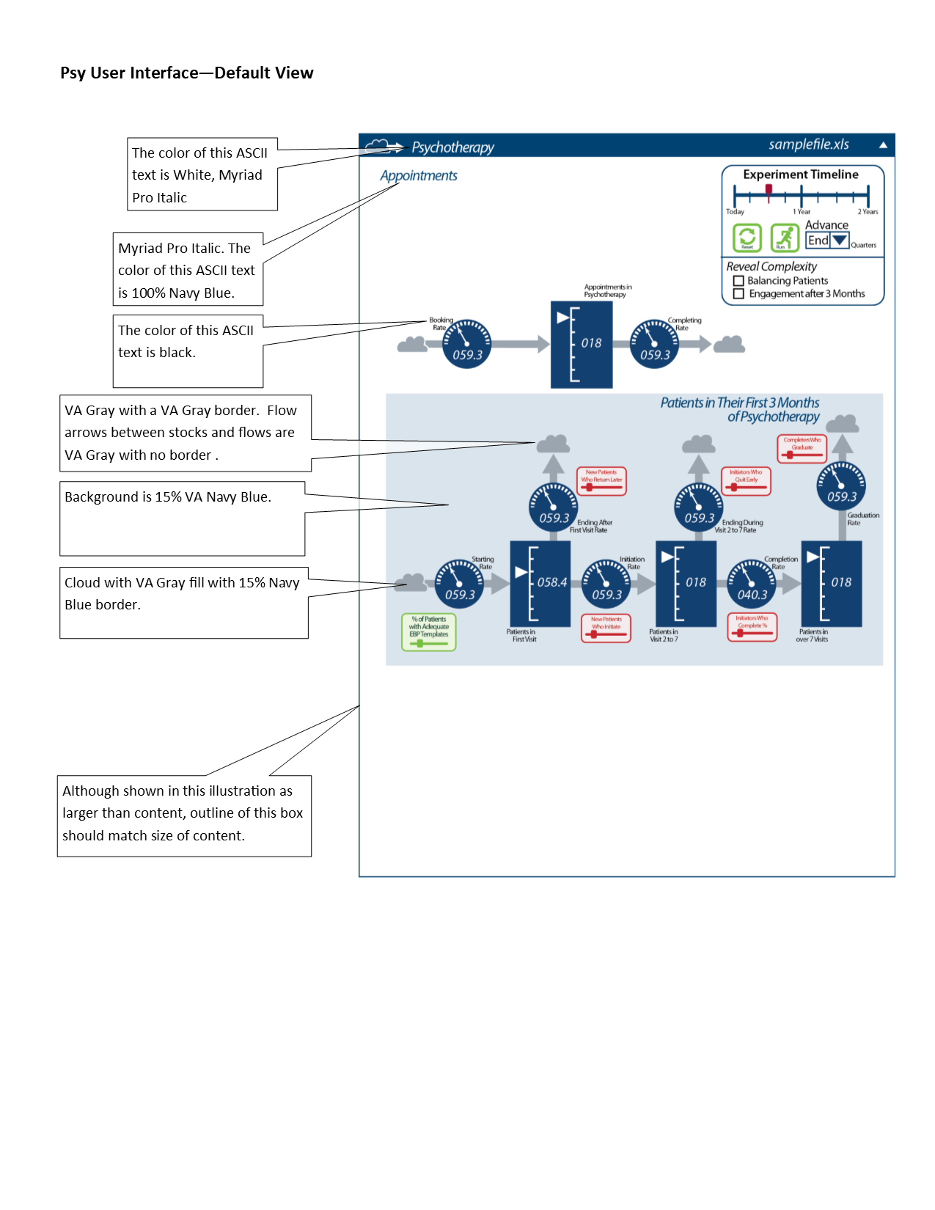

* 1. User Interface - Balancing Patients (Build) -- Figure 36

Figure 36

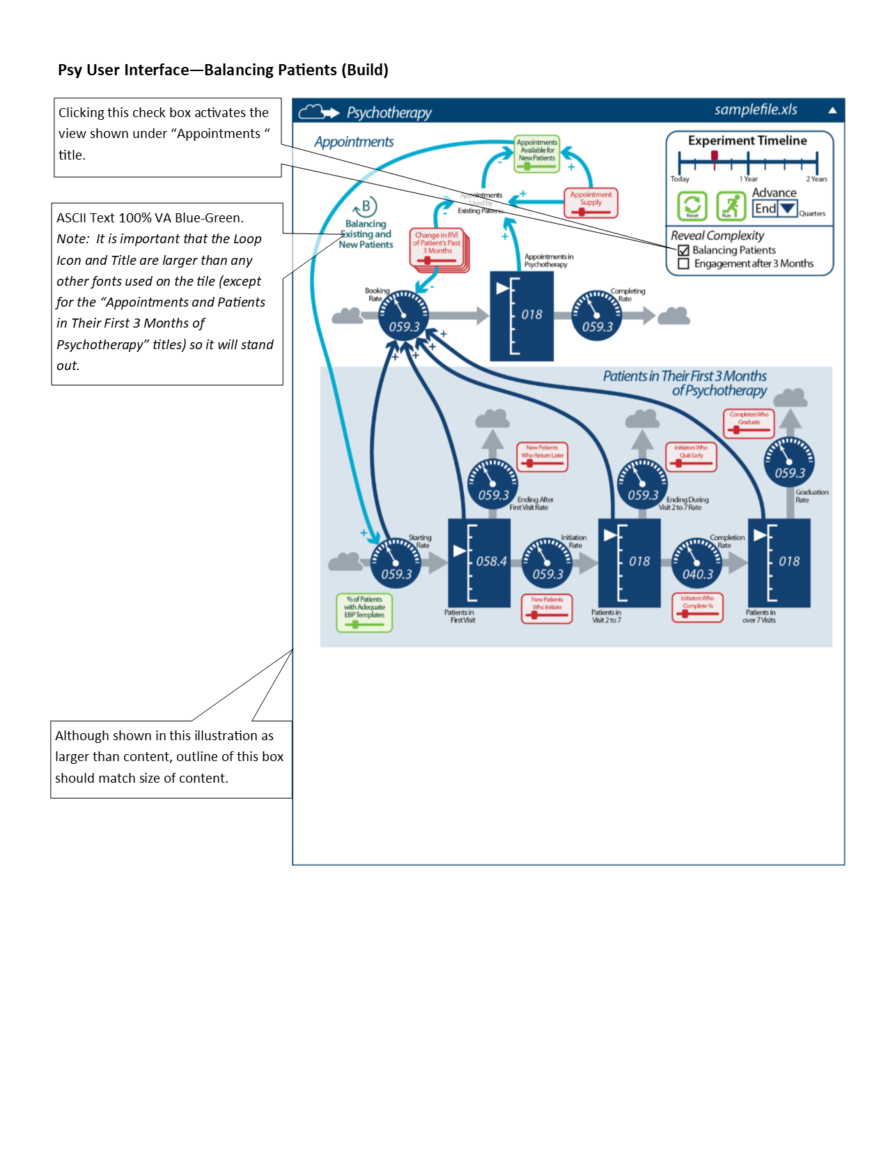

* 1. User Interface - Engagement after 3 Months (Build) -- Figure 37

Figure 37

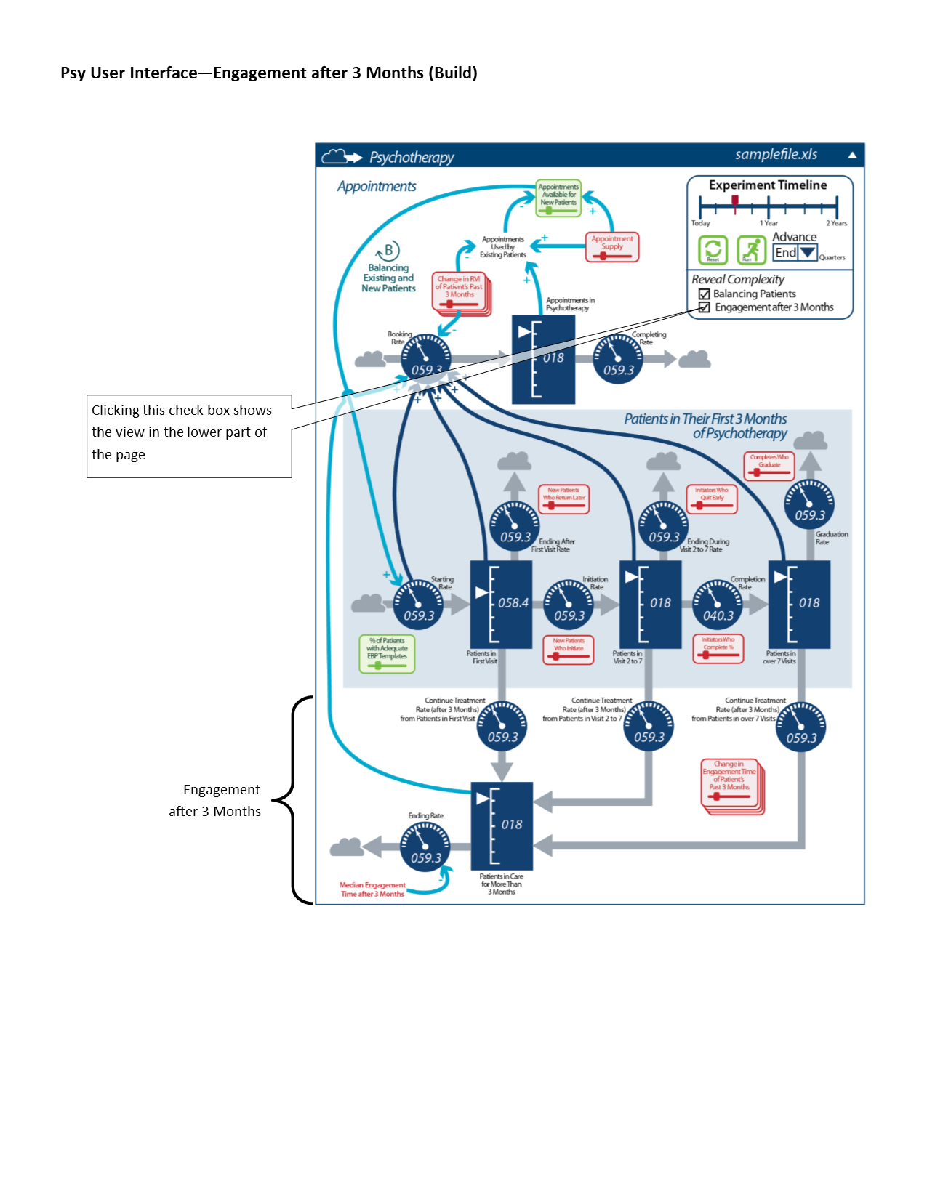

* 1. Experiments Tile -- Figure 38

Figure 38

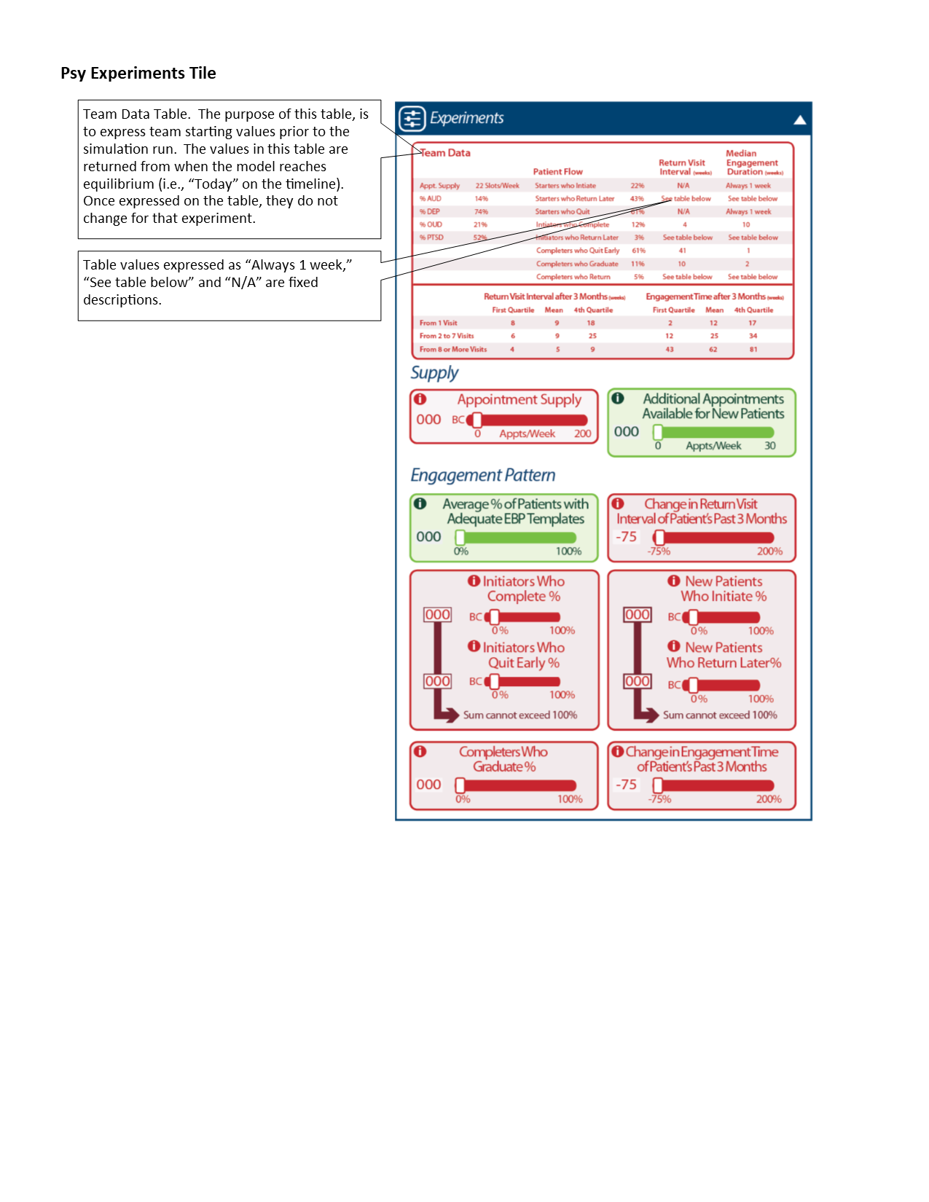

* 1. Expanded Outputs Tile -- Figure 39

Figure 39

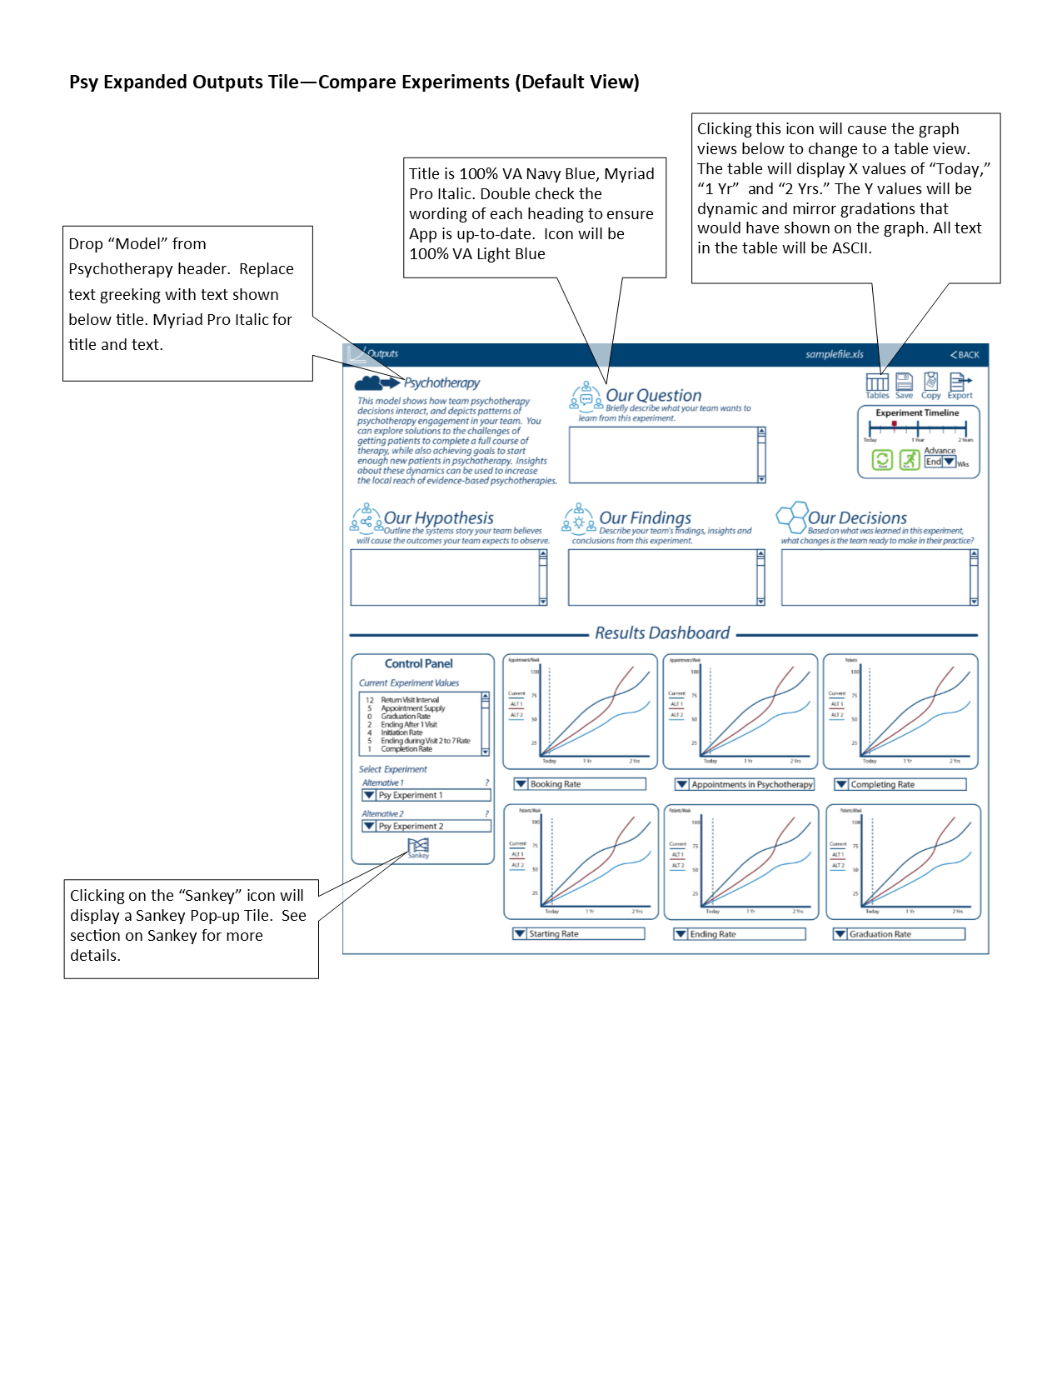

## 2.03 Player’s Dashboard / 5.9.10 Decisions Page (for Agg)

1. Below are diagrams that contain labels that have descriptions of design features, colors and other instructions for the model and each build layer.
   1. User Interface - Default View -- Figure 40

Figure 40  
 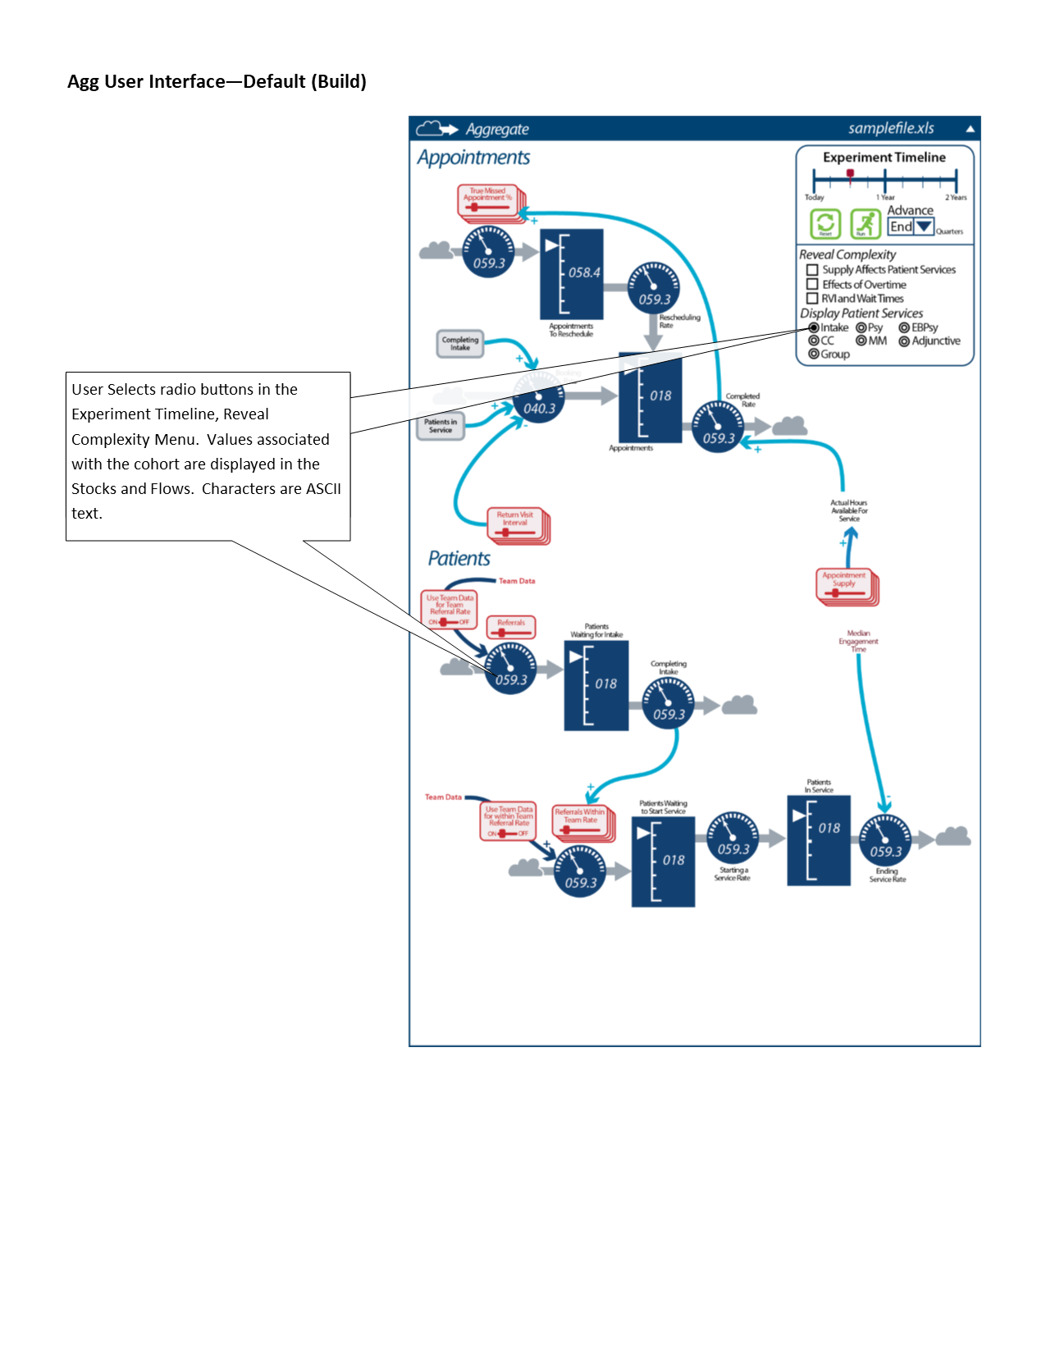

* 1. User Interface - Supply Affects Patient Services (Build) -- Figure 41

Figure 41

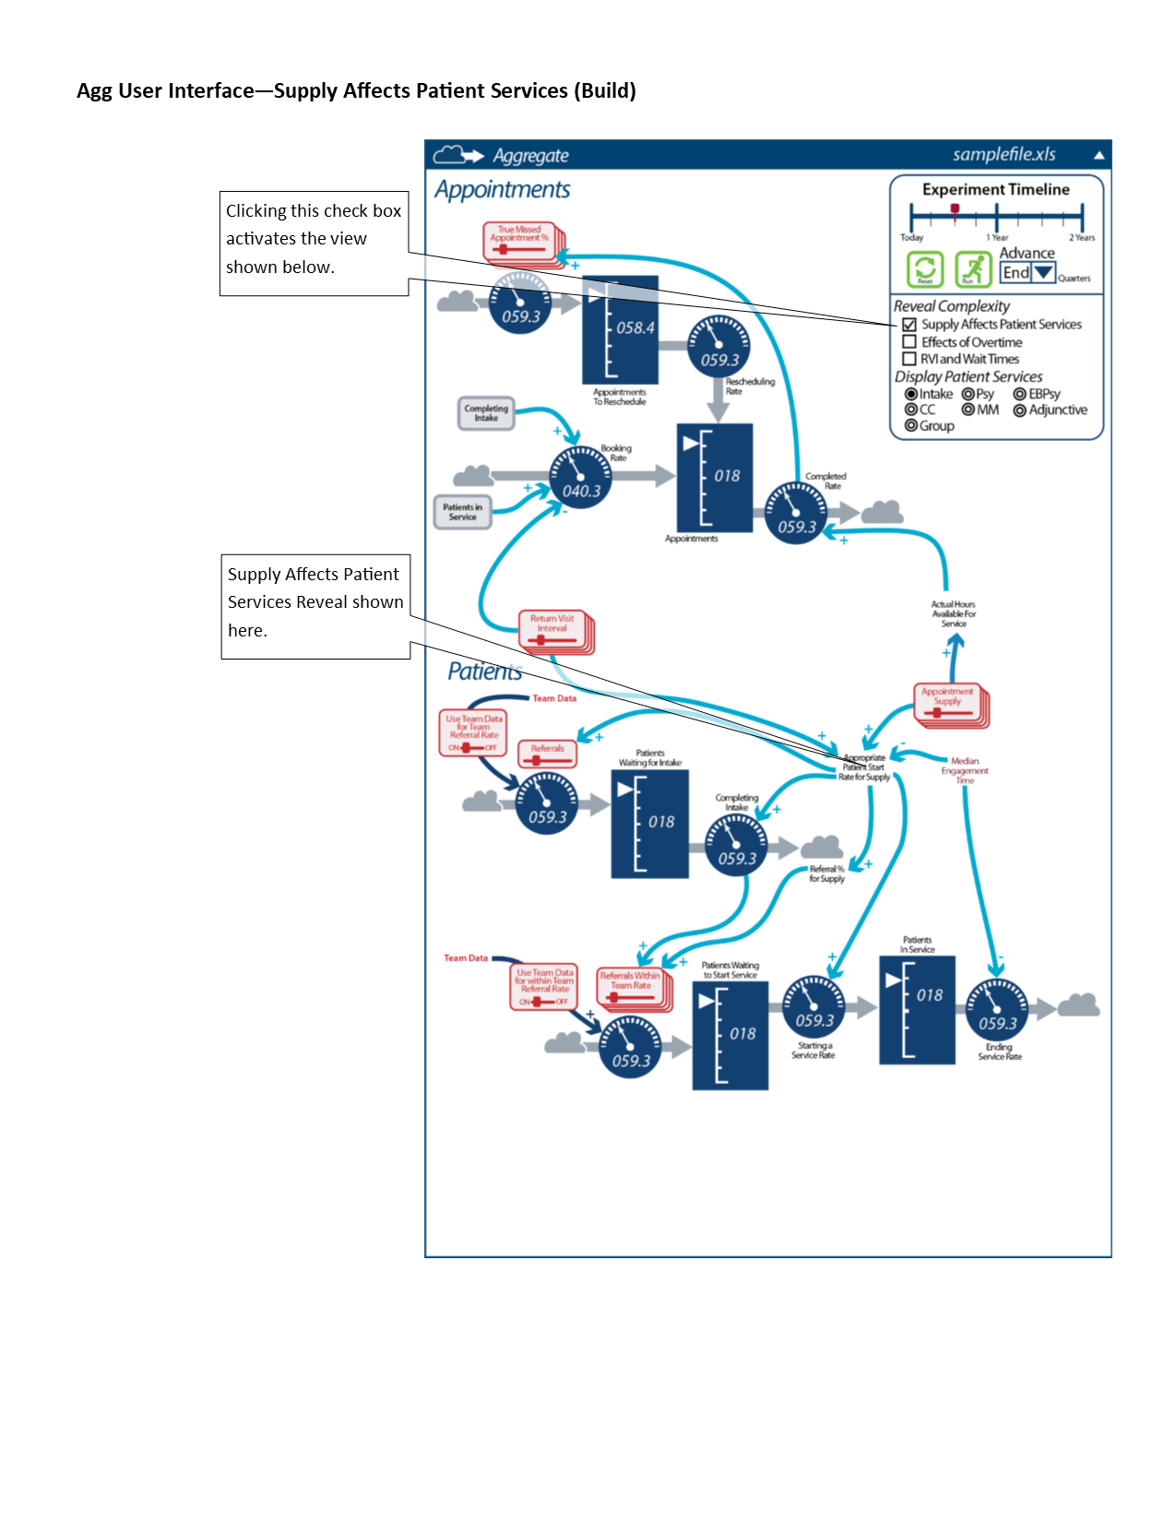

* 1. User Interface - Effects of Overtime (Build) -- Figure 42

Figure 42

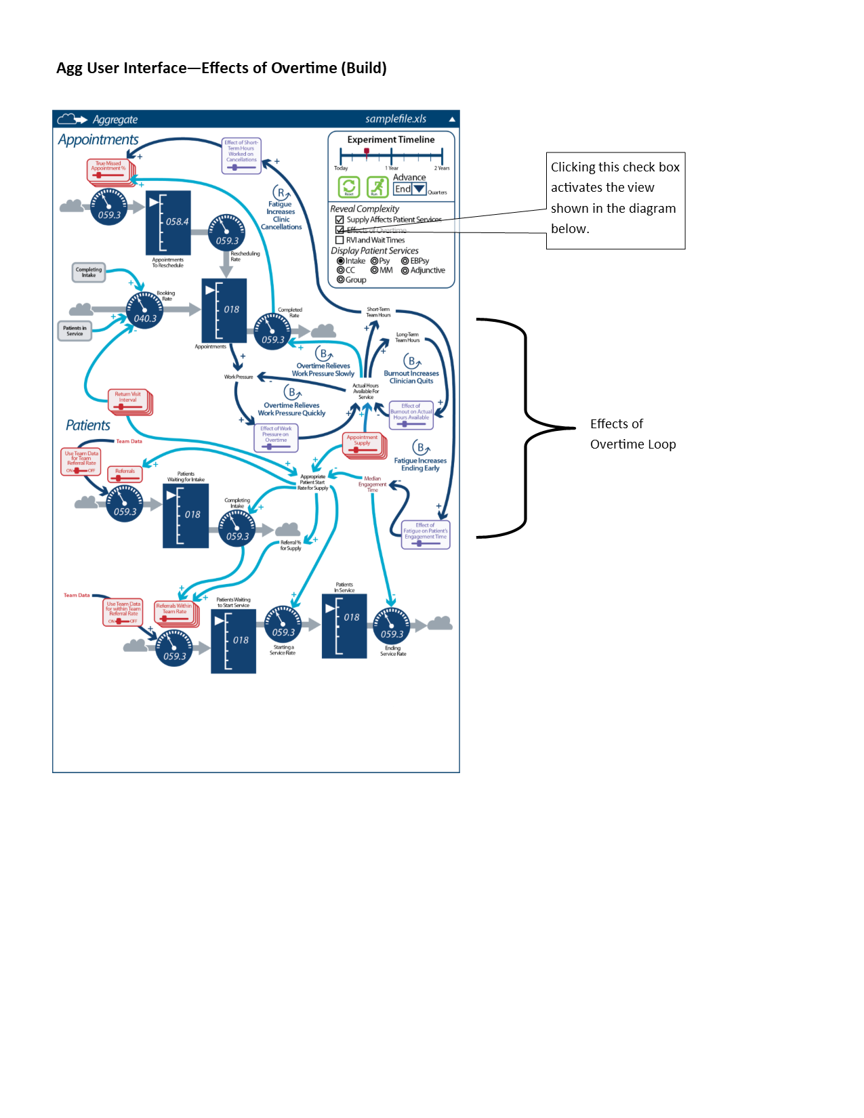

* 1. User Interface - RVI and Wait Times (Build) -- Figure 43

Figure 43  
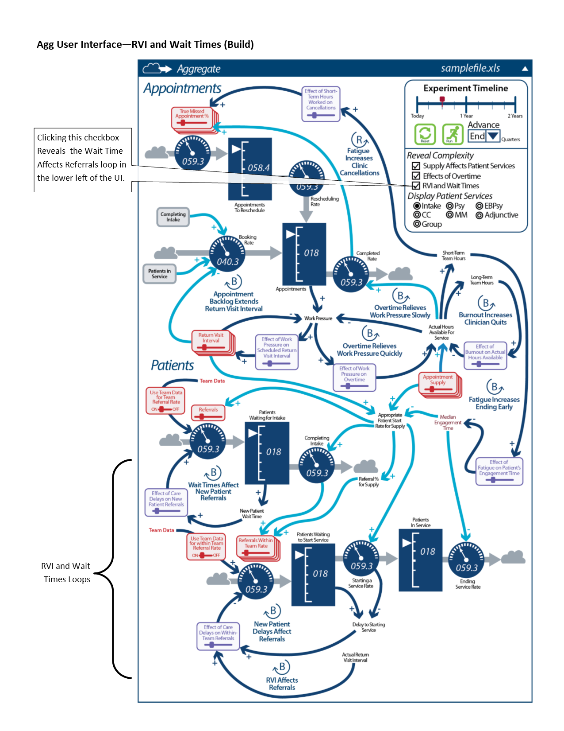

* 1. Experiments Panel -- Figure 44

Figure 44

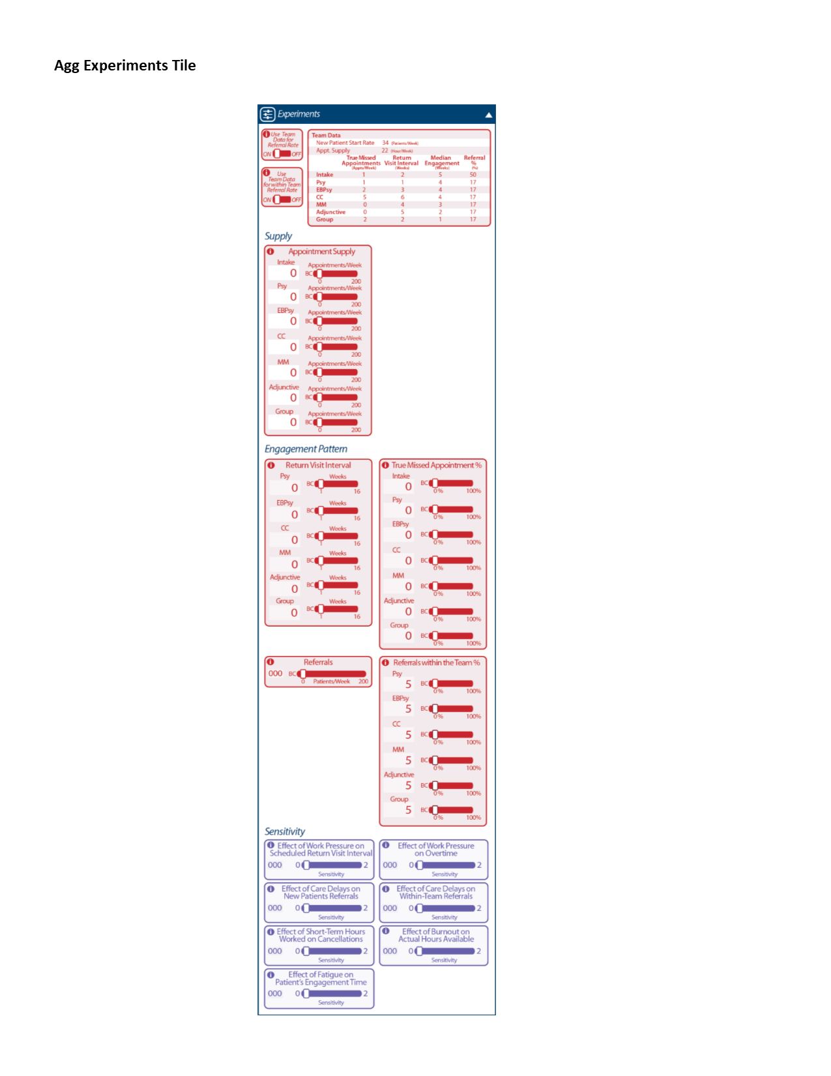

1. Expanded Outputs Tile - Compare Experiments Graph View (Default View) -- Figure 45

Figure 45  
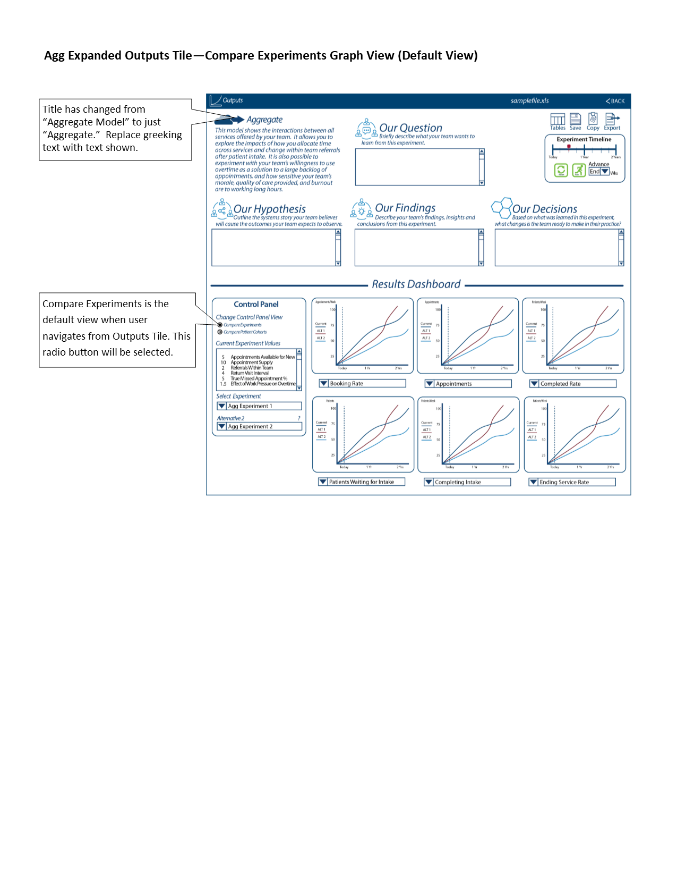

1. Expanded Outputs Tile - Compare Experiments Table View -- Figure 46

Figure 46  
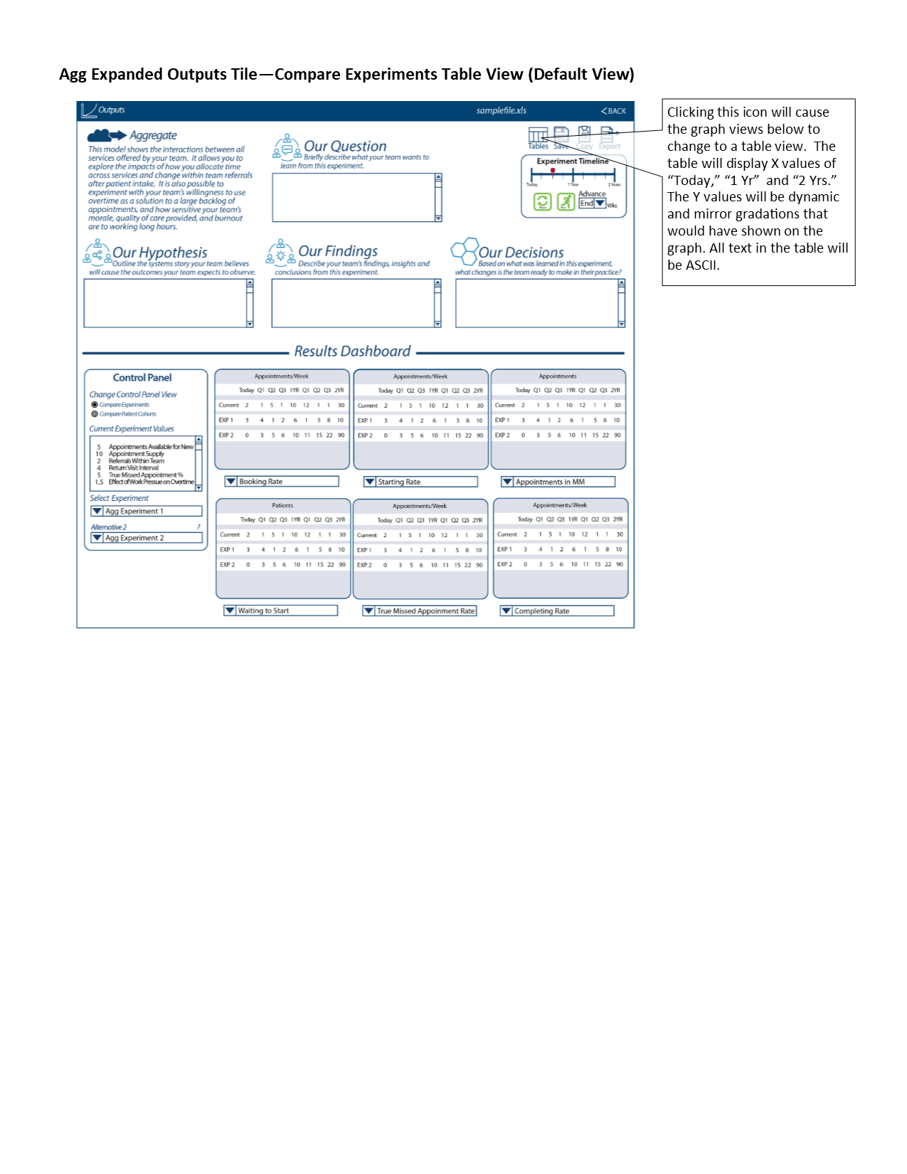

* 1. Expanded Outputs Tile - Compare Services Graph View -- Figure 47

Figure 47

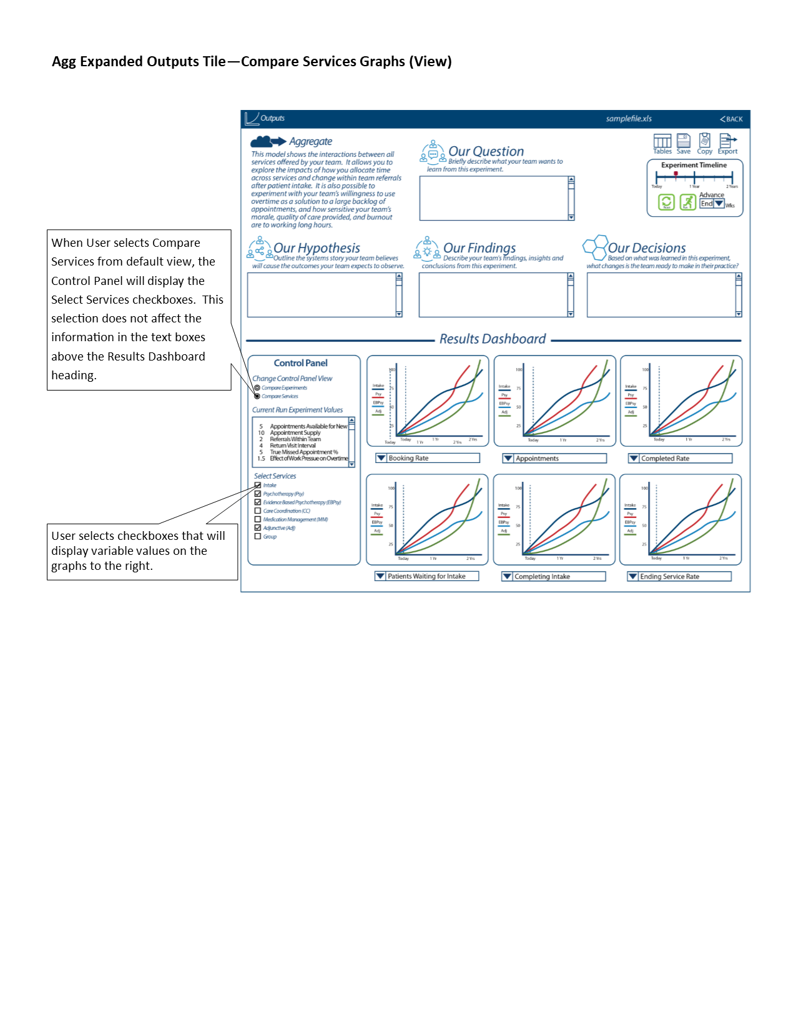

* 1. Expanded Outputs Tile - Compare Services Table View -- Figure 48

Figure 48

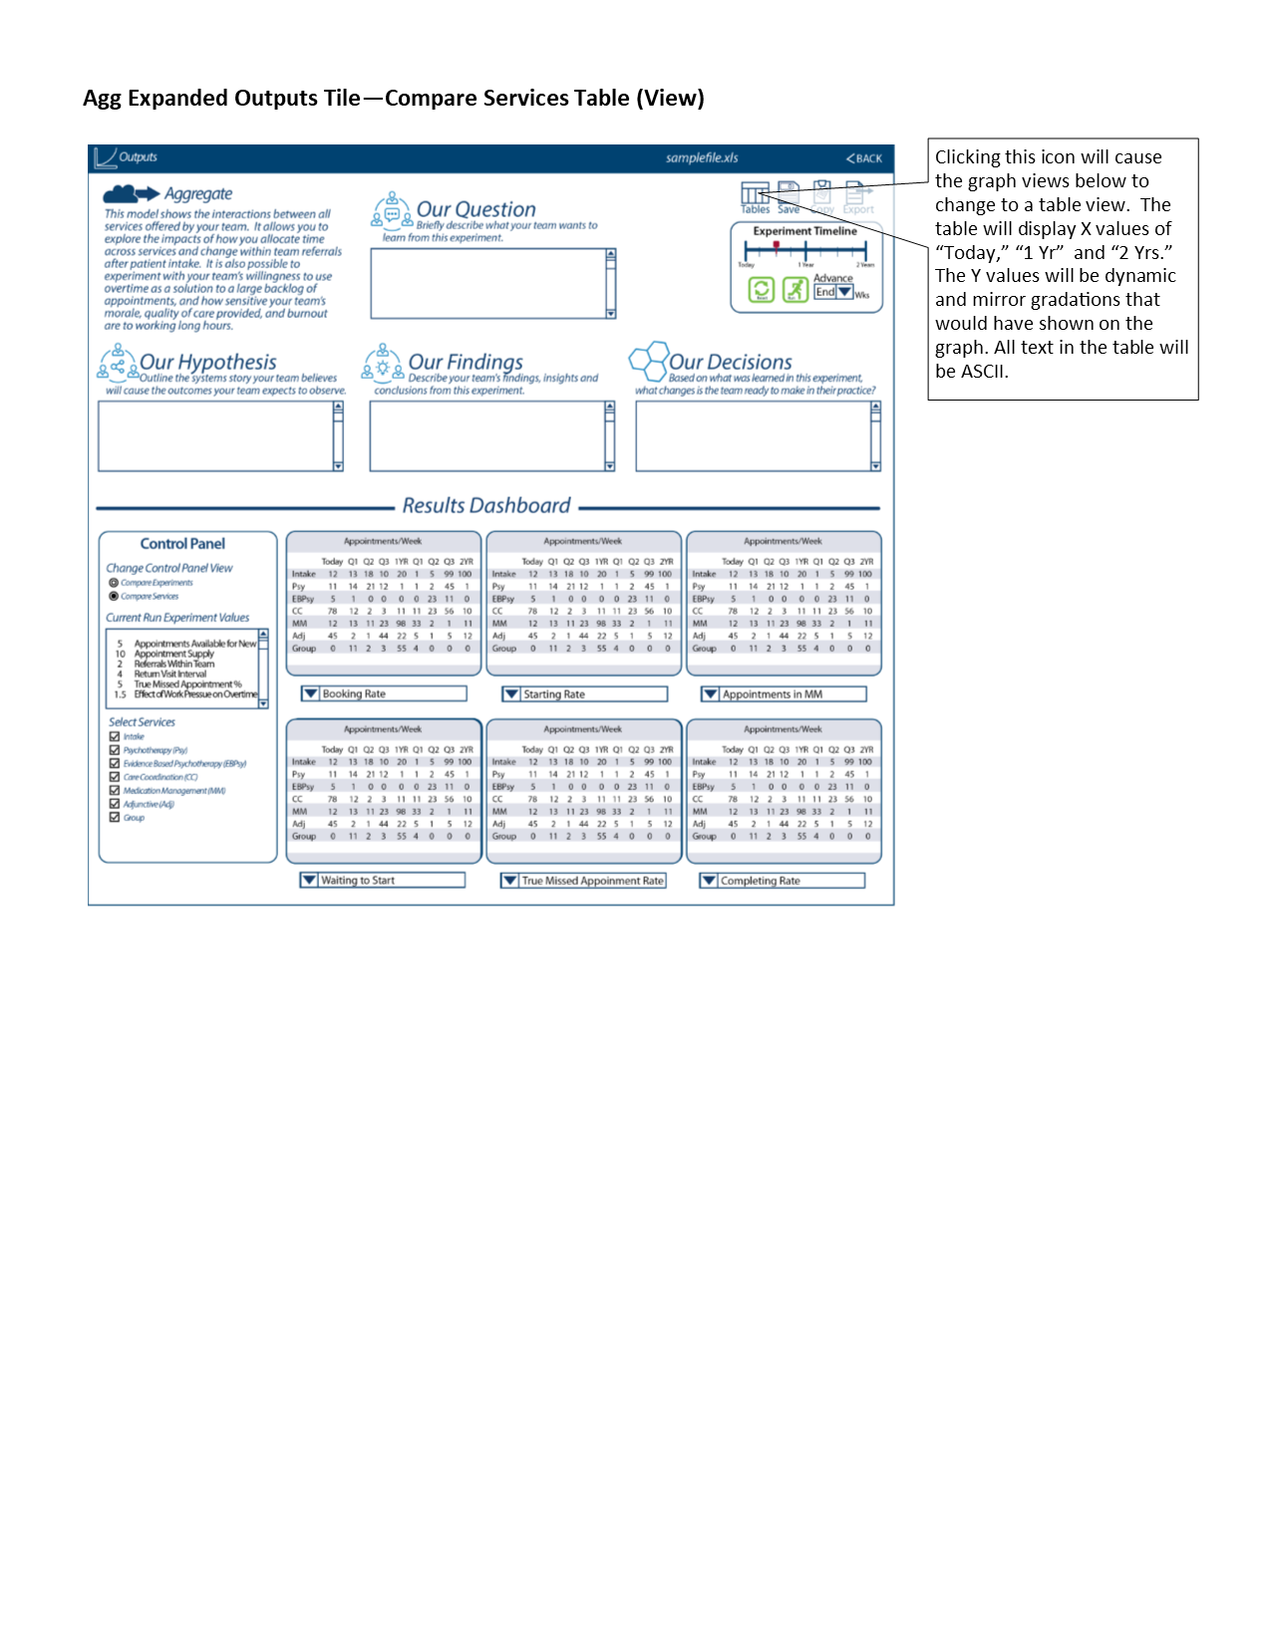

1. Variable Tables -- Link to Google Spreadsheet (and Sheet:”Agg Variables”): [G-SS](https://docs.google.com/spreadsheets/d/1KoyHmZiai6FRC6tmquLPA3541N2N5Lgi_FEdN1HvmFQ/edit#gid=0)

## 2.03 Player’s Dashboard / 5.9.6 Dashboard with access to key metrics

1. This functionality is captured in the Expanded Outputs Tile and is described in the above sections, for example: 2.03 Player’s Dashboard / 5.9.10 Decisions Page (for CC).
2. The text below indicates the updated text for the descriptions of the heder area of the Expanded Outputs Tile, and is consistent across all four Vensim models.
   1. “Our Hypothesis” new wording, “Outline the systems story your team believes will cause the outcomes your team expects to observe.”
   2. “Our Results” is changed to “Our Findings” with new wording, “Describe your team’s findings, insights and conclusions from this experiment.”
   3. “Our Decisions” wording is corrected, “Based on what you learned in this experiment, what changes are you ready to make in your practice?”
   4. “Select Control Panel View” is changed to “Change Control Panel View”  
      - “Model Run Alternatives Comparison” changed to, “Compare Model Runs”  
      - “Inter-Model Run Variables Comparison” changed to, “Analyze Variable Arrays”

## 2.03 Player’s Dashboard / 5.9.12 Ability to export data as a Comma Separated Values (CSV) File

1. The functionality has not changed from Iteration B.
2. Depending on latency, we may decide to record only at each Week instead of sub-week (for example, only record every 8th or 16th data point).
3. Although we are not making use of the data yet, we want to log the event (i.e., when User clicks on “Copy” or “Export” in the Outputs Tile or in the Expanded Outputs Tile) for use in “Use/Evaluation Analytics”.
   1. For more information, please see [link](https://docs.google.com/document/d/1Cj6zUd1i23b3wzzAFBZDabHEUh2FgxzaFbM_K0YtBWs/edit#heading=h.1edtvtsc2rrv) in Iteration B.
   2. Recording each time a User (i.e., a Player or Team Lead Role) clicks on “Copy” or “Export” may require a separate data store (from the existing Forio capability of recording “run data”). For example, in one run, a Player may click on “Copy” and “Export”, or a Player may only click on “Export”, or a Player may choose to do neither “Copy” nor “Export”.

## 2.03 Player’s Dashboard / 5.10.01 Introduction & Help: Text-based 'prepare' section

1. This feature/requirement is not needed.
2. Per BaseCamp discussions (Testing the VA PSD Simulation, <https://basecamp.com/2223176/projects/11877143/messages/73662154>, comments posted on 21-Dec) we will no longer need “prepare” text.
3. We had planned on having the “prepare” text as part of the “Welcome” Tile in the “Select” Page.
4. If we decide we need to re-include the “Welcome” Tile and any “prepare” text, we can add that for Iteration D.

## (Help Page Content) 2.03 Player’s Dashboard / 5.10.02 Introduction & Help: Text-based 'help' section AND 2.03 Player’s Dashboard / 5.10.03 Integrate tutorial videos AND 2.03 Player’s Dashboard / 5.10.04 Interactive tutorial walking through the user interface

1. This section describes the text and other content (including arrangement) for the “HELP” Page (for all Users). Use the headings and text below as a guideline for now; more specific wording and headings will be provided after the release of this Iteration C Design Document.
2. The “Help” Page will have the following four Tiles
   1. Using this tool
   2. Understanding the models
   3. Terms and abbreviations
   4. References and links
3. The content for the four Tiles (including subheadings and placeholders for Iteration C):
   1. Using this Tool
      1. **Navigation**  
           
         As shown on the main navigation bar, there are four main sections to this tool:  
           
         **Home** – This is the initial welcome page. It’s also the place where play actually starts for a given session. You can choose to either join an existing game or start a new one by choosing which model and set of team data you want to use for the session. Click “Play Simulation!” when you’re ready.  
           
         **Play** – Here you see a diagram of the model you chose: Care Coordination, Medication Management, Psychotherapy, or Aggregate. The header above it also shows which dataset is in use. You may need to scroll down to see all of the diagram. (See Help: The Models for explanations of these diagrams and each of the models.)   
           
         There are two other tiles on this page: Decisions, where you choose what decisions you want to simulate – which factors you’d like to simulate; and Results, where graphs of the results of your simulation will appear after you hit “Run”.  
           
         **Help** – You are here!  
           
         **Chat** – Chat lets you converse with either the rest of your team or with the Modeling to Learn facilitator. Note that comments are saved permanently. Also, like most chat applications, you can’t separate conversations by threads. So it’s best to only send chat messages for the facilitator while you are in a live session with them. If you’re experimenting on your own at another time, you might want to post a message to your teammates that they can see and respond to when they log in next.  
           
         TBD: Audio/Video – Audio of the above for 508, or is that accomplished by an app? Narrated version with screen shots for 508 and/or just different learner preferences?[1]
      2. Creating a simulation  
           
         Include the same youtube video link from previous Iteration development, along with the text preceding (before, or above) the video.  
           
         “The following video is for demonstrating the ability to embed a video.”
      3. Viewing results
      4. Saving and exporting
   2. Understanding the models
      1. Diagram basics and terminology
      2. Care Coordination
         1. Text (video script)
         2. Video (captioned)  
            Embed the following video: [link or instructions to be provided]
         3. Variables and parameters (table with units, definitions, and sources)
      3. Medication Management
         1. Text (video script)
         2. Video (captioned)  
            Embed the following videos (we will prob have two videos): [link or instructions to be provided]
         3. Variables and parameters (table with units, definitions, and sources)
      4. Psychotherapy
         1. Text (video script)
         2. Video (captioned)
         3. Variables and parameters (table with units, definitions, and sources)
      5. Aggregate
         1. Text (video script)
         2. Video (captioned)
         3. Variables and parameters (table with units, definitions, and sources)
   3. Terms and abbreviations
   4. References and links

## 2.04 Retune the Model for Different Locations / 5.3.1 Framework for Multiple Cities, States, other Locations AND 5.3.2 Ability to Upload Datasets by Location

1. There are a few ways we are accommodating the ability to handle multiple locations.
   1. Some of the is was described in Iteration B design and is included here for reference:
      1. How we are setting up teams to be a “team at a location”, for example “Team ATS, Menlo Park” is a team. For more information on this, see 2.05 User Management / 5.9.3 Set team name.
      2. How we are enabling the use of external Excel files to bring in data for the Vensim model.
      3. To manage the team names and Excel files, we recommend a easy-to-use naming convention.
2. Managing the external XL files
   1. This will be handled through a manual process of uploading the XL files to the appropriate directory in Epicenter
      1. The files will uploaded to “forio.com/epicenter/va/va-psd-sim/static/files”  
         [Need to confirm]
      2. The individuals will need to be given “author-level” credentials to be able to access the Epicenter directory.
   2. The process and information around filenames will be described in a separate document or other place of record.
      1. Part of the process will involve updating a external file that must contain the filename, for example, the filename must be appended to a list. This is what enables the simulation to provide the drop-down information and point to the correct XL file.

## 2.05 User Management / 5.4.2 Upload List of Users from a Comma Separated Values (CSV) file

This is a feature already supported by Forio Epicenter and was addressed in Iteration B.

## 2.05 User Management / 5.9.3 Set team name

1. All Users will be in one Group. Name of Group: “VA_PSD_Group”.
2. Each Team will be one distinct World. Takouba will provide a list of Worlds and how each World (by World number) will be mapped to a Team. When we display a Team Name, the Simulation will look up the Team Name based on the User’s World.
3. Each User will be assigned to one World that corresponds to their team.
4. As per our earlier communication if user has to be part of another game then have new login id.

## 2.06 Game Assignment / 5.4.3 Assign Users to Roles (Role Player, Simulation User role) and Teams

These requirements are a combination of features already supported by Forio Epicenter and how we addressed the requirements Iteration B.

## 2.06 Game Assignment / 5.4.4 Remove Users/ Reset Passwords/ Other User-management Features

These requirements are a combination of features already supported by Forio Epicenter and how we addressed the requirements Iteration B.

## 2.07 Game Progress / 5.9.8 Scoring / Compare to Other Teams (only for Admins)

1. The Facilitator Dashboard (see Figure 49 below) shall consist of gauges that use similar visual movements as the rate gauges in the UI. These will be larger and have colors that range from VA Red on the far left, to VA yellow in the middle and VA Green on the right. The values for the gauges will be determined by the Scoring Criteria described below. The settings for current rows (i.e., which teams have been selected, and for each team, which games have been selected) shall be saved in browser cookies, so if the Facilitator logs out and returns, they will see their current listing of open expanded and collapsed rows. The Facilitator can choose to collapse a row to save space, but there will be no “save” routine for the dashboard.
2. Scoring Criteria
   1. Run model: If the users start a game, and load a data set, and run model to the end, they will earn +20 points. The dial will move as illustrated in A.
   2. Text in "Our Question": If the users fill in any text in the “Our Question” text-field, they will earn an additional +20 points. The dial will move as illustrated in B.
   3. Text in "Our Hypothesis": If the users fill in any text in the “Our Hypothesis” text-field, they will earn an additional +20 points. The dial will move as illustrated in C.
   4. Text in "Our Findings": If the users fill in any text in the “Our Findings” text-field, they will earn an additional +20 points. The dial will move as illustrated in D.
   5. Text in "Our Decisions": If the users fill in any text in the “Our Decisions” text-field, they will earn an additional +20 points. The dial will move as illustrated in E.
3. Collapse and Expand icon will collapse or expand each team instance of the dashboard. For example, if the icon in “F1” was clicked, it would result in a collapsed row as shown in “F2”.
4. Choosing a team. The Facilitator would select the drop-down menu shown in item “G.” The drop-down menu would contain teams the Facilitator can see within their world. A team must be chosen before model files can be listed and presented in the model run drop-down menus as shown in item “K.”
5. Team Roster. The Facilitator can click on the icon next to item “H” to start a pop-up window that has a listing of the team lead and team members on the team.
   1. The pop-up show a list of the team members for the selected Team. The Team Lead should be identified with a “-- Team Lead” after the name (or in a separate column).
   2. We want to enable the Facilitator to jump to the “Chat” Page with the selected team auto-selected and shown in the Facilitators Tile. In other words, if the Facilitator clicks on chat icon next to the Team Leads name (in the Team Roster pop-up”, the Facilitator will be taken to the “Chat” Page, and the chat window will show the chat session with the selected Team Lead.
   3. If the Team has not been selected, disable the Team Roster icon.
6. Team Statistics. The facilitator can click on the icon next to item “I” to view a pop-up that contains team statistics. An empty pop-up window will suffice for Iteration C. We will determine appropriate statistics in Iteration D.
   1. If the Team has not been selected, disable the Team Statistics icon.
7. Close. When the facilitator clicks on the “Close” icon indicated in item “J” the row will close. A warning banner will be displayed asking the user if they are sure they wish to close the row, and that the row will not be saved. If the user selects “Yes,” the row will close and there will be no record of this dashboard. If the Facilitator wishes to see the row again, then they will need to re-setup the row.
8. Add Team. By clicking on this icon, shown by item “L” a new expanded row will show. The Facilitator can start as many rows as desired.

Figure 49 - Facilitator Dashboard

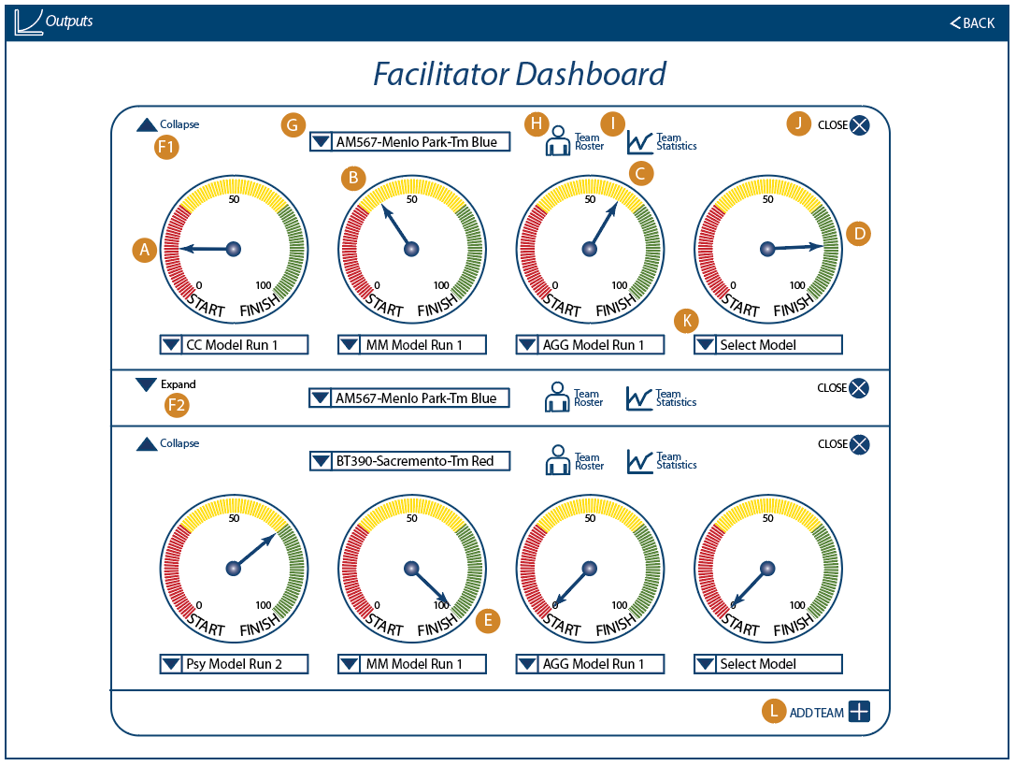

## 2.10 Exogenous Events / 5.8.1 Allow Administrator to Trigger Exogenous Events in the Simulation

1. This requirement is no longer needed, based on call on 17-Nov 2017 “Lindsey + James Review UI Decisions and Schedule Notes”.
2. More specific info is available: <https://basecamp.com/2223176/projects/11877143/messages/73934405>

## Unspecified in workplan / 5.7.2 Ability of Manager/Facilitator to Impersonate Team Members to View Decision Details

1. This is a feature already supported by Forio Epicenter.

## Updates to Iteration B

1. Please see above Wireframes for a description of some modifications to the Wireframe for Iteration C.
2. Update to Psy Model, Expanded Output Tile, for Sankey Charts  
   We may move this content into the section that describes Expanded Outputs Screen, specifically 2.03 Player’s Dashboard / 5.9.10 Decisions Page (for Psy).
   1. This section describes the Sankey Charts that will be available for the Psy Model. Only the Psy Model will have this feature.
   2. UI
      1. On the Expanded Outputs Tile, there is a “Sankey” icon at the bottom of the Control Panel area (see Figure 39).
      2. Clicking on the Sankey Icon opens an additional pop-up Tile. See Figure 50.

Figure 50

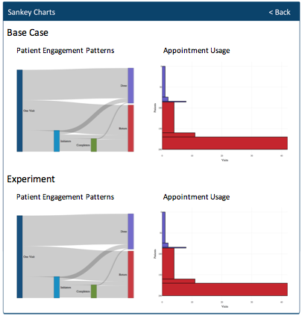

* + 1. There are two types of Sankey charts. The “left” chart (Patient Engagement Patterns) will be referred to as “Sankey1”; the right chart (Appointment Usage) will be referred to as “Sankey2”.
    2. There are also two sets of Sankey1 and Sankey2 charts: one for Base Case and another set for Experiment.
  1. Sankey Chart basic information
     1. References
        1. http://bl.ocks.org/d3noob/c9b90689c1438f57d649
        2. <https://developers.google.com/chart/interactive/docs/gallery/sankey>
        3. <https://savet.shinyapps.io/Sankey/>
           1. The above link is a deployed example showing both Sankey1 and Sankey2 charts. The link is provided as an example for review and discussion.
           2. Not all elements from the link are elements we want to include in the pop-up Tile. For example, we do not need the header text, “Cohort Size” selection, nor the “settings” icons.
           3. We would like to have the two Sankey charts   
              “line up” so that the y-axis are approximately the same height.
           4. The R codebase to render the deployed Sankey charts are available at:

<https://github.com/lzim/teampsd/commit/07f86b318ff939989a11c873a983d8003a4249d8>

https://github.com/lzim/teampsd/tree/master/data_script

* + 1. ~~Our~~ Sankey1 Charts will always have ONLY eight Sankey Flows (A through H) as indicated in Figure 51 below. (Ignore the labels in the figure.)

Figure 51

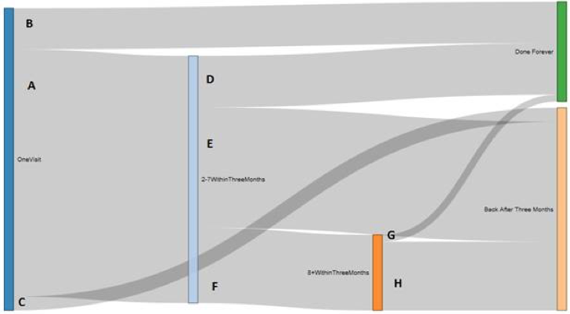

* + - 1. The colors [TBD]
    1. Sankey2 charts will always have ONLY the 6 “areas” as indicated in Figure 52 below.

Figure 52

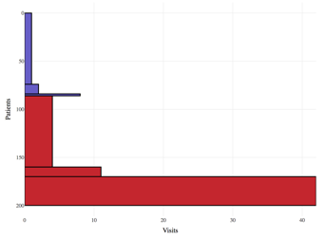

* + - 1. The colors of the areas:
         1. The top 3 areas should match the color of the bar at the right of the Sankey1 chart that corresponds to flows B + D + G.
         2. The bottom 3 areas should match the color of the bar at the right of the Sankey1 chart that corresponds to flows C + E + H.
      2. The heights of each area (for Sankey2) should match the height of the corresponding (adjacent) height of the Sankey1 chart.
    1. The formulations (using Vensim variables) for calculating the width of the flows are indicated in this [G-SS](https://docs.google.com/spreadsheets/d/1KoyHmZiai6FRC6tmquLPA3541N2N5Lgi_FEdN1HvmFQ/edit#gid=431359049), in the “sankey” sheet.
       1. ~~For reference we will call each flow “SFA” for Sankey Flow A, “SFB, etc. We will have SFA to SFH.~~
       2. ~~In order to produce the Sankey Charts, we need values for all the flows (SFA through SFH).~~
       3. ~~We want to render TWO versions of the Sankey Charts~~
          1. ~~One is “Base Case”, the second is “Experiment”.~~
          2. ~~Each chart will have 7 values that are gathered from Vensim variables.~~
          3. ~~Formulas using Vensim variables are below in Table 04 and also repeated in the Sheet “Sankey” in~~ [~~this G-SS~~](https://docs.google.com/spreadsheets/d/1KoyHmZiai6FRC6tmquLPA3541N2N5Lgi_FEdN1HvmFQ/edit#gid=431359049)~~.~~

~~Table 04~~

|  |  |  |
| --- | --- | --- |
| ~~Flow~~ | ~~Base Case Calculation~~ | ~~Experiment Calculation~~ |
| ~~A~~ | ~~("% Go on to 2-7 Data in <3mo")*"SankeyScalar"~~ | ~~"E2" * "(Cohort Ratio)"~~ |
| ~~B~~ | ~~("%Visit1-n-Done Data")*"SankeyScalar"~~ | ~~"E3" * "(Cohort Ratio)"~~ |
| ~~C~~ | ~~(1-("% Go on to 2-7 Data in <3mo" + "%Visit1-n-Done Data"))*"SankeyScalar"~~ | ~~"E4" * "(Cohort Ratio)"~~ |
| ~~D~~ | ~~("%Visit2-7-n-Done Data")*(("% Go on to 2-7 Data in <3mo")*"SankeyScalar")~~ | ~~"E5" * "(Cohort Ratio)"~~ |
| ~~E~~ | ~~(1-("%Visit2-7-n-Done Data" + "%Visit2-7-n-More<3mo Data"))*(("% Go on to 2-7 Data in <3mo")*"SankeyScalar")~~ | ~~"E6" * "(Cohort Ratio)"~~ |
| ~~F~~ | ~~("%Visit2-7-n-More<3mo Data")*(("% Go on to 2-7 Data in <3mo")*"SankeyScalar")~~ | ~~"E7" * "(Cohort Ratio)"~~ |
| ~~G~~ | ~~("%Visit8PL-n-Done Data")*(("%Visit2-7-n-More<3mo Data")*(("% Go on to 2-7 Data in <3mo")*"SankeyScalar"))~~ | ~~"E8" * "(Cohort Ratio)"~~ |
| ~~H~~ | ~~(1-("%Visit8PL-n-Done Data"))*(("%Visit2-7-n-More<3mo Data")*(("% Go on to 2-7 Data in <3mo")*"SankeyScalar"))~~ | ~~"E9" * "(Cohort Ratio)"~~ |

1. PLAY Page -- General Information that applies to all pages, especially the “PLAY” Page
   1. ASCII Text. All text in the viewable in the tiles will be ASCII text to enable browser accessibility assistance devices to be able to “read” the label.
   2. Fonts. Myriad Pro - Regular and Myriad Pro - Italics. In general, the Regular font is used. Italics are reserved for titles only. In rare cases, such as the model descriptions in the Expanded Outputs Tile, there is more extensive use of italics.
   3. Icons. (See example below) Icons in the headers must be identifiable by browser accessibility/assistance devices to be able to “read” the icon.
      1. Example 1. Information Icon  
         
      2. Example 2. Close Button  
         
   4. TAB Order for controllable elements. Users will access controllable elements on within the tile (i.e., Experiments Tile).
   5. Variable Crosswalk Table. A Google Sheet that identifies Vensim model variables and links to labels in the User Interface can be found at [VA PSD C](https://docs.google.com/spreadsheets/d/1KoyHmZiai6FRC6tmquLPA3541N2N5Lgi_FEdN1HvmFQ/edit#gid=133039034)
2. PLAY Page -- Experiment Timeline and Reveal Complexity Menu (formerly Calendar)
   1. For the specific “Reveal Complexity” text and functionality, please refer to the “User Interface” details in the respective “2.03 Player’s Dashboard / 5.9.10 Decisions Page” sections. Figure 53 and the embedded text are meant to describe the functionality and graphical elements of the Experiment Timeline.

Figure 53

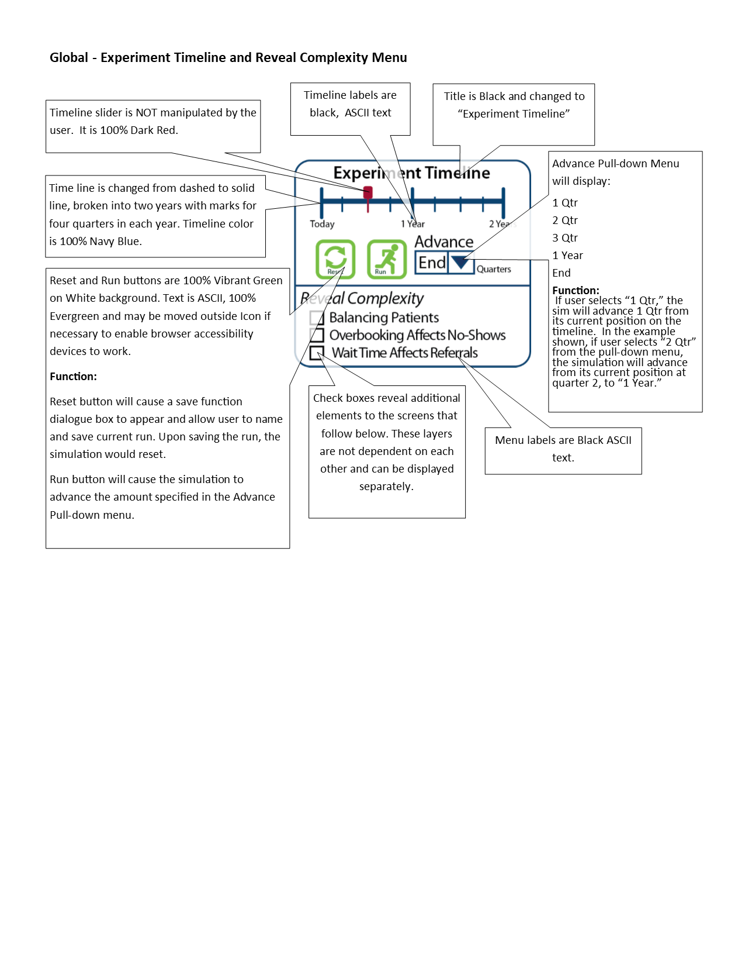

1. PLAY Page -- Experiments tile, Information Pop-up Tile

Figure 54  
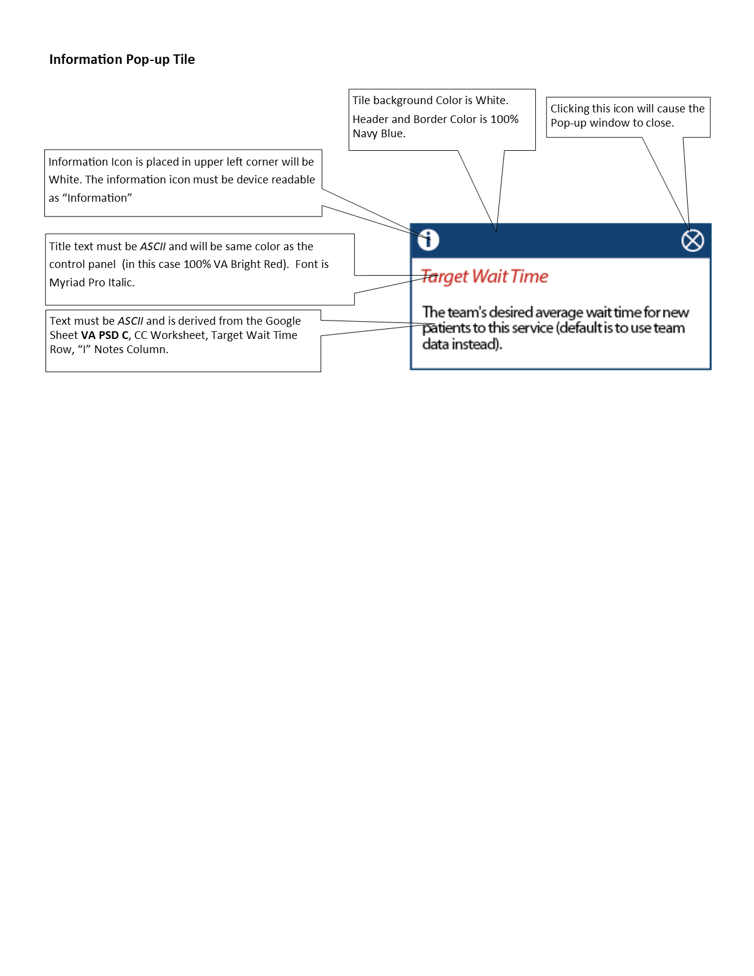

1. PLAY Page -- Expanded Outputs Tile > Information Pop-Up Tile
   1. On either the Table View (Example from CC, Figure 22) or Graph View (Example from CC, Figure #3), clicking on the “?” next to the “Alternative 1” or “Alternative 2” in the Control Panel will bring up the “Information Pop-up Tile” (Figure 55).
   2. The text for the Information Pop-Up Tile will come from the saved Scenarios selected from the drop-down (i.e., Select Experiment) in the Expanded Outputs Tile.

Figure 55

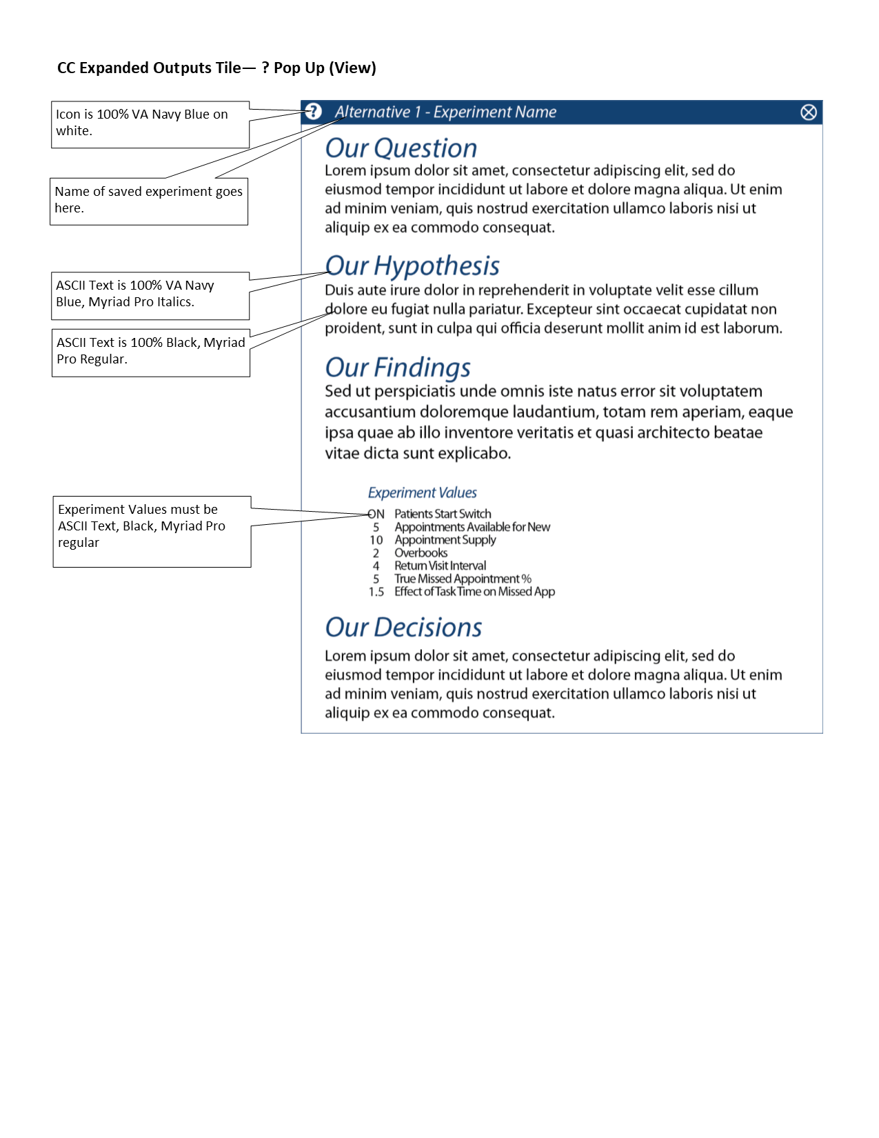

1. PLAY Page -- Outputs Tile > Graph, Alternatives Table, and Patient Cohorts Views. On either the Graph View (Figure ##) or the Table Views (Figure ## and Figure ##), graphs or tables shown are selected in the Expanded Outputs Tile.
   1. Graph View (Figure 56) is the default view upon entry to the page.   
      1. The x-axis
         1. The x-axis indicates “time” and should be a fixed (i.e., does NOT contract/grow depending on current time of the model.
         2. Only the labels “Today”, “1 Yr”, and “2 Yrs” should be shown in the x-axis labels.
            1. Minimum value of the X-axis is not “zero”, but it starts at Time = -13 weeks.
            2. “Today” is the label that corresponds to Time = 0 week.
            3. “1 Yr” is the label that corresponds to Time = 52 weeks.
      2. “2 Yrs” is the label that corresponds to Time = 104 weeks.

Figure 56

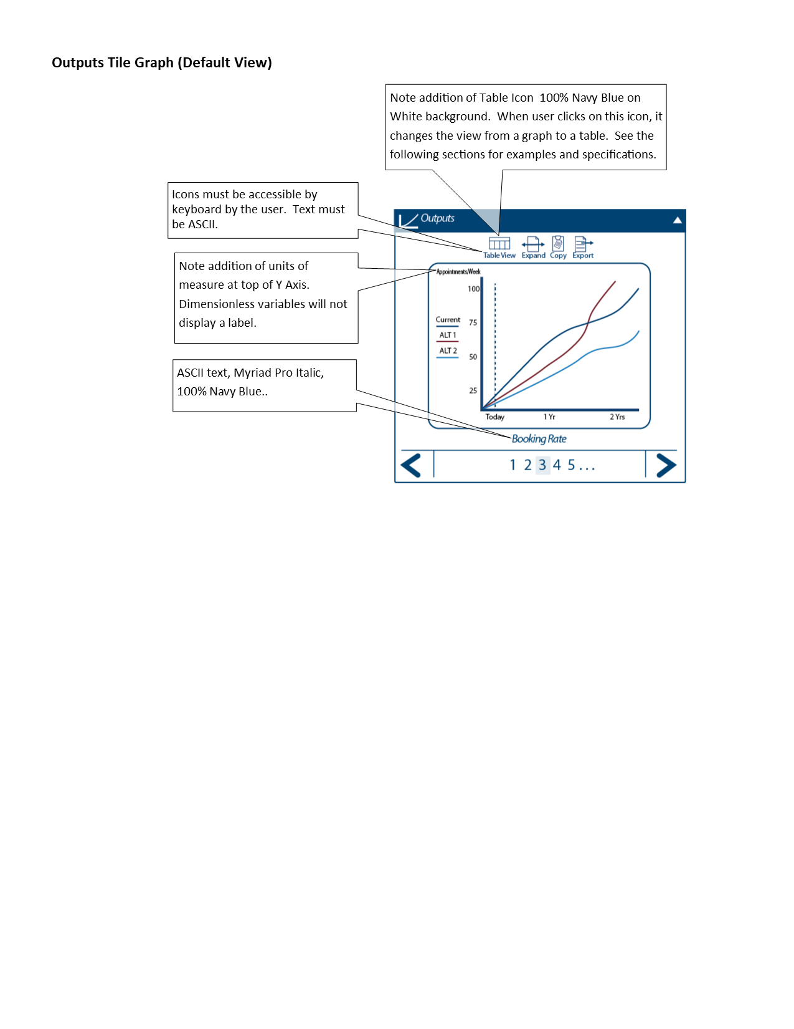

* 1. Tables Views  
     1. Patient Cohorts Table View -- Figure 57

Figure 57

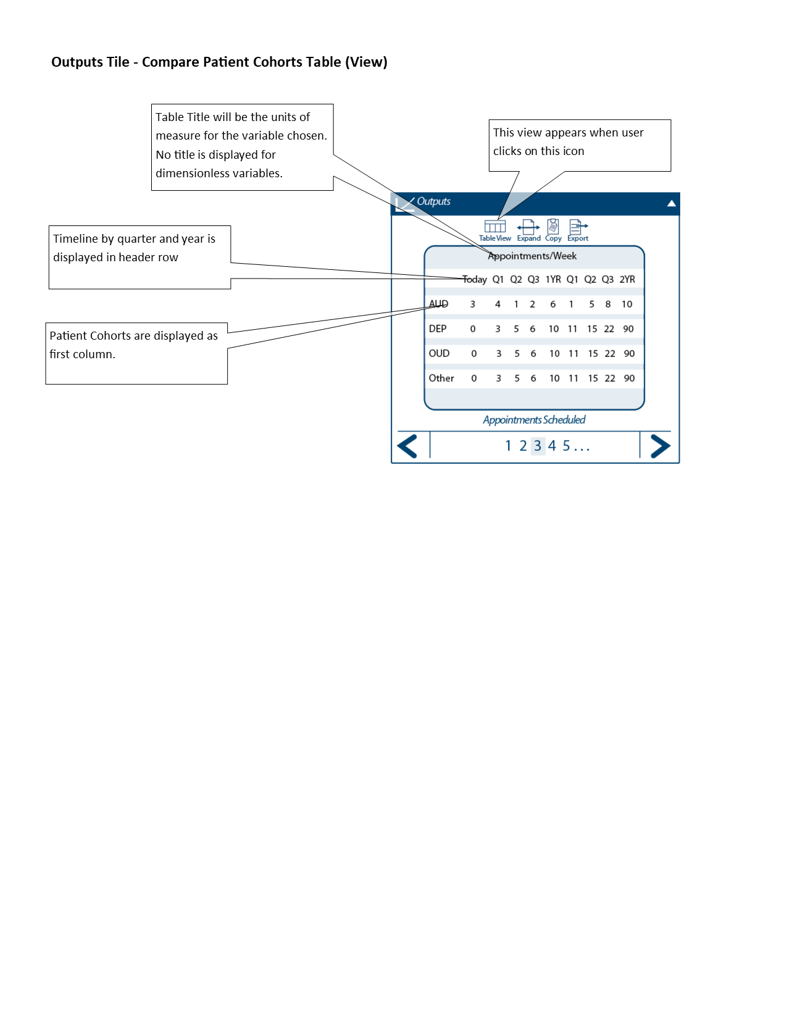

* + 1. Alternatives Table View -- Figure 58

Figure 58

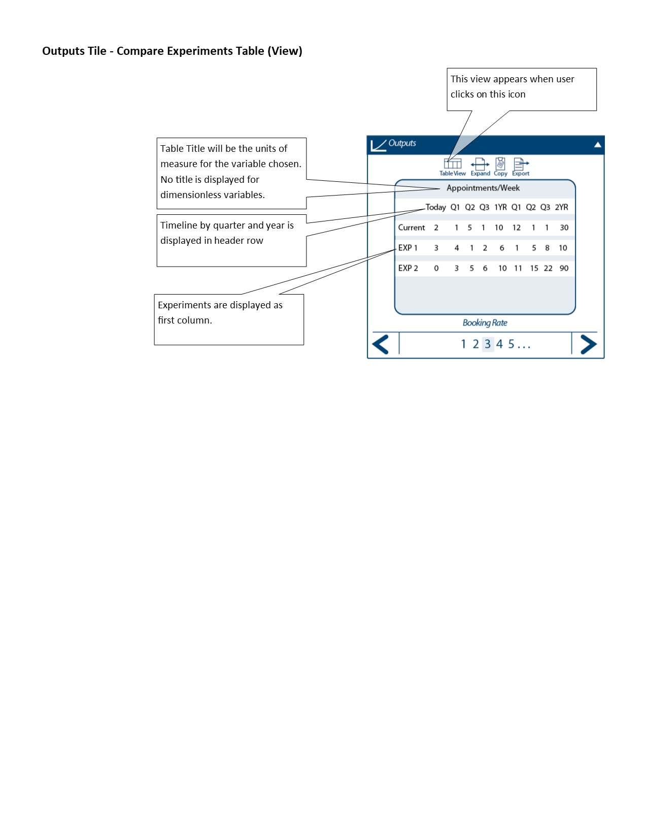

* + 1. The column labels and the values for the variables that are shown are queried from the following weeks:
       1. Today = 0 week.
       2. Q1 = 13 weeks.
       3. Q2 = 26 weeks.
       4. Q3 = 39 weeks.
       5. 1 Yr = 52 weeks. (Note: label should be “1 Yr”, not “1YR”.)
       6. (the second) Q1 = 65 weeks.
       7. (the second) Q2 = 78 weeks.
       8. (the second) Q3 = 91 weeks.
       9. 2 Yr = 104 weeks. (Note: label should be “2 Yr”, not “2YR”.)

1. Text changes to Expanded Output Tile. Please see description and text changes in 2.03 Player’s Dashboard / 5.9.6 Dashboard with access to key metrics (Agg).

1. Please include the preceding text in the Simulation, including “TBD: ”.